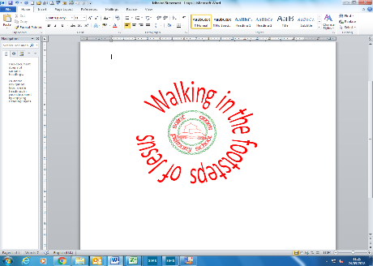
Science – What is in your habitat?
Year 2 - Autumn Term
In this unit our BIG question is…
What is living, once lived or never lived?
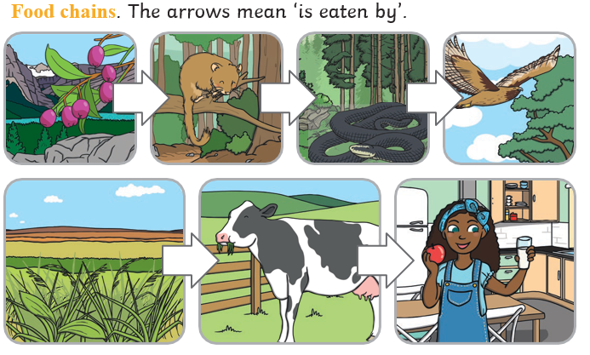
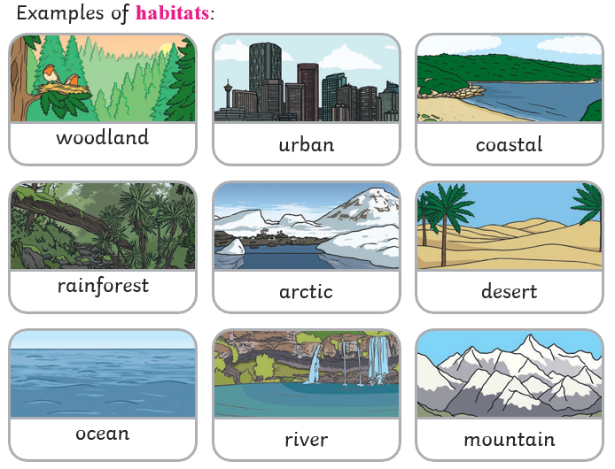
Famous Scientist-Joan Beauchamp Proctor
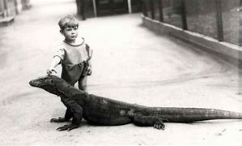
Joan was born in 1897. She loved reptiles ever since she was a little girl. She followed her passion to a successful career at the National History Museum and the London Zoo, designing the Reptile House which is still in use today. She also dispelled many of the myths surrounding Komodo dragons, even bringing one to children’s tea parties.

For this unit we are becoming BIOLOGISTS because we are studying what is in a habitat.
Key Vocabulary
habitat | A habitat is the natural place something lives. A habitat provides living things with everything they need to survive such as food, shelter and water.
living | Things that are living have all the life processes. They move, breathe, sense, grow, make babies, get rid of waste and get their energy from food.
once lived (dead) | Things that are dead were once living. They did have all the life processes but don’t now.
never lived | Things made out of metal, plastic or rock were never living. They never had the life processes.
food chain | A food chain shows how each animal gets its food. Food chains are one of the ways that living things depend on each other to stay alive.
carnivore | An animal that eats meat
herbivore | An animal that only eats plants
omnivore | An animal that eats plants and meat
decay | Destroyed by natural processes.

