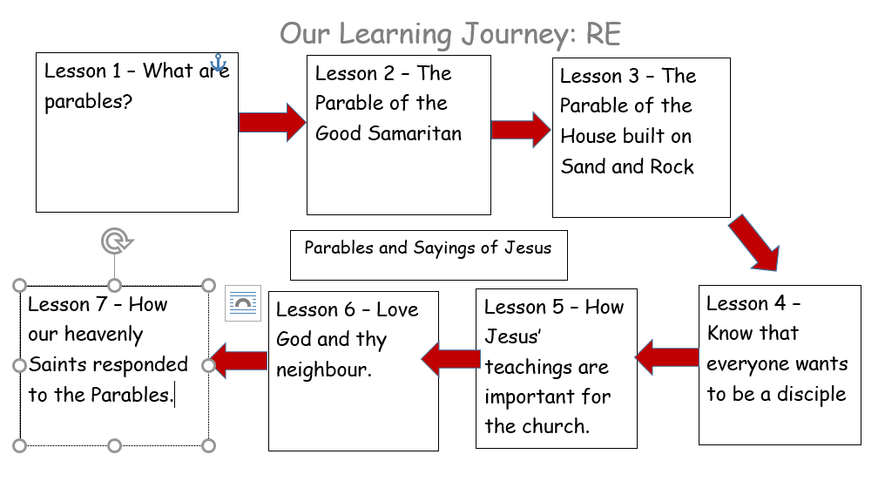
Mk 4: 1-9 Lk 8: 4-8, 11-15 – The Parable of the Sower.
Mt 7: 21-27 The Parable of the House built on Sand and Rock.
Mt 22: 1-14 – The Parable of the King’s Wedding Feast.
Parables & Sayings of Jesus
Knowledge Organiser
1

In this unit you will gain a greater knowledge and understanding of the Parables of Jesus. We will explore the kingdom of God from the teachings of Jesus and ways in which Christians respond to the teachings today.
Bible References:
Learning Journey:

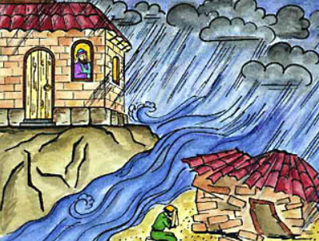
AT2: ER1 (Scripture): What is the most important message from the parable of…? ER2: How can this message be applied to your life?
AT2: ER2 & AT3: AE1: Jesus ended the Parable of the Good Samaritan by saying, “Go and do likewise.” What does this mean?
AT3: AE2: Which parable would be the most suitable parable to use to teach a younger child? Why?
AT2: ER2 & AT3: AE2 Which of the Sayings of Jesus in the parables do you think is the most important?

- What questions do you have about these painting?
- Why do you think the artist represents the Holy Spirit in this way?
- What puzzles you about these painting?

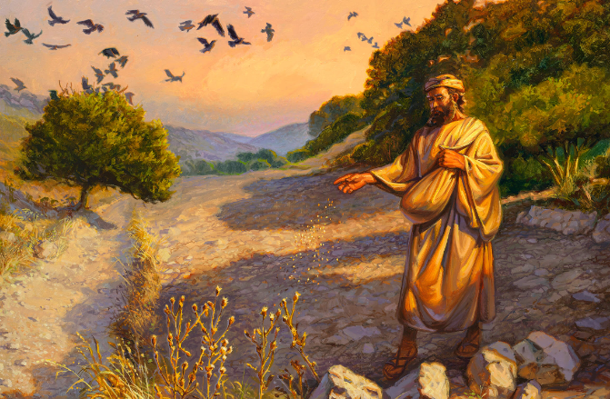
Catholic Social Teaching – Rights and Responsibilities
Rights and Responsibilities (what are we learning from the parables and how are we applying this to our own life)
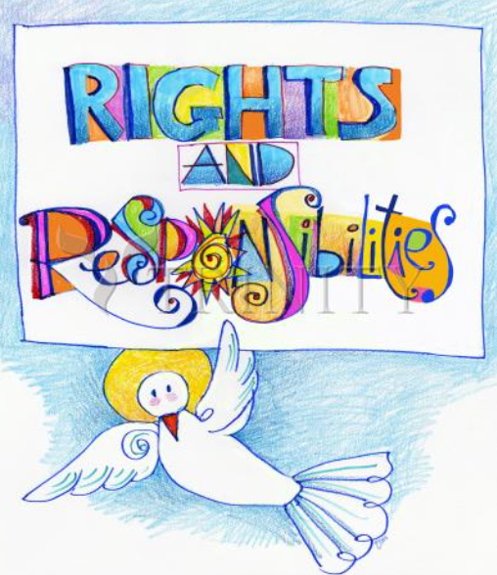
Key Vocabulary
Parable, Holyland, Samaritian, Levite, Priest, Saint, Kingdom of God.

