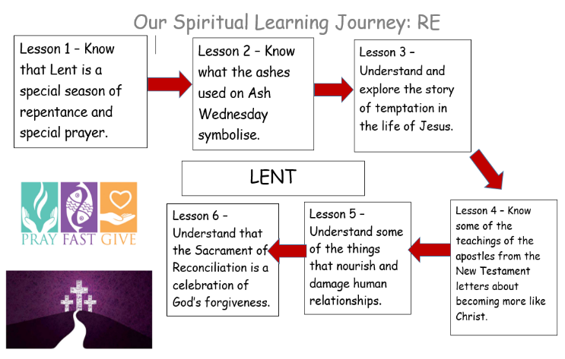
Mt. 4: 1-11 – The Temptations of Jesus
Lk. 6: 1-8, 16-18 – Prayer, Fasting and Almsgiving
Lk. 18: 9-14 – The Parable of the Pharisee and the Publican
Mk. 1: 1-20 – The Call of the disciples
Lk. 5: 27-28 – The Call of Levi
Mt. 9: 9-10 Mt. 19: 16-22 – The Call of the Rich Young Man
Mt. 13: 44-46 – The Parables of the Kingdom
Mt. 5: 3-12 – The Beatitudes of Jesus

Lent
Knowledge Organiser
1

In this unit you will explore some of the symbols and practices associated with the celebration of the Season of Lent. Through the life and teaching of Christ you will learn about prayer, fasting and almsgiving and the forgiveness that God offers to those who believe in him.

Bible References:
Learning Journey:

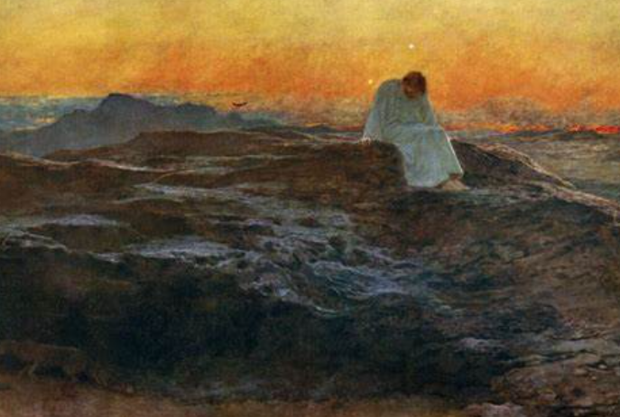
AT2: ER2 (Symbols): Why are the ashes an important symbol during the time of Lent?
AT3: AE2: What advice would you give to someone who has been tempted to do something wrong? Use the teachings of Jesus to help you.
AT2: ER2: How can you apply Christ Teaching’s to your own life?
AT2: ER2: Is it always easy to seek forgiveness? Explain your answer.
AT2: (worship) Why do Catholics go to the Sacrament of Reconciliation and how does it make you/others feel?

- What questions do you have about these painting?
- Why do you think the artist represents the Holy Spirit in this way?
- What puzzles you about these painting?

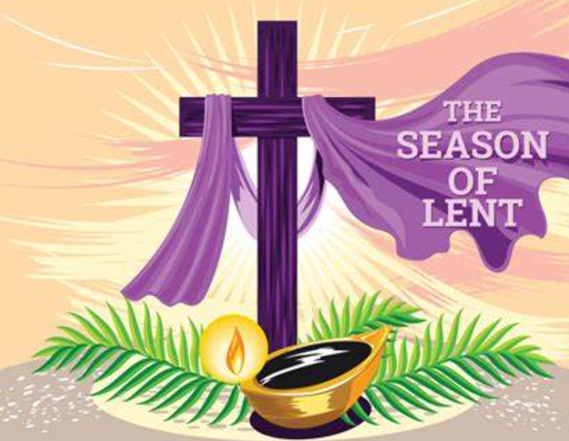

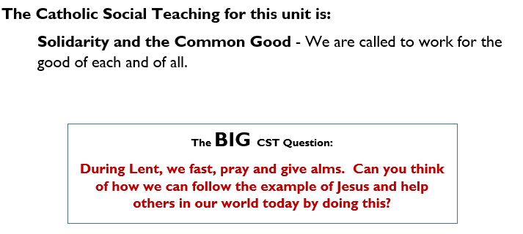
Key Vocabulary
Lent, Repent, Temptation, Corinthians, Colossians, Ephesians, Sacraments, Healing, Forgiveness, Reconciliation

