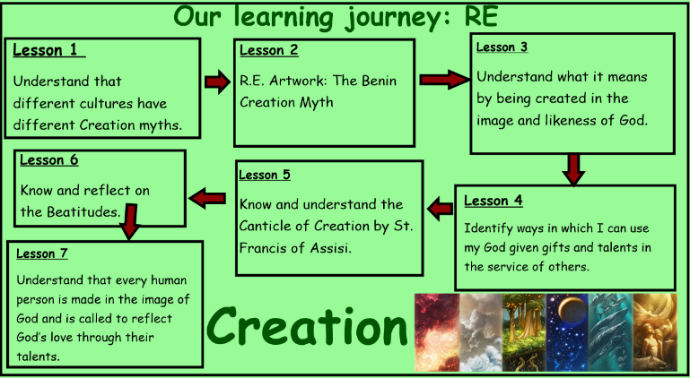
Genesis 1: 1-31
Genesis 2: 5 – 24
Psalm 103 (104) – Psalm in praise of God the Creator
Mt 5: 1-12 The Beatitudes of Jesus
Lk. 6: 20-23 The Beatitudes of Jesus
In this unit you will hear about key beliefs about the creation of human beings and the creation of the world. We will be introduced to the story of creation as a way of explaining that God is the creator. We will be reflecting on our God given talents and living our lives in the response to the teaching of Christ.
Learning Journey:
Creation
Year 5
Knowledge Organiser

Bible References:

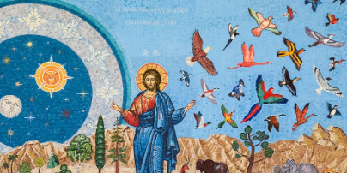
ER2 - Why does God sometimes ask us to do difficult things?
ER1/AE1 - What have you learnt about God through the stories we have studied? (Link your answer to the story) ER1/ AE1
AE2 - What do you think it means when it says we are all made How do you think you are made in God’s image and likeness?
ER2 - How do the Beatitudes of Jesus link to reconciliation?

- What questions do you have about this painting?
- Why do you think the artist represent the Abraham in this way?
- What puzzles you about this painting?

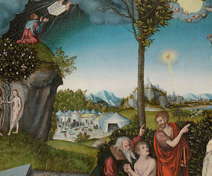
Catholic Social Teaching – Stewardship of Creation
How can children be encouraged to value and care for creation?
Why do we, as adults and children, need to work towards justice for all?
What are some of the ways people can look at the world today that the author of Genesis could not and what do you think this means for us? (e.g. space, knowing the diversity of the world, volcanoes, icebergs, rainforests, deserts.)


