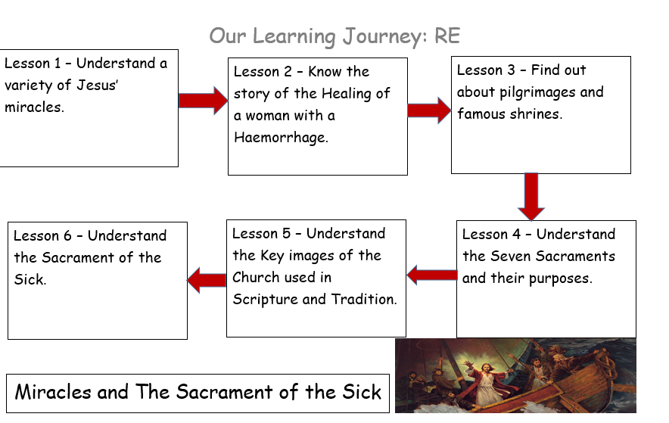
In this unit you will hear about some miracles of Jesus and the work of the Church to heal and care for the sick in Christ’s name.
Mt. 8 23-27
Lk 8 22-25 – Jesus Calms The Storm
Mt 14 13-21 – Feeding of the Five Thousand
Mt 8 28-34 – Healing of the Demoniac
Lk 18-35 Healing of the Blind Man
Learning Journey:
Miracles and Sacrament of the Sick
Year 5
Knowledge Organiser

Bible References:

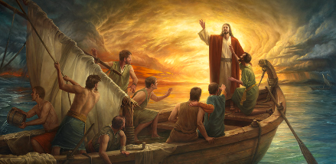
AT3: AE1/3: The meaning of the word “Church” is more than just a building. It houses the People of God and is the Body of Christ here on earth. – What does this mean to you?
AT3: AE2 (actions) How have the actions of Jesus led us to our belief in him today?
AT2: ER2 Give some reasons why people decide to visit places of pilgrimage. Why do they believe it is important?
AT3: AE2/3: In your opinion, which of the seven sacraments is the most important? Explain your point of view
AT3: AE2: Are pilgrimages just for sick people? Explain your point of view and give a reason for it.

- What questions do you have about this painting?
- Why do you think the artist represent the Abraham in this way?
- What puzzles you about this painting?

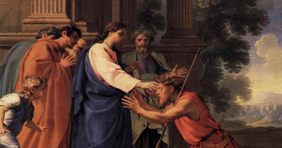
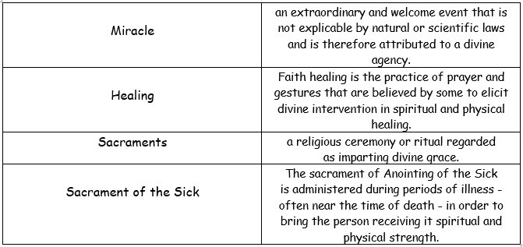
Catholic Social Teaching – Stewardship of Creation
How can children be encouraged to value and care for creation?
Why do we, as adults and children, need to work towards justice for all?
What are some of the ways people can look at the world today that the author of Genesis could not and what do you think this means for us? (e.g. space, knowing the diversity of the world, volcanoes, icebergs, rainforests, deserts.)



