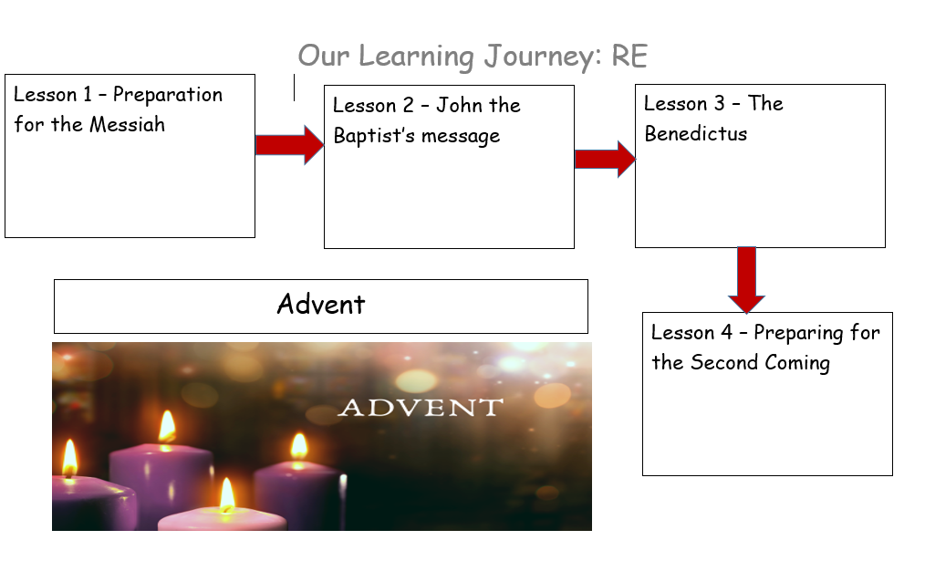
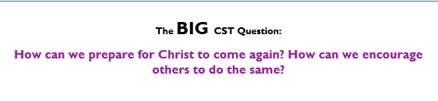
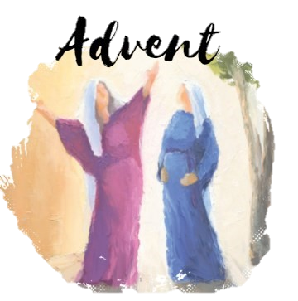

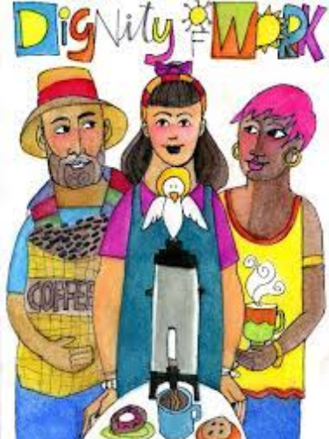
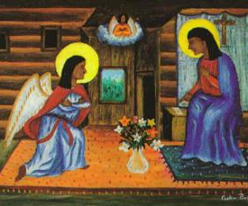
Catholic Social Teaching - Dignity of Work
We all have the right and duty to participate fully in society.

Bible References
Micah 5: 2-5
Jeremiah 23: 5-6
Lk.1 – The Birth of John the Baptist
- What questions do you have about this painting?
- Look in between Mary and the Angel. Why is there another person in a cloud?
- How do you think Mary felt when the Angel Gabriel appeared?
- What does this story teach us about forgiveness? How can we apply this story in our life?
AT2: ER1: What do you think about the Old Testament teaching about the coming of the Messiah?
AT2: ER1 (belief): How do the messages that we learn, about coming of the Messiah help us to appreciate the person of Jesus?
AT2: ER2: Why do you think the news of the birth of this child was so surprising?
AT3: AE3: Which of the Old Testament messages do you feel is most important?
Vocabulary
Advent
Benedictus
coming
Messiah
John the Baptist
Zechariah

During this unit, I’m going to:
- know and understand that Christians prepare to remember the first Coming of Christ and prepare for his Second Coming during Advent.
- know and discuss the messages of those who have proclaimed the coming of Christ.
- understand that John the Baptist’s message of preparation can help Christians to prepare for Christ to come again.

Advent: Year 5
Knowledge Organiser
This unit links the Old Testament and the New Testament in terms of preparing for the coming of Christ during the Season of Advent.

