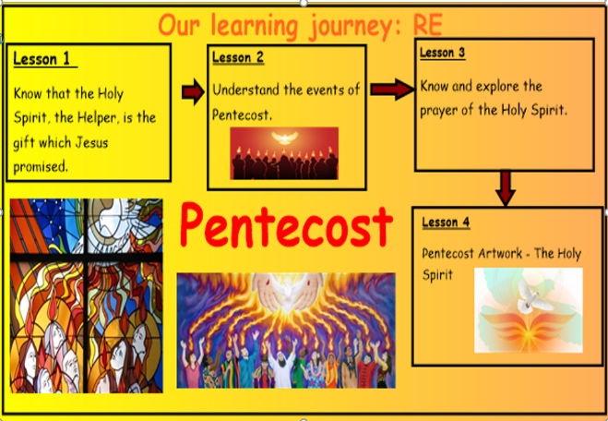
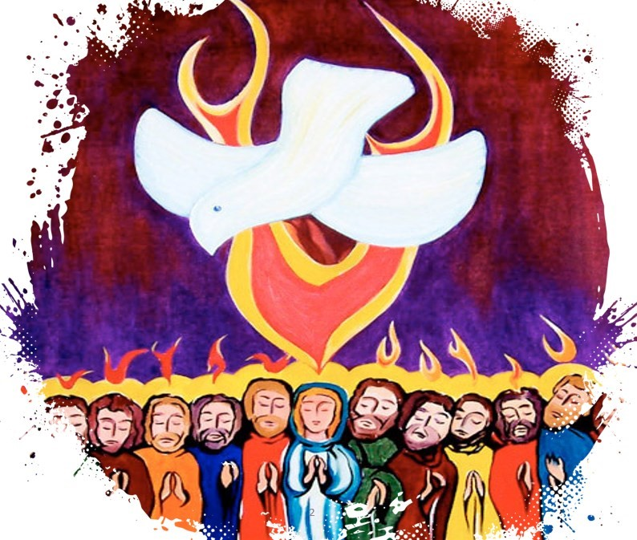

Holy Spirit, Pentecost, Holy Trinity,
transformation, power, advocate, truth

Class prayer: Use parts of the Creed, Gloria and Prayer to the Holy Spirit in Collective Worship.

Vocabulary
Learning Outcomes:
Pentecost: Year 5
Knowledge Organiser
1

Opportunities for thought and reflection throughout:

- Which of the several names given to the Holy Spirit do you think is the most profound? Why?
- How did the Holy Spirit transform the lives of the disciples?
- What do Catholics believe about the Holy Spirit? How does this impact on their lives?
- How would someone who was filled with the Holy Spirit act?
- What questions would you like to ask the Apostles at the time of Pentecost?

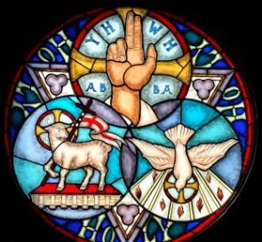
Bible References:

John. 14-16 – Jesus’ teaching about the Holy Spirit
Acts 1: 6-9 – Jesus promises the Holy Spirit

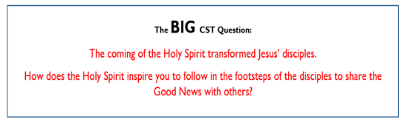
Names given to the Holy Spirit

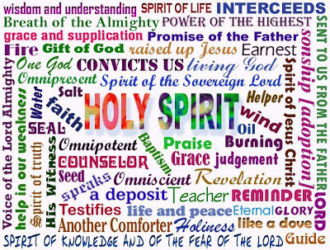
- What questions do you have about this painting?
- Why do you think the artist Jesus’ promise to the Holy Spirit in this way?
- What puzzles you about this painting?



