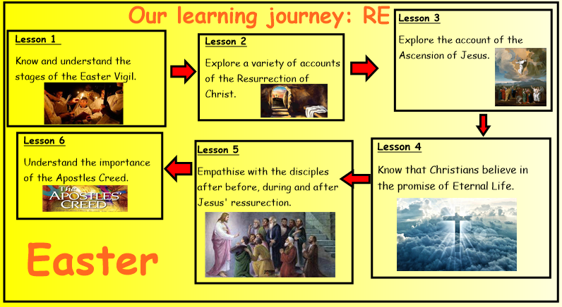
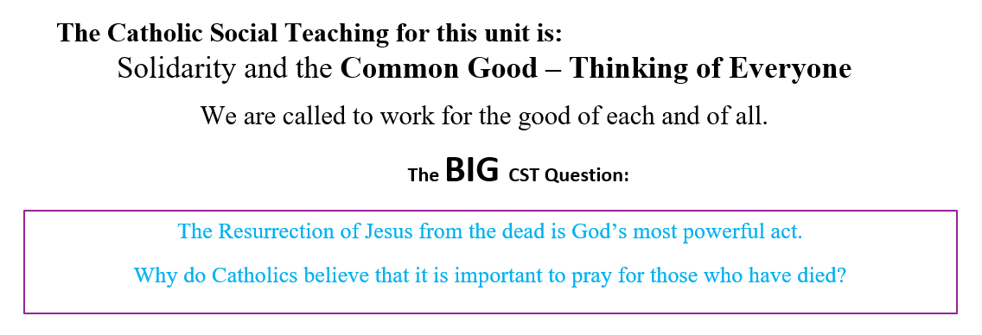
This unit you will be introduced to accounts of the Resurrection appearances of Christ. In this unit you will study the story of the Ascension and will learn about Christian belief in the presence of Christ in the world today. You will also empathise with the disciples before, during and after Jesus’ resurrection.
Learning Journey:
Easter: Year 5
Knowledge Organiser

Bible References:
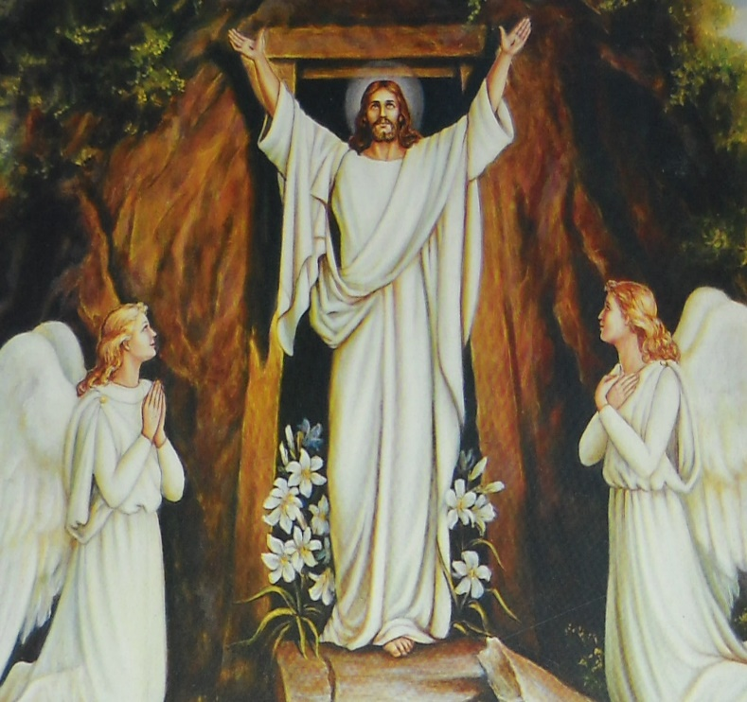
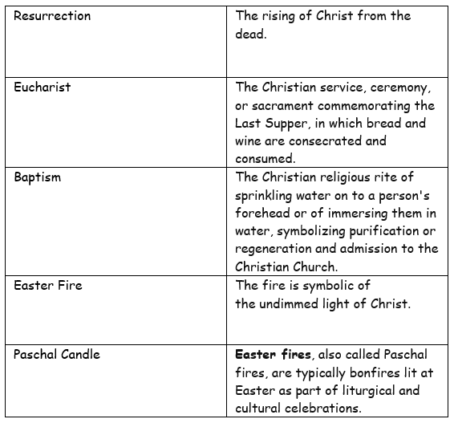
- What questions do you have about this painting?
- Who is in this image? What is happening?
- How does this painting compare to another you have seen?

Why is the Easter Vigil the most important festival of the Christian Year? Can your partner explain why?
How were the lives of the disciples changed by the Resurrection of Jesus? What do others in your group suggest?
Can you use evidence from a Gospel account to explain why the Resurrection changed the lives of the disciples?
What do we believe about the story of the Ascension? What happened to Jesus? Discuss this with your partner?
Give some reasons why we should have hope of eternal life.
How should hope of eternal life change how we live our lives?

Mark. 16: 19-20 – The Ascension of Jesus into Heaven
Luke 24:50-53 – Praising God at the temple.

