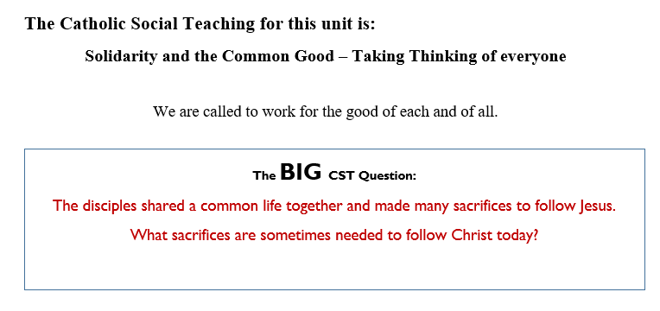
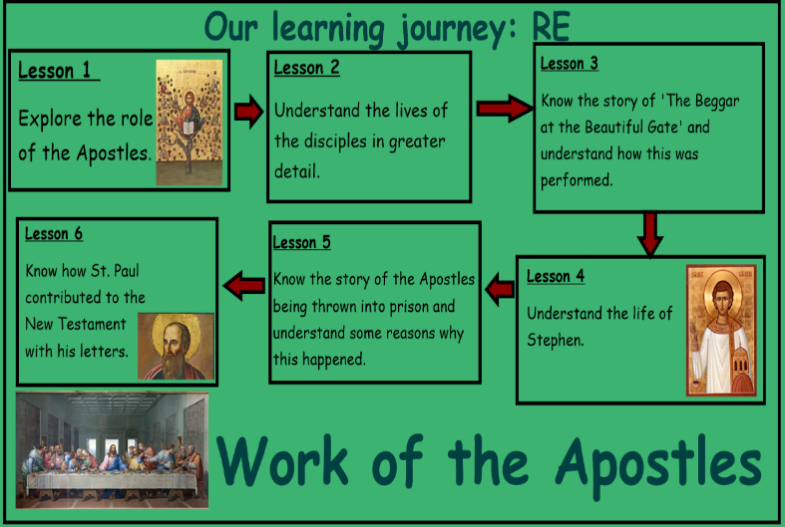
This unit you will be introduced to the roles of the Apostles and understand their lives in greater detail. You will know the story of ‘the Beggar at the Beautiful Gate’ and understand the life of Stephen. You will also know why the Apostles were thrown into prison.
Learning Journey:
The Work of the Apostles: Year 5
Knowledge Organiser

Bible References:
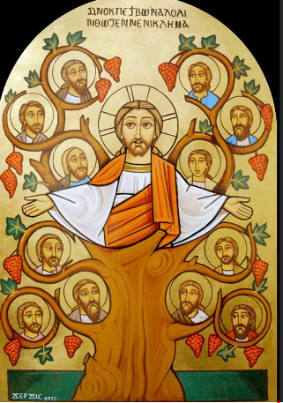
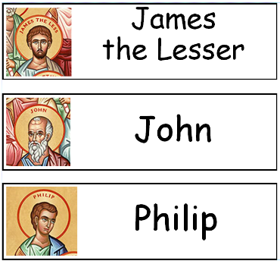
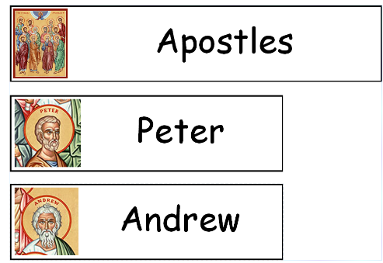
- What questions do you have about this painting?
- Who is in this image? What is happening?
- How does this painting compare to another you have seen?

What do you think the most difficult thing for the apostles to do was? What does your partner think?
Why were Peter and John able to perform the miracle? Explain your reasons to a partner
Why were some apostles imprisoned? Can you give your partner three key reasons?
Is it possible to be a Christian without going to church?
What do you think made people want to follow St Paul?
Which of his letters is the most significant to us a Christians? Can you use evidence to support your view?
What qualities are needed to be a disciple of Christ?

Matthew 10:2-4, Mark 3:16-19, Luke 6:13-16, and Acts 1:13.



