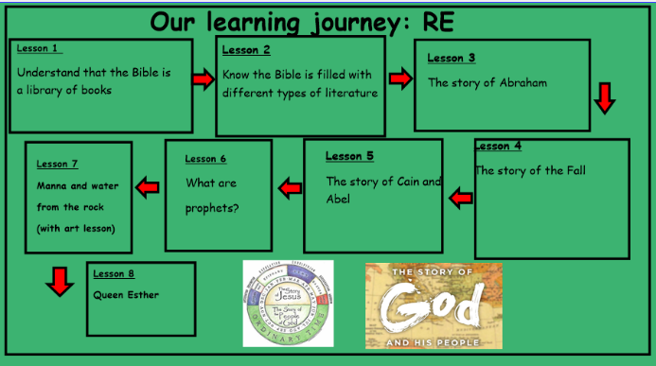
In this unit, you will be given opportunities to develop your knowledge and understanding of the structure of the Bible and the forms of literature that are found in the different books. You will be introduced to stories of significant people in the Old Testament and discover what some of these stories tell us about your relationship with God. This unit builds on the Old Testament units from Year 4 and the work on the Passover in Year 5. It also provides a foundation for work on the Sacrament of Confirmation when we consider God’s call in the lives of Christians today

P R I O R L E A R N I N G
It would be helpful if the children have:
l experience of Easter stories
l appreciation of Easter symbols.

S K I L L S

W H E R E T H E U N I T F I T S I N
This unit builds on previous work in Year 3 and Year 4
about the Easter Story and how the Church celebrates Easter
Genesis 3: 1-15 – The Story of The Fall Genesis 4: 1-13 – The Story of Cain and Abel Exodus 16: 1-18 – The Story of Manna From Heaven
Exodus 17: 1-7 – The Story of Water From The Rock Exodus 19:-20:17 – The Giving of the Commandments to Moses
Joel 2: 12-17 – The Writings of Old Testament Prophets
Hosea 14:2-3
Learning Journey:
The Story of the people of God: Year 6
Knowledge Organiser
1
Bible References:

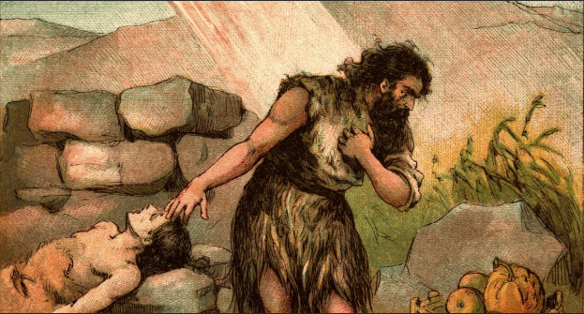
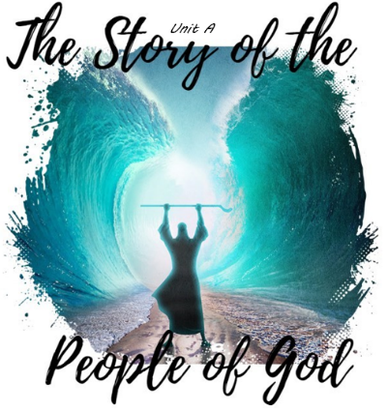
ER2 - How do we overcome our emotions to create peace and harmony in the world?
AE3+4 - ‘The ten commandments are outdated’ discuss their viewpoint using specific examples of the commandments
AE2 – Why is the Old Testament important? Use evidence in your answer

- What questions do you have about this painting?
- Why do you think the artist represent the Christmas Story in this way?
- What puzzles you about this painting?

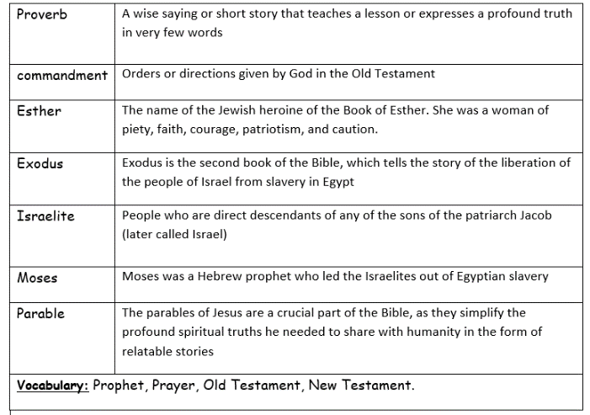
Catholic Social Teaching – Stewardship of Creation
How can children be encouraged to value and care for creation?
Why do we, as adults and children, need to work towards justice for all?
What are some of the ways people can look at the world today that the author of Genesis could not and what do you think this means for us? (e.g. space, knowing the diversity of the world, volcanoes, icebergs, rainforests, deserts.)



