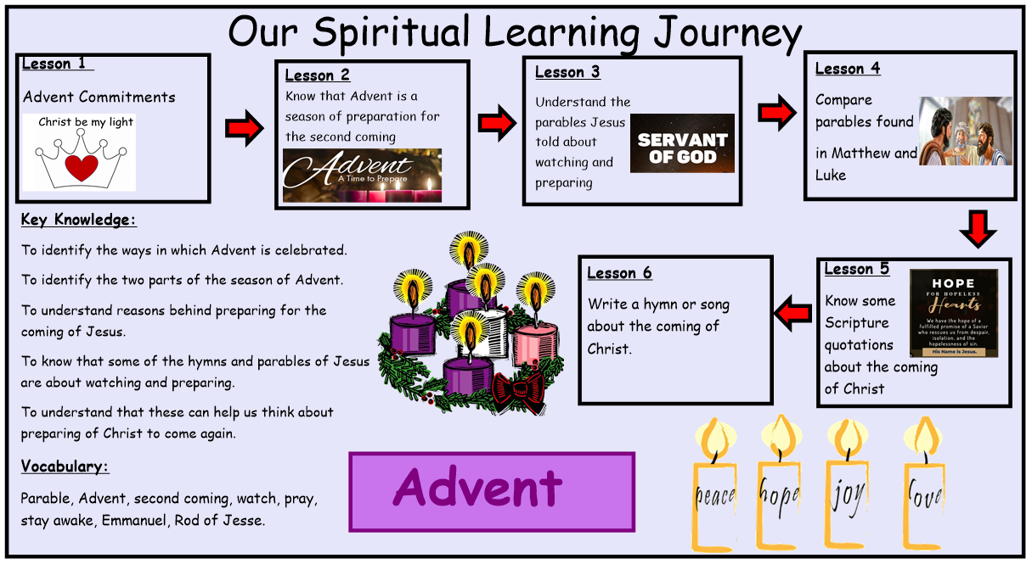
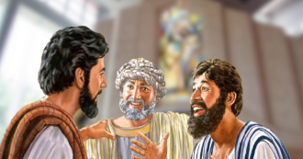
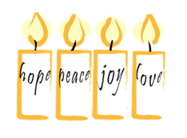
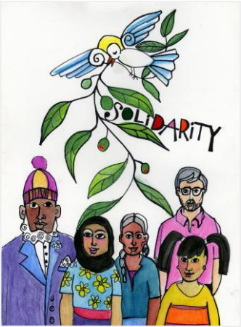
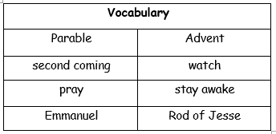
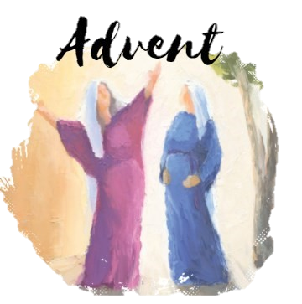
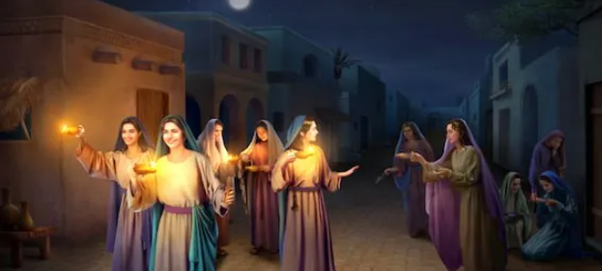
What questions do you have about this painting?

How can we be a better follow of Christ during Advent?
AT2: ER1: How will you prepare for the coming of Jesus Christ during Advent? How will this bring you closer to Christ?

AT2: ER1 What advice would you give to others about preparing for the second coming of Christ?

AT3: AE4: Compare your views with a partner. How do they differ?

AT2: ER2: How can we respond to the needs of others during the season of Advent?

Advent: Year 6
Knowledge Organiser
Catholic Social Teaching Solidarity and Peace

Which Sacraments can we receive to bring us peace during this special season?
How can we share Christ’s peace with others during Advent?

Bible References
Mt 25: 1-13 – The Parable of the Bridesmaids
Lk. 12: 35-40 – The Parable of the Servant Waiting for The Master to Return
Micah 5: 1 – From the City of David He Will Come
Isaiah 7: 3-5 – Emmanuel
Exodus 24: 9-15 – Moses Climbs the Mountain of The Lord
What questions do you have about this painting?

How can we, as followers of Christ, fill our lamps with oil?

How has someone else answered this question? How does it differ to your response?
In this unit the children will be given opportunities to develop their knowledge and understand of the two parts of the Season of Advent. A time to prepare for Christ to come again and a time to prepare to celebrate his birth at Christmas. Through some Parables of Jesus and some of the prayers and hymns of the Church they will explore these themes.

