Learning Project WEEK 6: Food
Age Range: KS1
Weekly Maths Tasks (Aim to do 1 per day) | Weekly Reading Tasks (Aim to do 1 per day)
- Working on Numbots - your child will have an individual login to access this.  - Play on Hit the Button - number bonds, halves, doubles and times tables.  - Look in the cupboards and the fridge. Sort some of the foods you can find into different groups. Which food group has the most or least amount of items? Which item of food is the lightest or heaviest? Why might this be?  - Play the game Fruit Fall - answer the data handling questions based on how many pieces of fruit you catch.  - Choose and draw a 2D shape of your choice. List how many sides, vertices and lines of symmetry it has. | - Read out aloud the ingredients on the back of a tin or cereal box to an adult?  - Can you add the sound buttons onto three words?  - Find a cooking book in the house or online and read the ingredients needed to make something.  - Find a food leaflet in the house and read some of the items. Make a list of the food in alphabetical order and add on sound buttons.  - Read a variety of books and make a list of all the different types of food you find.
Weekly Phonics/Spellings  Tasks (Aim to do 1 per day) | Weekly Writing Tasks (Aim to do 1 per day)
- Daily phonics - your child to practice their sounds and blend words. Interactive games found on link below.  - Phonics play  - Top Marks  - Spelling  - Spell the days of the week  - Spell common exception words  - Spelling City | Ask your child to:  - Create a shopping list for the week. Can your child group the items into food groups on their list e.g. fruit and vegetables, meat, dairy.  - Write a recipe for a healthy meal of their choice. Can they use subheadings for the ingredients and instructions.  - Write a set of instructions for making toast. Can they use imperative verbs?  - Design a new label for a cereal box. What eye catching information will you add? Can you use an exclamation mark?  - Write a poem about your favourite food. Will it rhyme?  - Design a new milkshake. Which ingredients will you include. Can you label the milkshake. Will you have a mascot that is linked to your new creation? Can you make the milkshake?
Learning Project - to be done throughout the week: Food
Food
The project this week aims to provide opportunities for your child to learn more food. Learning may focus on where different foods originate from, what makes a healthy meal, opportunities to cook etc .

Balanced diet: Show your child this video about how to have a balanced diet.

Play these games about healthy eating.
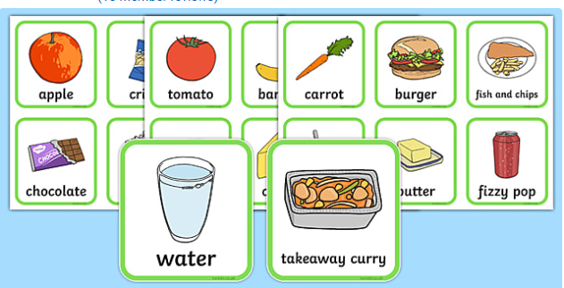
What do we have today? Look in the kitchen to see if you can create an A-Z list of foods.

Fruit and vegetables - Draw pictures of fruit and vegetables in your house. Label the fruit and vegetables and place in alphabetical order.

Sorting activity: Collect food from the kitchen and sort into healthy and unhealthy foods.

Design a poster - think about the foods you like to eat and food that you need to eat to keep you healthy. Create a poster that you can put in the kitchen or in the school hall. Will you be able to use any food wrappers or make your poster interactive?

Healthy lunchbox: can you play this game and make a healthy lunchbox?

Traditional food: Many cultures have various dishes of food to celebrate their festivals. Find out about a festival and compare it to a different festival. What are the similarities? What are the differences? How is the food prepared? Do you have any traditional food you enjoy with your family?

Restaurant: Can you plan a menu? Think about what you would like to have on your menu. Can you design a menu for a vegetarian? Can you design a menu for a vegan? Will you have options on your menu for people who have allergies?
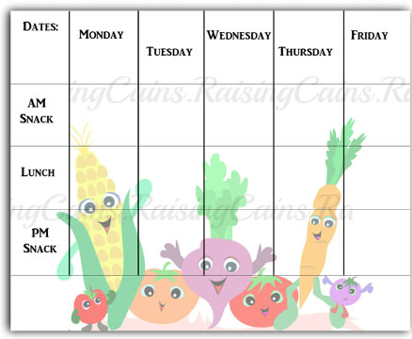
Look around the house for any leaflets or take away menus. What price is the food? Can you do any meal deals?

Designing a school menu. Can you design a new school menu? What could you add? What would you keep the same? Will it be a healthy school menu? Can you find pictures or draw pictures to add to your menu? Plan out your menu and remember to include prices.
Will you have a different menu everyday?

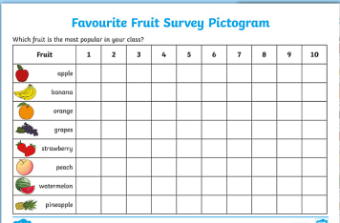
Cooking: find a few recipes and check if you have the ingredients at home and cook a meal for your family. Think about a starter, main and dessert. Can you cook as a family? Who will do the measuring?

Fruit survey: ask in your family the different fruits they like to eat. Collect the information and add it to your tally chart. Can you represent this information in a particular way?
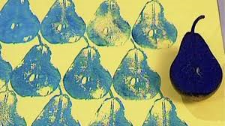
Fruit and vegetables printing: Look at the work of the artist: Lynn Flavell. How does she represent fruit and vegetables? Can you create a piece of artwork in the style of Lynn Flavell.

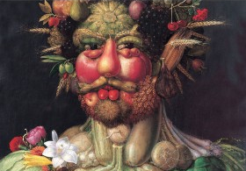
Look at the work of Giuseppe Arcimboldo.
Using different drawing materials, can you create a picture of your own?
Additional learning resources parents may wish to engage with
Classroom Secrets Learning Packs - These packs are split into different year groups and include activities linked to reading, writing, maths and practical ideas you can do around the home.
Twinkl - to access these resources click on the link and sign up using your own email address and creating your own password. Use the offer code UKTWINKLHELPS.
Headteacherchat - This is a blog that has links to various learning platforms. Lots of these are free to access.
#TheLearningProjects

