
Tuesday
Decimals: Multiply decimals by integers

Mild
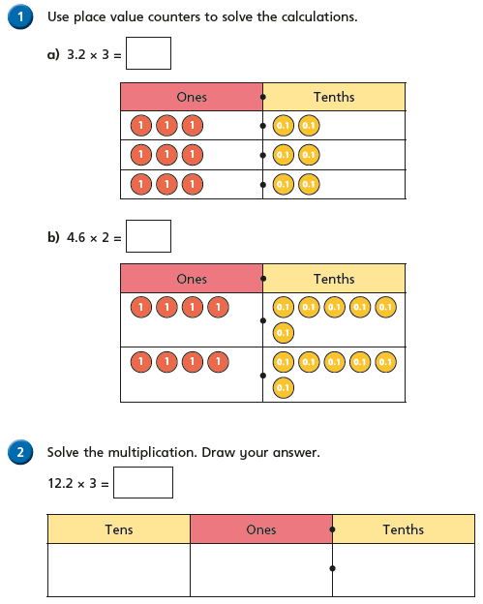

Write the question out in your book before writing the answer.
- 9 x 4.3 =
- 3.7 x 5 =
- 4 x 8.3 =
- 7.22 x 6 =
- 7 x 8.73 =

 Sophie buys a book for each of her 7 friends. The book costs £7.98 each. How much did she spend all together? | Lucy washes cars to raise money for charity. She charges £3.32 for each car she cleans. In one morning she washes a total of 6 cars. How much money has she made?

Mrs Mills shares the calculation below with Class 6:



