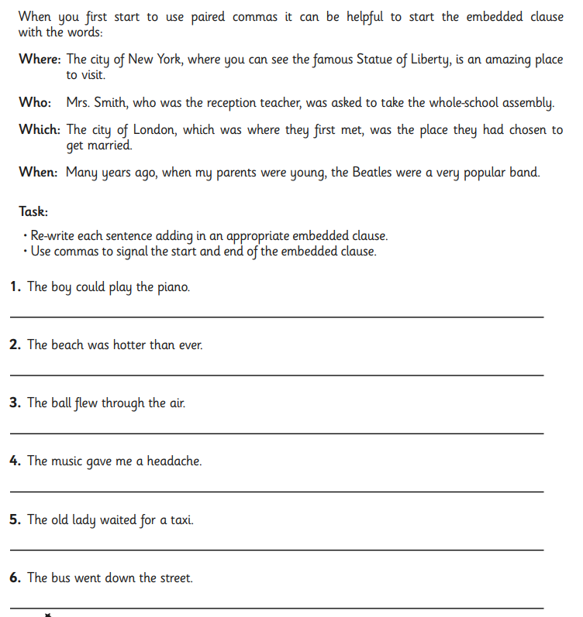
TASK ONE: Complete the activity to apply your knowledge of embedded clauses. Re write the sentences out into your workbook.



