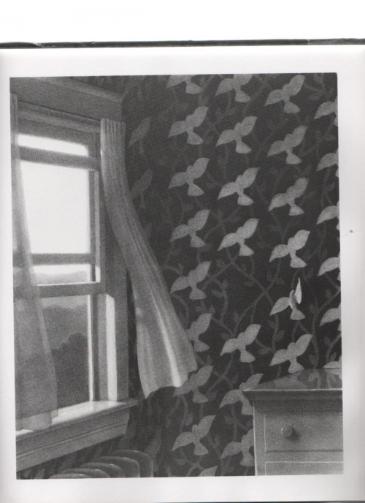 | What do you wonder about this picture?
I wonder why…
I wonder how…
I wonder what…
I wonder if…
I wonder when…
I wonder can…

This will help build ideas around your mystery story opening
DESCRIPTION: What can you see? How do you feel? What can you touch? What can you hear? What can you smell? | Alliteration? Onomatopiea? Similes? Metaphors? Personification?
Use the grammar techniques below to build sentences.

Powerful opening sentence
Will your opening sentences be scary? Startling? Or just a hint at the mystery to come? First sentences should be interesting enough to grab readers' attention and make them want to read the rest of the story.
3 adverb openers
Slowly, rapidly, hesitantly, carefully, heartily, suspiciously, curiously
Scene setting language
Grab your reader’s attention! Paint an image in their head. Give every detail: size, colour, exact position.
Repeat opening for power
It made the hairs on the back of my neck stand on edge. It made my teeth chatter uncontrollably. It made me feel incredibly uncomfortable.

Sense description-powerful verbs
Suspense sentences
Short and catchy for effect. Sometimes 1 word only.

WAGOLL
It was a warm, summer’s night, so I decided to tentatively open the sash window. Although it required me to move out of my bed, I knew it meant a better night’s sleep. Slowly and cautiously, I moved my tired, sleepy body towards the window, which was at the other side of my bedroom. As I moved, I unfurled my body, which was stiff and warm, stretched my arms outwards, grasping my clammy palms outwards to reach the bedroom walls either side of me. Unsurprisingly, I had no idea the impact of leaving the window open that night…
Arising suddenly the next morning, I was filled with a peculiar feeling. I could not shake the sensation, that was both uncomfortable and distracting, that took hold of my unrested body. Shivering uncontrollably, I hopped out of bed (with more energy than the night before) to close the open window.
Eerily, despondently, nervously, I crept into bed that night. My eyes were wide with fear and anticipation of...well I’m not sure exactly. My room, that I usually adore, had a very unwelcoming atmosphere. When I looked towards the window, it made the hairs on the back of my neck stand on edge. It made my teeth chatter uncontrollably. It made me feel incredibly uncomfortable.
Wearily, after several nights of uncertainty, my gaze was drawn to the walls, which were outdated and filled with memories. Something was not quite right. Strange...
I shook my head from side to side as I began to realise that the birds on it were, missing. Impossible! How could that be?
My heart felt like a lead balloon pulsating in my chest.
Where had they gone to?
That's when I realised...

Version 2
The flimsy curtains flapped in the breeze as the early morning rays beamed through the open window. All was quiet apart from the sweet chorus of birds from a distant tree and the gentle swishing of branches below.
Cemented like glue, I tried desperately to wriggle free; my wings so frantic to escape the grasps of the wall. I saw my chance. I had to take it! With all my energy, I pushed my tiny, hollow body forward, kicking with my feet, pecking, flapping, until….I was free! Free to fly. Free to begin my life in the sky where I belonged.

