
Thursday
Solve division problems without leaving a remainder
Fluency starter: 5 a day
Mild


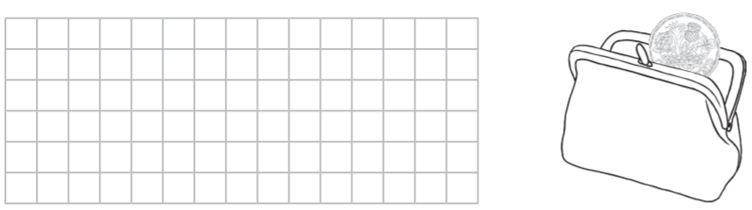
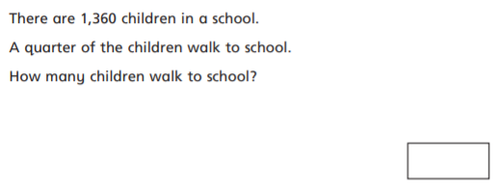
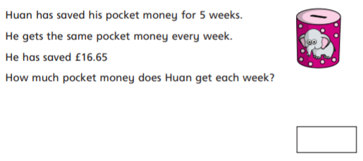

Maisie has £15.50 which she’d like to share equally between her and four friends. How much money will each of them receive?

Jack has £10.40 which he would like to spend equally on two games in the arcade. How much can he spend on each game?

Ellie has £15.69 in her piggy bank. She decides to share it equally between her and her two brothers. How much money will each sibling have?

Freddie is going on a school residential for four days. He wants to work out how much money he has to spend per day. He has £8.48 in total. How much will he be able to spend per day?

