
Thursday
Solve division problems without leaving a remainder
Fluency starter: 5 a day
Medium
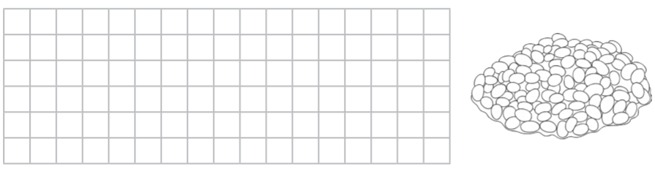

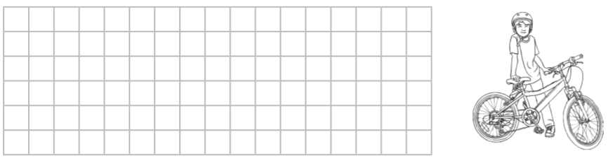

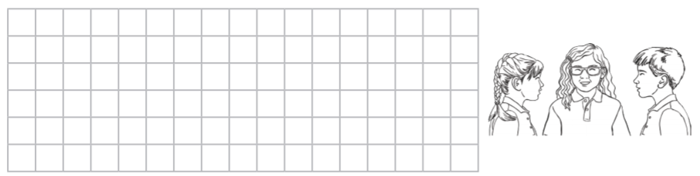
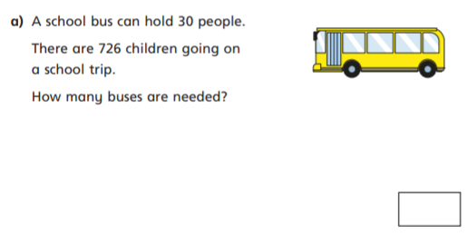

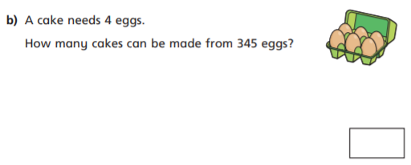

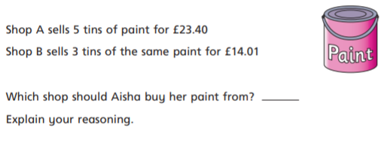
Jess is baking a cake and needs to share the mixture equally between 4 cake tins. The mixture weighs 4.012kg. How much mixture does she need to put into each tin?

Jaxon has 10.025 litres of homemade lemonade left after his party. He wants to share it equally between his five friends. How much lemonade will each friend receive?

