Wednesday 8th January Science

WALT: To identify and name a variety of common animals

Finish drawing and label your animal

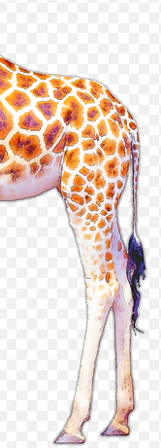

Clue 1
__________________________________________________________________________________________________________
Clue 2
__________________________________________________________________________________________________________
It is a fish an amphibian a bird a reptile a mammal

