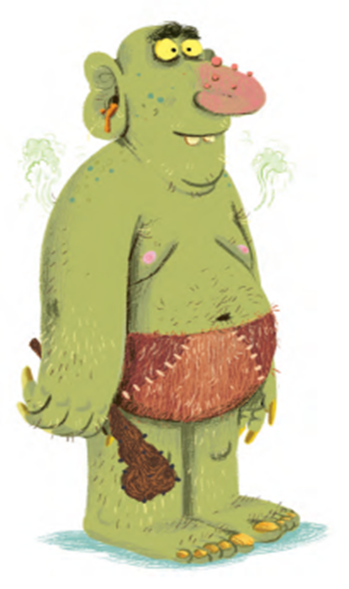
Help sheet

What does the troll look like?

What does the troll smell like?

What does the troll sound like?

Here are some sentence starters if you would like to use them…
The troll looks like…
The troll smells like…
The troll sounds like…

Remember!
- Fronted adverbials
- Adjectives
- Adverbs
- Punctuation

