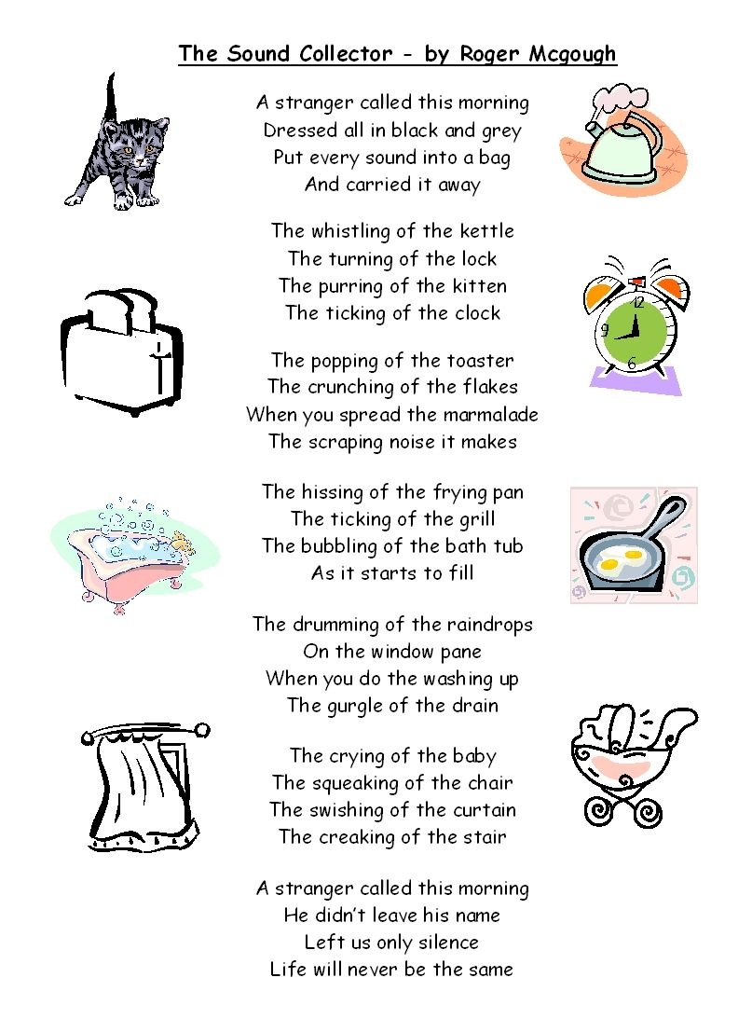
VIPER – INFER & PREDICT
- Why do you think poet might have dressed the sound collector in black and grey?

- Where did the sound collector visit and take sounds from?
How do you know?

- ‘Life will never be the same’
Do you agree? Why? How would it be different? How might it still be the same?

VIPER – INFER & PREDICT
- Why do you think poet might have dressed the sound collector in black and grey?

- Where did the sound collector visit and take sounds from?
How do you know?

- ‘Life will never be the same’
Do you agree? Why? How would it be different? How might it still be the same?

