Activity 1 – Which adjectives and adverbs go into the groups?
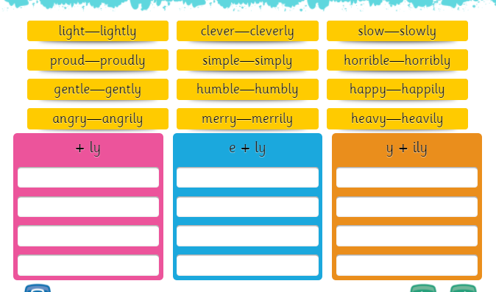
One has been done for you!
Light - lightly

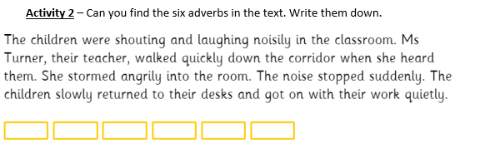

Activity 3 – Can you write a sentence to describe the troll from ‘The Three Billy Goats Gruff’ using some adverbs?
For example:
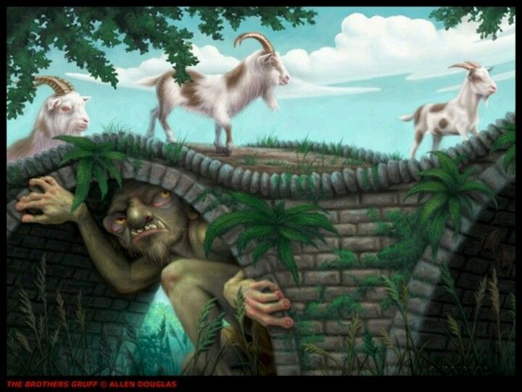
Slowly, the troll waited for the smallest billy goat to walk onto his bridge and without a warning he suddenly jumped out!

