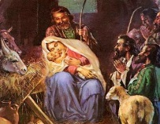
Activity 1
Answer the following questions about the story.

- What was the bright light that was shining? What happened?

- How did the Shepherds feel at this time?

- What did the Angel say to the Shepherds?

- How did the Shepherds feelings change?

- How did the Shepherds feel when they saw Jesus in a manger?
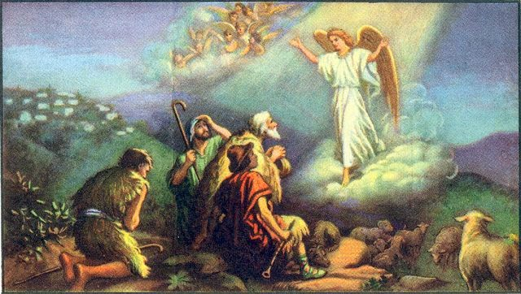

Activity 2

Complete the following sentence:

This was an extraordinary moment in the Shepherds lives because....

