Vertebrates are organisms with a backbone. | Invertebrates are organisms without a backbone.
Skeletons

Vertebrates and Invertebrates

Amazing Bodies
A skeleton has three functions – protection, movement and support.
Carbohydrates provide you with energy to move and keep warm.
Roughage keeps your digestive system healthy.
Fats are used to keep us warm.
Dairy source of calcium that keeps bones and teeth healthy.
Proteins are needed for growth and repair.
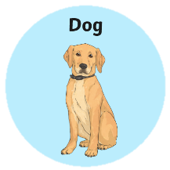
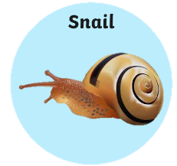
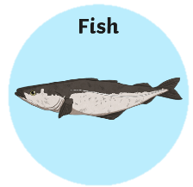
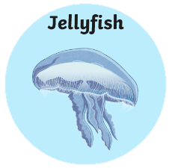
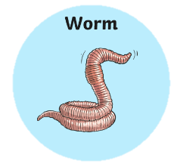
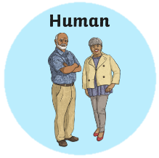
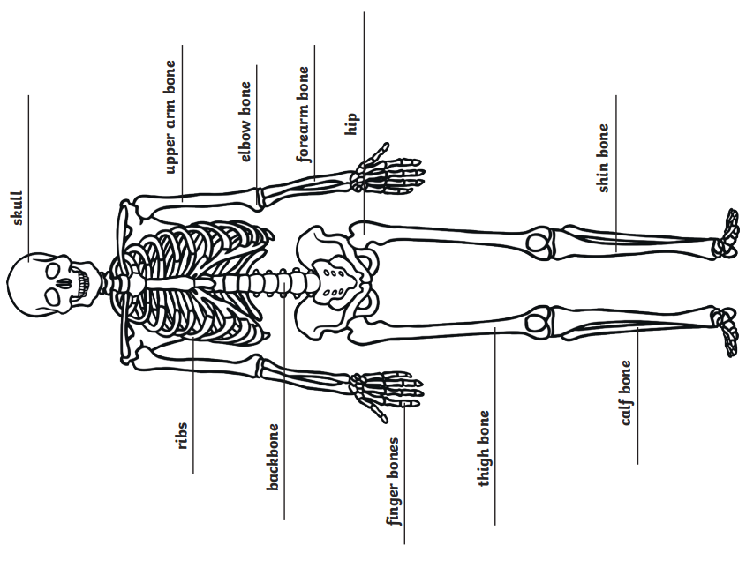
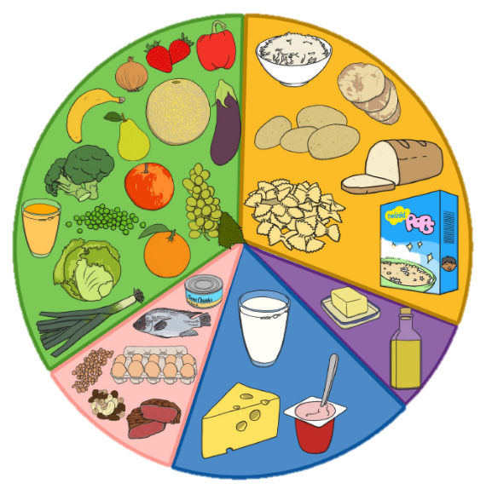
Food Groups

Vocabulary
Nutrition | The act or process of eating and using the nutrients in food for living and growing.
Vertebrate | An animal that has a skeleton with a backbone inside its body.
Invertebrate | An animal that does not have a backbone or skeleton inside its body.
Carbohydrate | It is formed by plants, and it is used in the body to easily produce and store energy.
Protein | Proteins are found in all living things and are a necessary part of life processes.  Eggs, meat, and beans are good sources of protein.
Vitamins | Needed for the health and normal working of the body. Humans get most of their vitamins from food.
Joints | A place or point where two or more parts come together or are connected.
Fibre | A type of carbohydrate found in foods such as fruits, vegetables and grains.
Balanced Diet  Sticky Knowledge (from Year 2) | A diet that consists of the right amounts of certain foods needed to maintain health or growth.
Survive | To remain healthy and alive.
Healthy | Things that are good for your body.
Dairy | Containing or made from milk.
Voluntary muscles are muscles you do have control over. | Involuntary muscles are muscles you do not have control over.
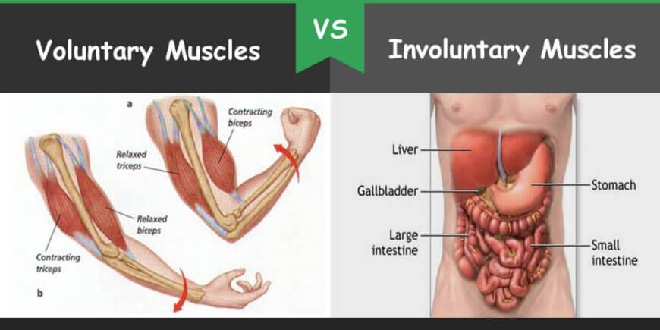
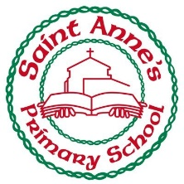
Voluntary and Involuntary Muscles

Amazing Bodies
Year 3 Knowledge Organiser Autumn One

