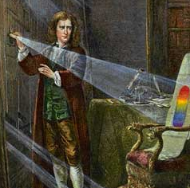
Reflection

Famous Scientists linked to Light and Dark

Can you see me?
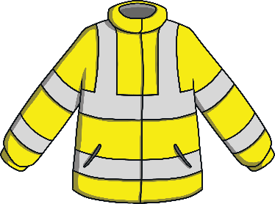
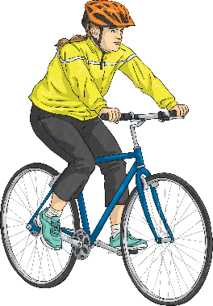
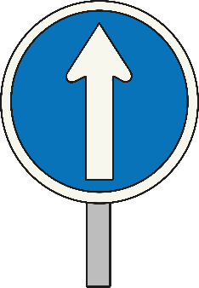
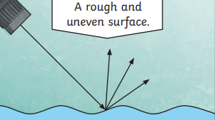
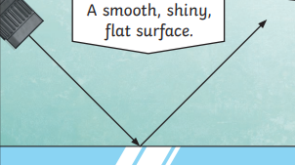
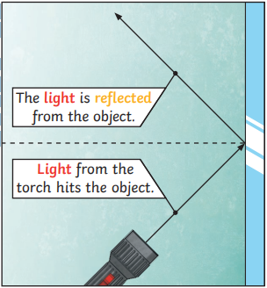
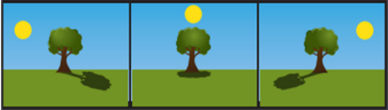
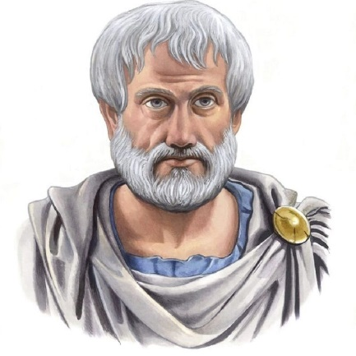
We need light from a light source to be able to see things. Light travels in a straight line.

When light hits an object, it is reflected (bounces off). If the reflected light hits our eyes, we can see the object.

Some surfaces and materials reflect light well. Other materials do not reflect light well. The surfaces that reflect light best are smooth, shiny and flat.

Reflective surfaces and materials can be very useful…
A shadow is caused when light is blocked by an opaque object. A shadow is larger when an object is closer to the light source. This is because it blocks more of the light.
When the light source is directly above the object, the shadow will be directly underneath. When a light source is to one side of an object, the shadow will appear on the opposite side. The shadow will also be longer.
Isaac Newton discovered that light is made up of seven colours – red, orange, yellow, green, blue, violet and indigo.
Aristotle made discoveries about how waves of light cause our eye to see colours differently.
How are shadows formed?

Vocabulary
Shadow | A dark area or shape produce by an object coming between rays of light and a surface.
Reflect | Sending light, heat, sound or an image back without absorbing it.
Ultraviolet light | Radiation not visible to the human eye.
Luminous / Non-luminous | Objects that give out their own light / objects that don’t have their own light.
Light Source | Anything that makes light, whether that is natural or artificial
Infrared | Type of energy that’s invisible to human eyes but that we can feel as heat.
Ray | A narrow beam of light
Beam | A line of light
Opaque  Sticky Knowledge (from Year 1 and 2) | Something that blocks the light from passing through.
Transparent | Something that lets nearly all the light falling on it pass through.
Translucent | Blocks some of the light passing through it.
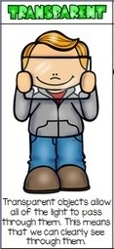
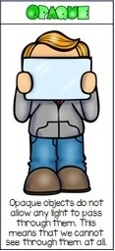
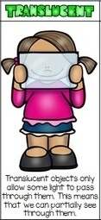
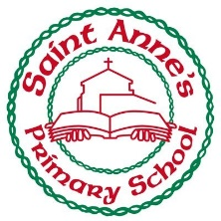
Transparent

Opaque

Translucent

Can you see me?
Year 3 Knowledge Organiser Autumn Two

