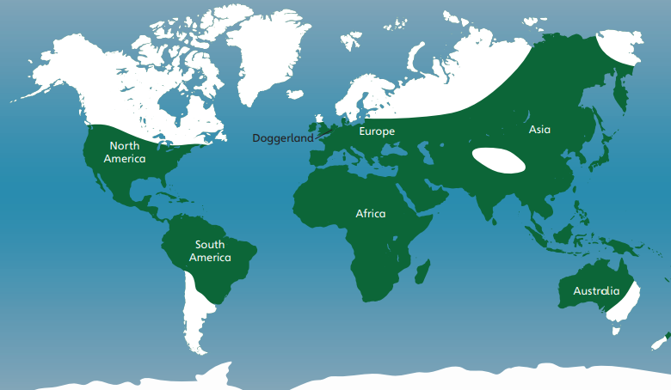
Skara Brae
Skara Brae is a famous Neolithic village on an island in Scotland. People lived there about 5,000 years ago, but archaeologists only discovered it in 1850, because it had become buried with earth during a storm.
Prehistoric Sites

The Frozen Planet during the Ice Age

Prehistoric Britain
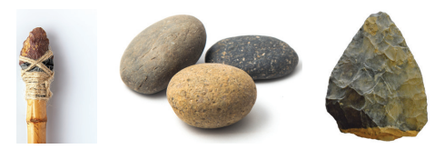
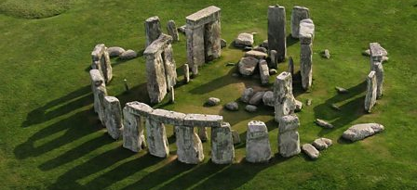
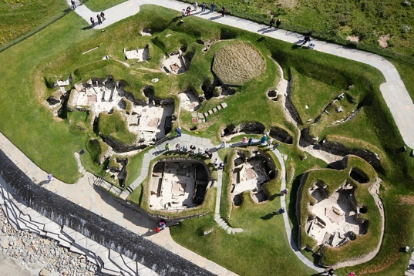
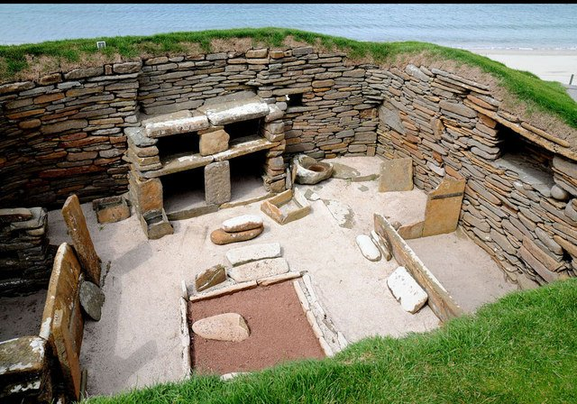
Stone Spear
Hammer Stones
Hand Axe
Stone Age Tools

Stone Henge
Stonehenge is a circular group of huge stone blocks in Wiltshire, England. People built Stonehenge in stages between 5,000 and 3,500 years ago. No one knows for sure why Stonehenge was built. Many scholars think that it was a place of religious worship. Stonehenge is mysterious because some of its stones come all the way from Wales!

Vocabulary
Homosapiens | The scientific name for humans.
The Ice Age | A very long period when the earth was extremely cold.
Palaeolithic Era | The early stone age. Humans used very basic tools.
Mesolithic Era | The middle stone age. Humans perfected their tools.
Neolithic Era | The new stone age. Humans began farming.
Neanderthals | Another type of human. They are now extinct.
Extinct | Animals that used to be alive but now they are all dead.
Bronze | The first metals that humans used. It is made from copper and tin.
Iron | A metal that is harder and stronger than bronze.
Archaeologist | Someone who studies the past by looking at objects, buildings and remains.
Nomadic | Early humans who did not have fixed homes.
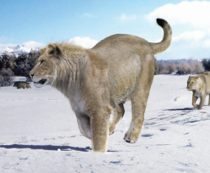
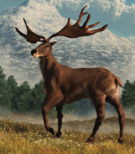
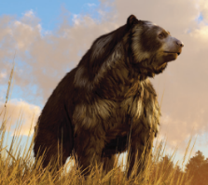
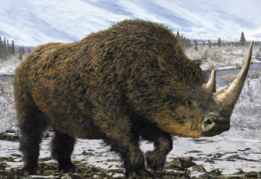
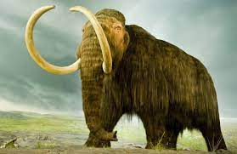
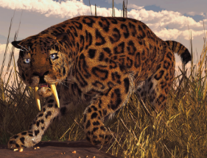
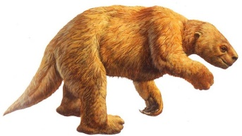
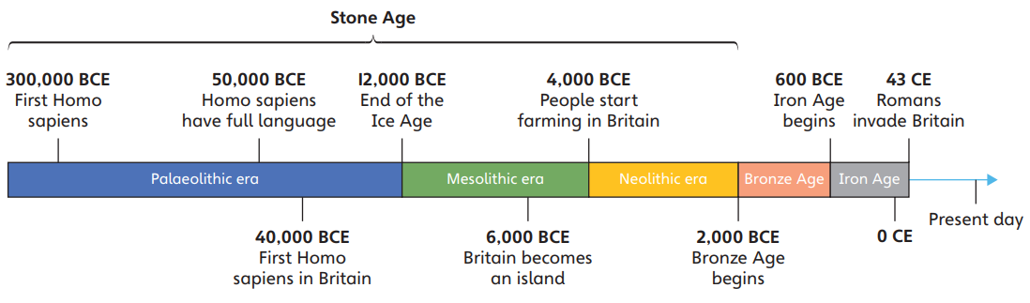

Cave Lion
(extant)
Cave Bear
(extinct)
Irish Elk
(extant)
Woolly Rhinoceros
(extinct)
Sabre-toothed cat
(extinct)
Woolly Mammoth
(extinct)
Giant Sloth
(extinct)
Prehistoric Animals

Timeline of the Prehistoric Period

Prehistoric Britain
Year 3 Knowledge Organiser Autumn Two

