The Difference Between Villages, Towns and Cities

Settlement Patterns

Villages, Towns and Cities
Nucleated – houses and buildings are centred around a focal point
Linear – houses and buildings are arranged along a line, usually a road or river
Dispersed - houses and buildings are spread out
Isolated – house or building on their own
Village  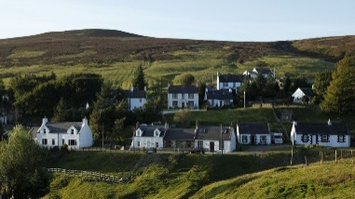  Example – Briel, Switzerland | - In the countryside  - Some services such as a post office, a small shop and sometimes a small place of worship  - There may be a doctors practice and a primary school  - Many people are leaving villages to move to towns and cities.
Town  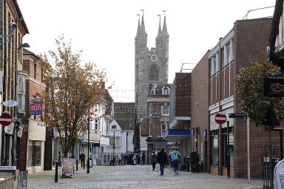  Example – Ashford, Kent, UK | - Services such as primary and secondary schools, train stations, hospitals and shopping centres  - Large supermarkets and at least one place of worship
City    Example – London, UK | - Many different types of services, including universities, sports stadiums and a large variety of shops • Many restaurants, transport links and different places of worship  - Many people move to cities because there are more opportunities for employment and leisure.
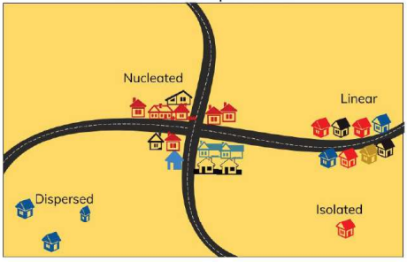
What are the Settlement Patterns

Vocabulary
Population | The number of people in a particular place.
Distribution | How something is spread out.
Population Density | The number of people per square kilometre.
Settlement | An area where humans live.
Megacity | A city with at least 10 million people.  1950 - two megacities (New York and Tokyo) 2010 - 23 megacities  2019 - 33 megacities
Leisure | Activities that people do in their spare time when they are not working.
Hunter-Gatherer | People who move around from place to place.
Nomadic People | Someone who hunts and collects their food from the wild.
Land Use | The purpose or use that an area has.
Residential  Land Use in Cities | Housing of all types
Commercial | Businesses, offices and shops
Transportation | Roads, bus lanes, railway lines, cycle paths
Industrial | Factories, warehouses, rubbish and recycling facilities
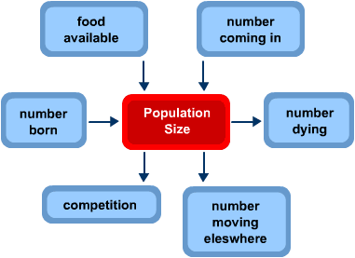

What affects population?

Villages, Towns and Cities
Year 3 Knowledge Organiser Autumn One

