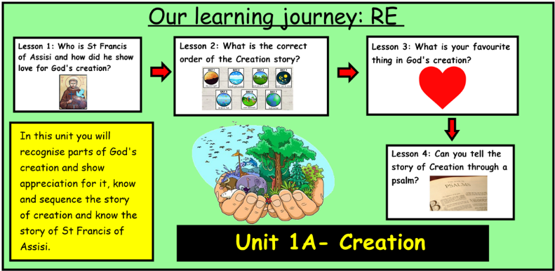
Genesis 1: 2-4 – The Story of Creation
In the beginning - God started creation.
The first day - light was created.
The second day - the sky was created.
The third day - dry land, seas, plants, and trees were created.
The fourth day - the Sun, Moon, and stars were created.
The fifth day - creatures that live in the sea and creatures that fly were created.
The sixth day - animals that live on the land and finally humans made in the image of God were created.
By day seven - God finished his work of creation and rested, making the seventh day a special holy day.

Bible References:
Unit 1A - Creation Knowledge Organiser
Learning Journey:
Learning Journey:

In this unit you will recognise parts of God's creation and show appreciation for it, know and sequence the story of creation and know the story of St Francis of Assisi.
This unit builds on previous learning in nursery and reception of the story of Creation.
Prior Knowledge:
Knowledge of the story of creation. Some knowledge of God creating the world. The ability to identify things that you are thankful for.

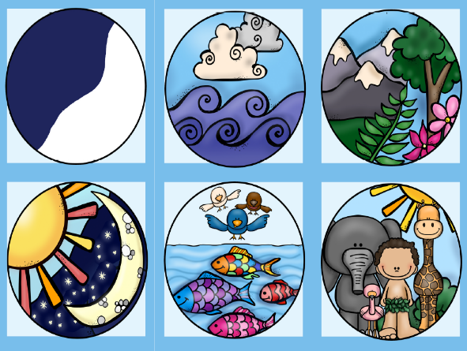
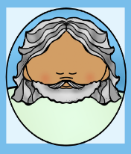
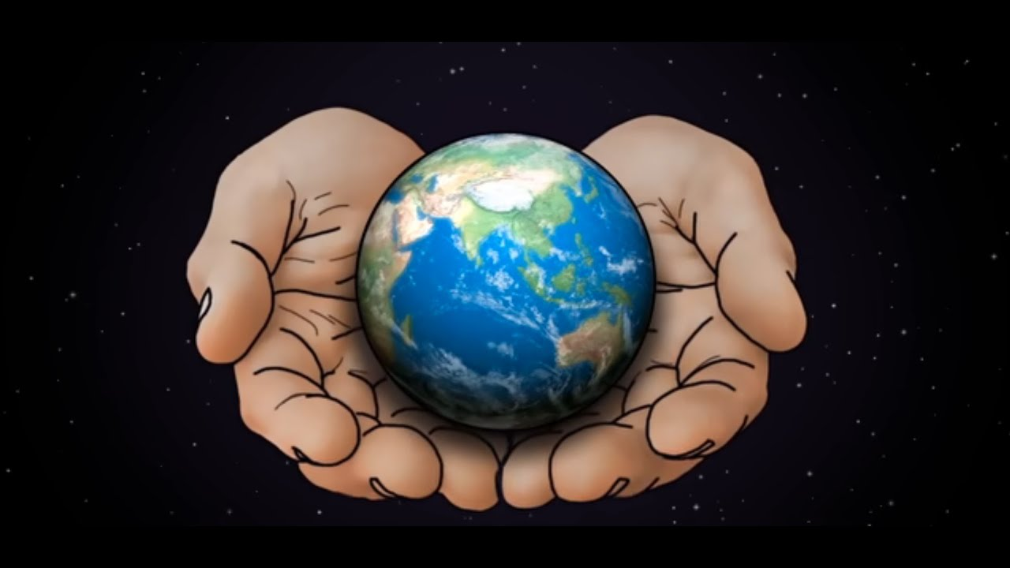
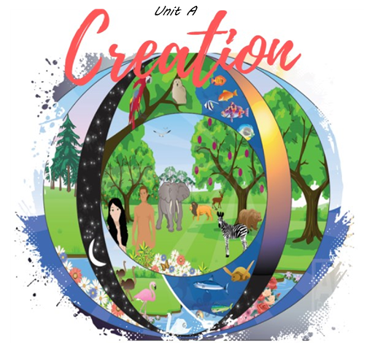

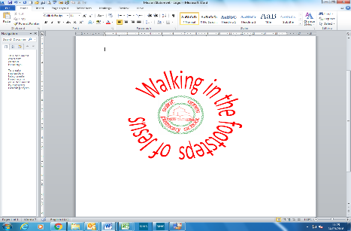
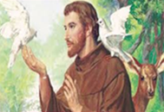
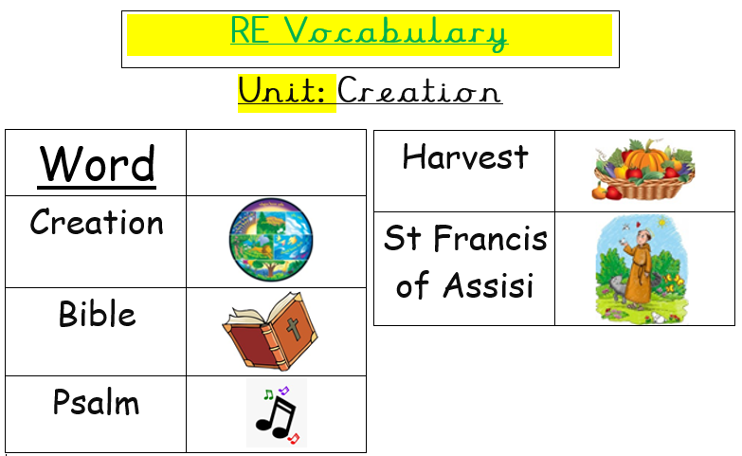
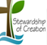
I wonder…
1. Is there anything about Creation that interests you?
2. What does Creation make you wonder?
3. What are you curious to know about St Francis of Assisi?
4. What questions would you like to ask God about Creation?
5. What is your favourite thing that God created? Why?

St Francis of Assisi is the patron saint of the environment, animals and birds. He is also year 1s class saint.
ER1: What does this image make you wonder?
ER2: What questions do you have about this image?

Catholic Social Teaching: Stewardship of Creation
How can children be encouraged to value care for creation? Why do we, as adults and children need to work towards justice for all? What are some of the ways people can look after the world today?

