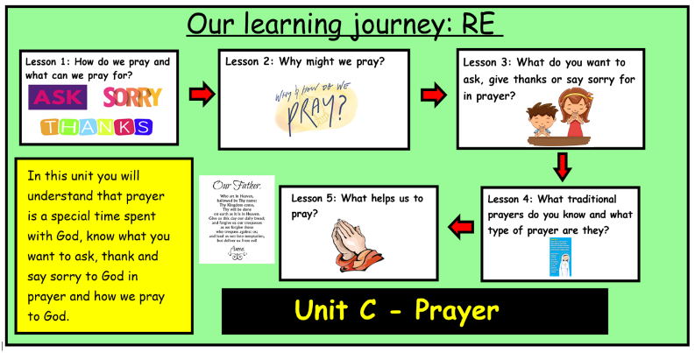
Mt. 6: 9-15 – Jesus Teaches His Disciples How to Pray
Lk. 11: 1-4

Bible References:
Unit C - Prayer Knowledge Organiser
Learning Journey:
Learning Journey:

This unit is designed to develop the children’s understanding of prayer as a special way of spending time with God. In the unit the children will also explore the vocabulary, actions, places and aids associated with prayer, with particular reference to the prayer of praise and intercession. The children will also explore how Christians give praise to God in the psalms and in prayers like the “Glory Be To The Father” and the “Our Father”.
Prior Knowledge:
In Early Years, children have learnt and understand what prayer I, have experience of praying with others and have heard the ‘Our Father’ prayer.

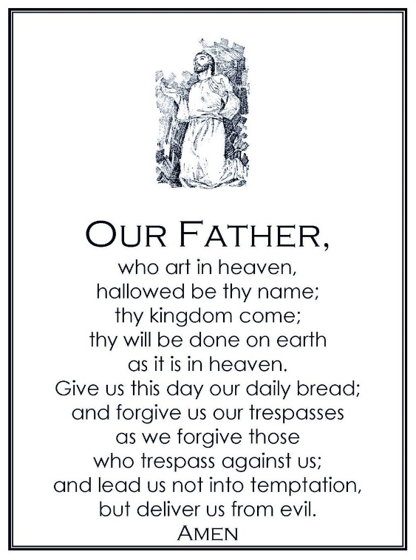
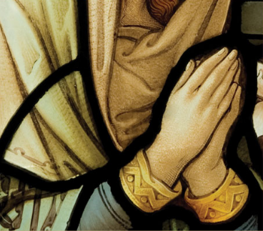

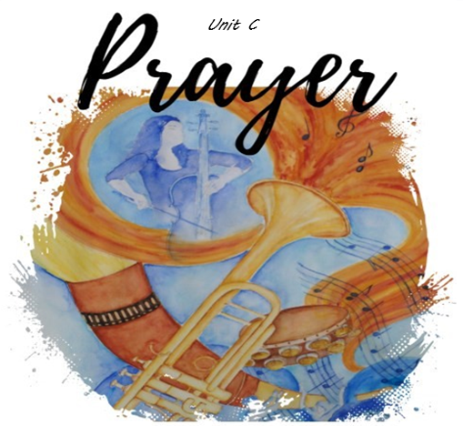

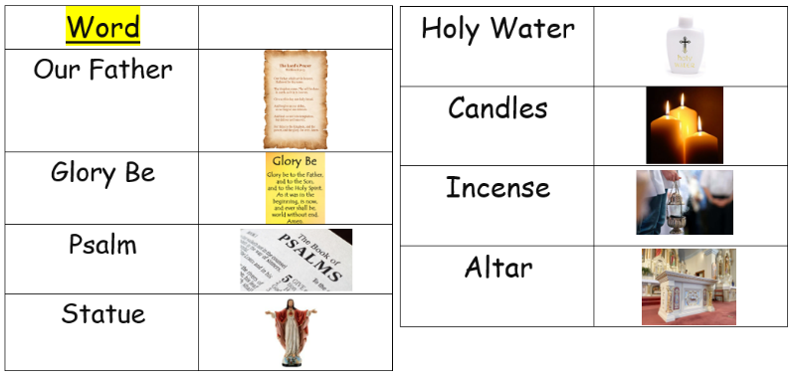

Catholic Social Teaching:
Distributive Justice: How can we create a prayer service
Option for the Poor: serving our local and wider communities
How can children be encouraged to serve their local and wider communities? Who needs help and how can they be helped?
I wonder…
1. Is there anything that you would like to pray for?
2. Who can you pray for?
3. What are you curious to know about prayer?
4. How does praying make you feel?

ER1: What does this image make you wonder?
ER2: What questions do you have about this image?

