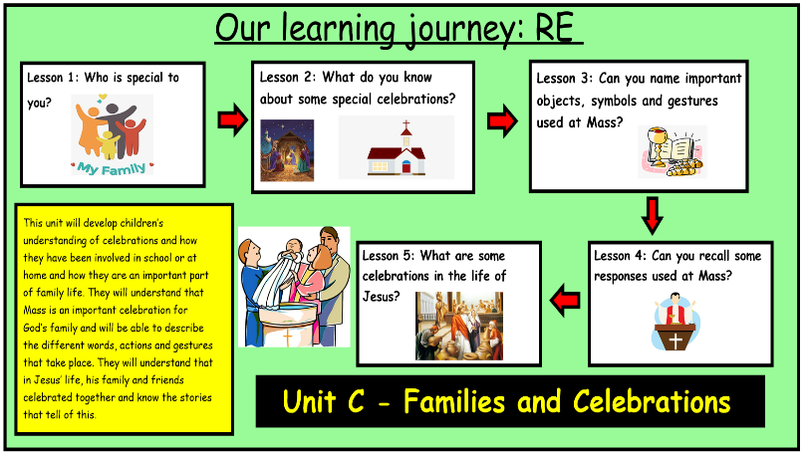
Lk. 2: 22-38 – The Presentation of Jesus in the Temple
Jn. 2: 1-11 – The Marriage Feast at Cana

Bible References:
Unit B – Families and Celebrations
Knowledge Organiser
Learning Journey:
Learning Journey:

This unit is designed to develop children’s understanding of celebrations and how they have been involved in school or at home and how they are an important part of family life. They will understand that Mass is an important celebration for God’s family and will be able to describe the different words, actions and gestures that take place. They will understand that in Jesus’ life, his family and friends celebrated together and know the stories that tell of this.
Prior Knowledge:
In Early Years, children have learnt and understand about different celebrations that take place in family and school life.

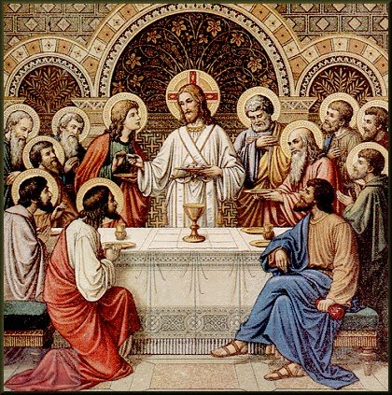

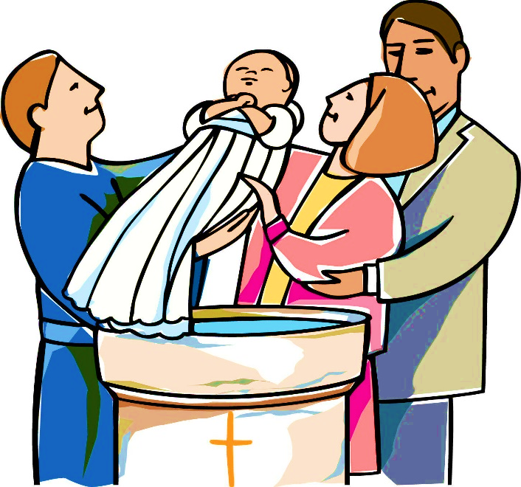
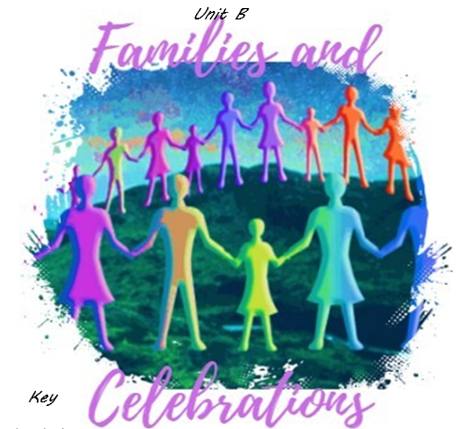

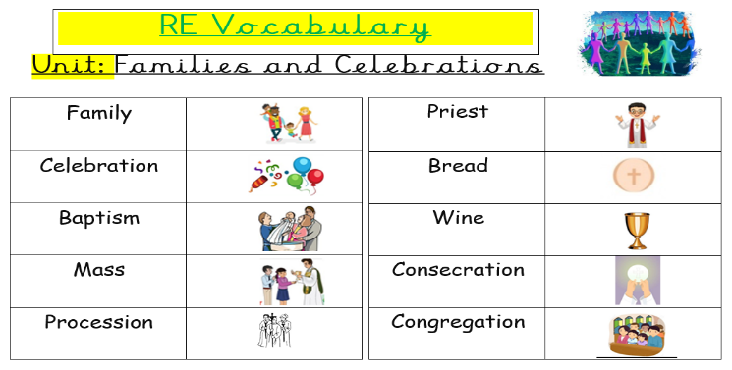
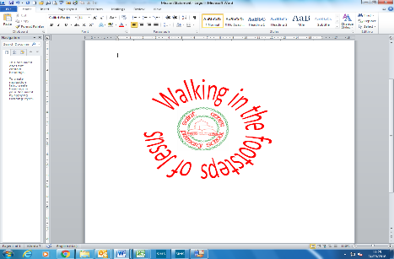
ER1: What does this image make you wonder?
ER2: What questions do you have about this image?
ER4: What celebration is happening in this image?
ER4

I wonder…
1. What does it mean to celebrate together?
2. What sorts of celebrations are there?
3. Why do we celebrate?
4. How do we celebrate?

Catholic Social Teaching:
Solidarity: How are we connected to people all over the World
What celebrations are celebrated all over the world that help to bring people closer to God as well as celebrating God?

