Music Development Plan
School: St Anne’s Primary School
Local music hub: Solihull Headteacher: Mr Linehan
1 – Overall objective/ vision | St Anne’s vision is for  EVERY CHILD TO LOVE MUSIC AT ST ANNES AND FOR EVERY CHILD TO FEEL THEY CAN SING AND PLAY INSTRUMENTS TUNED / UNTUNED  Music and singing is integral to the life of St Anne's. We provide a vibrant musical experience for all children with lessons based on the Kapow Music Scheme. We provide opportunities for all children to create, play, perform and enjoy music, to develop the skills, to appreciate a wide variety of musical forms, and to begin to make judgements about the quality of music.  The overall objective is to provide a rich, diverse, and progressive music curriculum for all children (including during school hours and enrichment after school).  This will be delivered through outstanding music teaching and leadership.  Opportunities to learn musical instruments and sing as part of a choir, participating and performing regularly in both whole class and extra curricular ensembles, both in and out of school will showcase our children and make our school a leader in music education within the local community and beyond. This will also maximise cultural capital for all our children, their overall wellbeing and confidence, while creating a supportive community of music making.
2 – Key components | The Key components to our successful music provision are:  - Quality First Teaching  -weekly one hour lesson  -Ensuring the use of Kapow scheme to supplement St Annes Unique and Special music curriculum  -Teacher videos accessed for CPD  - Retrieval – using a range of strategies as well as quizzes on Kapow  - Display vocabulary and refer to in lesson  - Knowledge Organisers- display and on tables  - Ensure use of instruments is being implemented  - SEND- KAGAN for percussion. Instruments are used in pairs- observe and support  - Adaptive resources when available on Kapow for SEND  - Whole class instrumental progression. Ocarena Y2, Whole class Unit Instrumental Y4.  - Choirs & instrumental ensembles  - Whole school singing assemblies- worship prayer through song- every phase assembly includes a hymn  - Daily Class Liturgy and Prayer-singing hymn (guided by Music Lead)  - Performance opportunities both within and outside of school.  - Music Learning Journals  - Contact has been made with John Henry Newman to arrange collaboration between the schools
3 – Classroom instrumental teaching | Year 2: Whole year Ocarena delivered by class teachers using Ocarena workshops.  Year 3: Ukulele Afterschool club delivered by Sarah Richings.  Year 4: Whole year Whole Class Instrumental unit (Kapow) delivered by class teachers.  All instruments for whole class delivery are owned by the school. Parents in year 2 have option to purchase ocarina for home practice.
4 – Implementation of key components | The whole school follows the Kapow Music scheme, which is very comprehensive and teacher friendly.  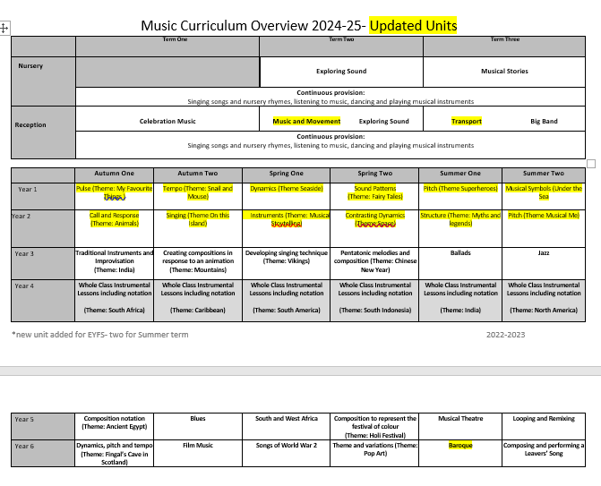  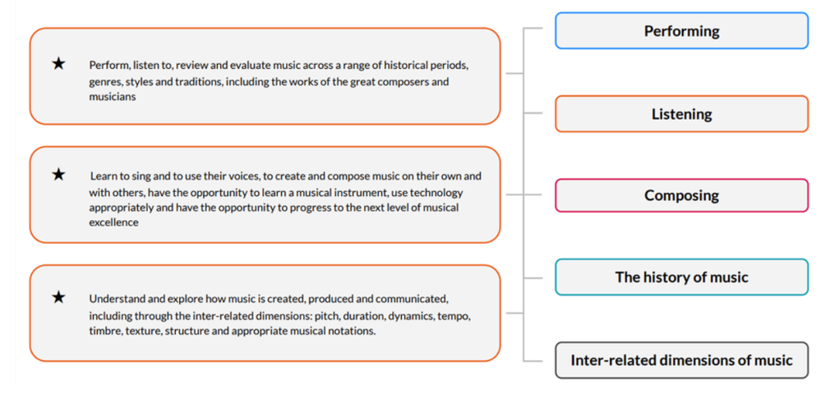  This is the schedule across the school. Some units will be updated in Sept 2024 for year 1 and 2. The music curriculum is based on a spiral model with skills and knowledge embedded and built upon form Nursery to y6 ensuring children are secondary ready.  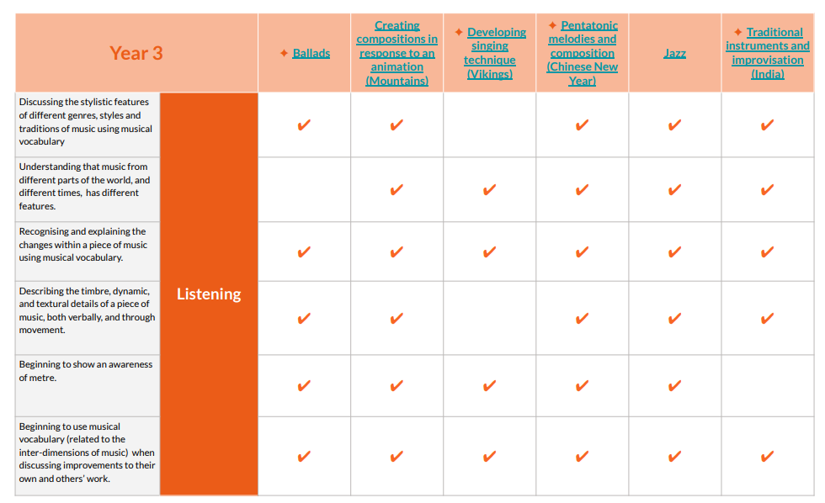  Year group example of key knowledge and skills for a year.  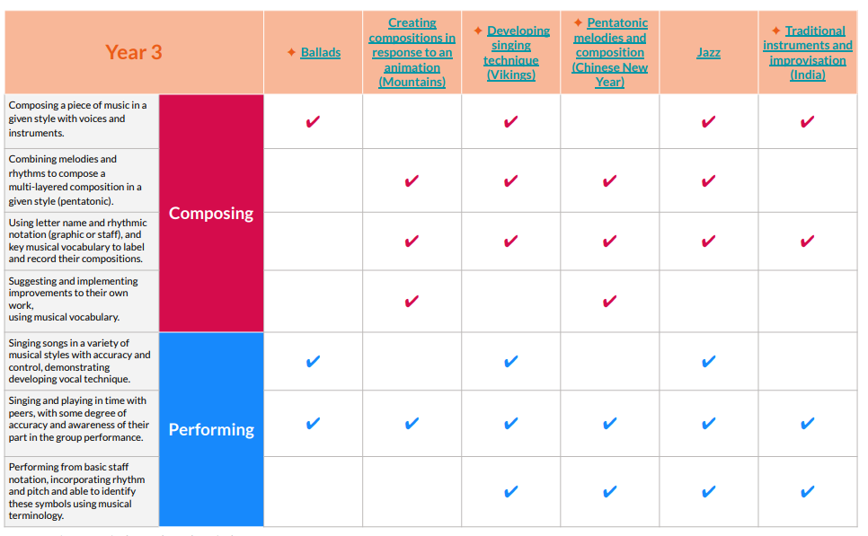  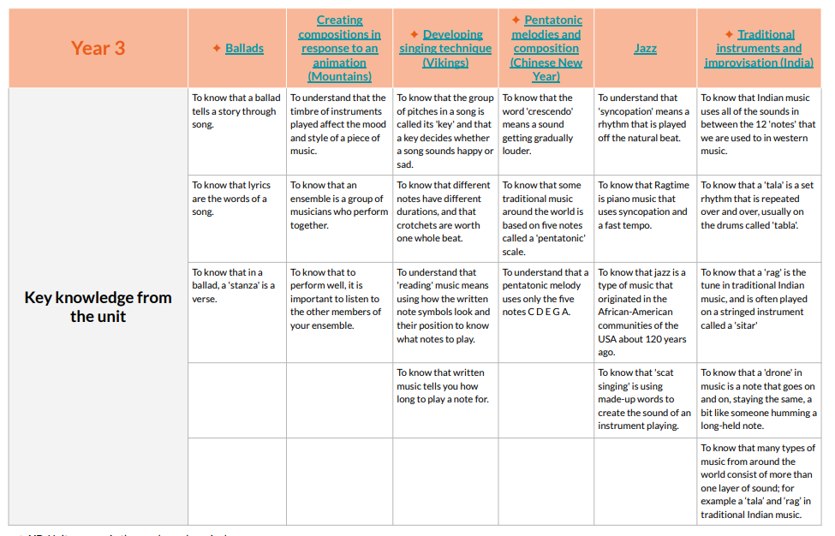  National Curriculum Coverage- an example of how national curriculum coverage is mapped out with Kapow..  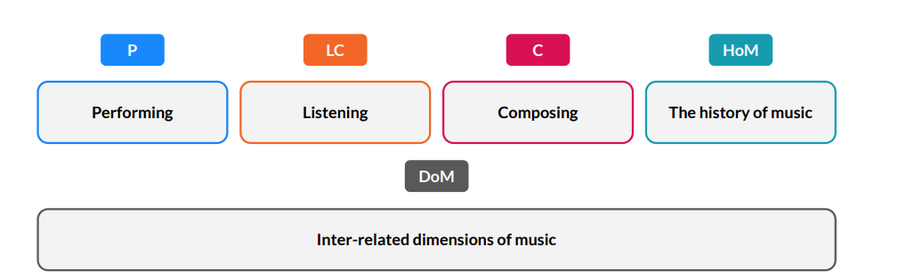  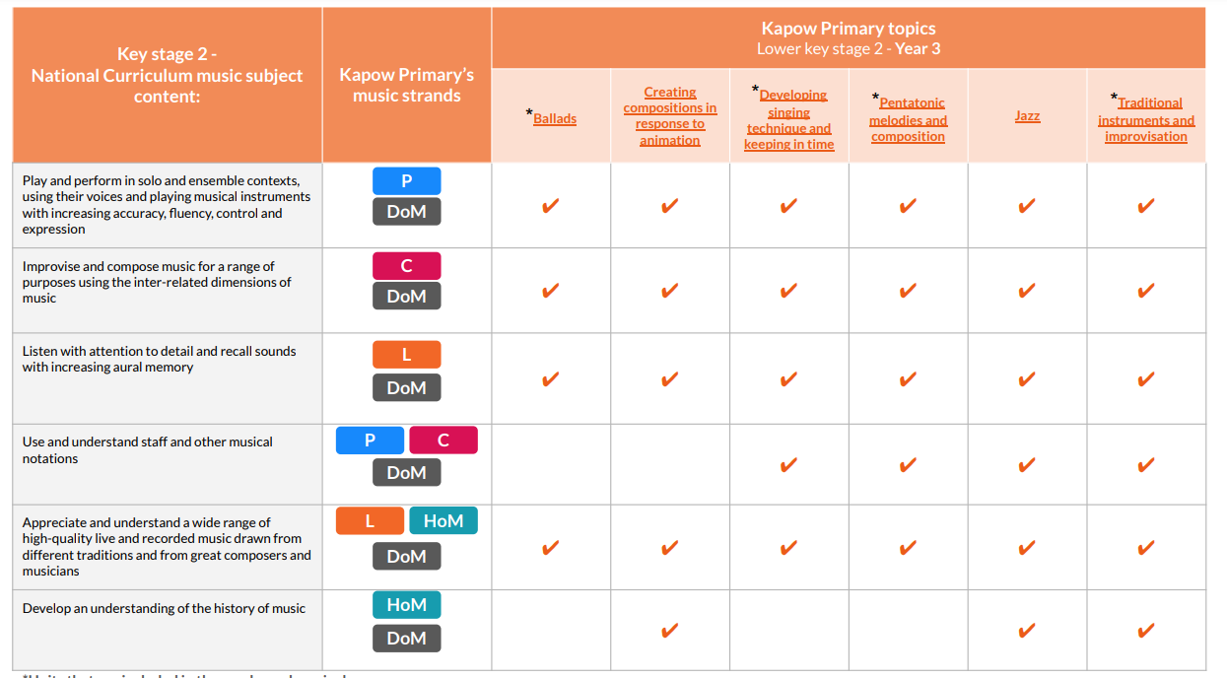  Music curriculum – EYFS, KS1, KS2, SEND.  School song bank for Liturgy and Worship.  Classroom instrumental teaching in year 2, 3 and 4. Y5/6 Keyboards to be introduced  Enrichment after school opportunities- Glockenspiel, Ukelele, Choir  St Anne’s choir have performed at Chelmsley Wood shopping centre for the Christmas Light switch on.  Music planning and CPD – Increase capacity of music delivery beyond the music lead.  Choir/ensemble –Young Voices  Whole school/ Key Stages singing – Hymn of the week sent out by Georgia Ingleston, central location for the weekly hymns created for all staff to access, a hymn is sung in each phase assembly and in whole school assemblies on Friday, increase in the range of hymns sung this year  Performance opportunities –We provide a range of performance opportunities for children in school and beyond for parents to attend: Young Voices, Carol Concert, Christmas Performances, Curriculum showcase.  Visiting Music specialist workshops- Kodaly singing games  Prayer through singing- Catholic Life- Sacramental Celebrations in Church, Assemblies, Class Liturgy
5 – Communication activities | Communication with parents would take place via Curriculum Showcases, Liturgical Masses and Assemblies, ParentPay, newsletters, Twitter and the school website.
6 – Evaluation process for the success of the Music Development Plan | There will be termly learning walks, pupil interviews, support for staff (ECTs).  Music lead report back to SLT.  Music Learning Journals  Performances
7 – Transition work with local secondary schools | We work with local secondary schools this academic year.  Work with the Secondary school Head of Department regarding the Y7 expected level of musical knowledge and understanding.
8 – Budget materials and staffing | Audit of instruments  Enrichment timetable for next year- ukulele, glockenspiel, choir, boomwhackers
9 – Pupil Premium and SEND provision | Pupil Premium children are monitored to ensure that they have access to all clubs  SEND - The music provision is easily accessed by all children. A teaching assistant in each lesson will ensure those who struggle will be given extra guidance. KAGAN groups support this
10 – Summary Action Plan | Write a list of immediate actions – make them SMART (specific, measurable, achievable, relevant, time-bound).  - Keyboard whole year group implementation- y5  - CPD Kapow scheme and update LTP planned changes  - Links with secondary schools  - Source free workshops  - Rebecca Shrewsbury Kodaly singing games for repeat next year  - Whole school plan a trip to theatre to see a musical performance

Useful links
The power of music to change lives: a national plan for music education
Building a musical culture in a primary school – the nuts and bolts for success

