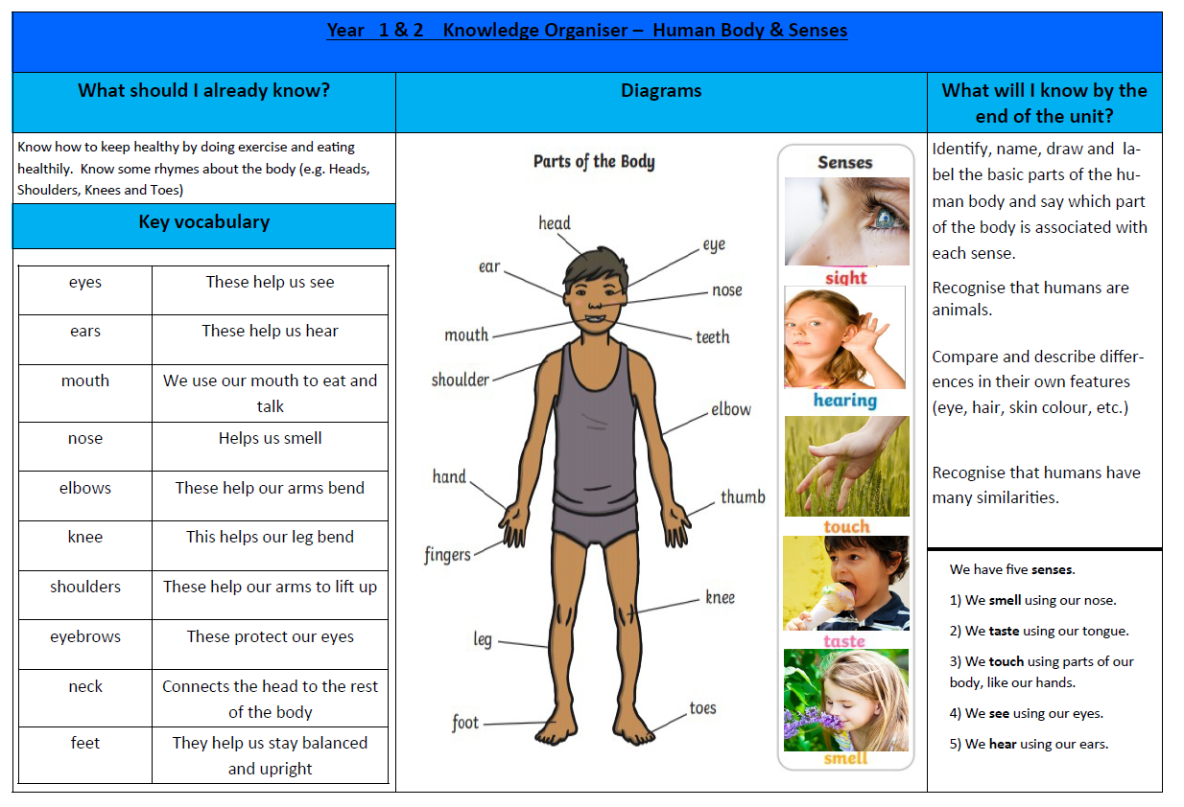
Year 1 Knowledge Organiser Autumn Term:- Human Body and Our Senses

