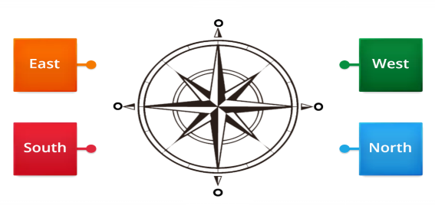
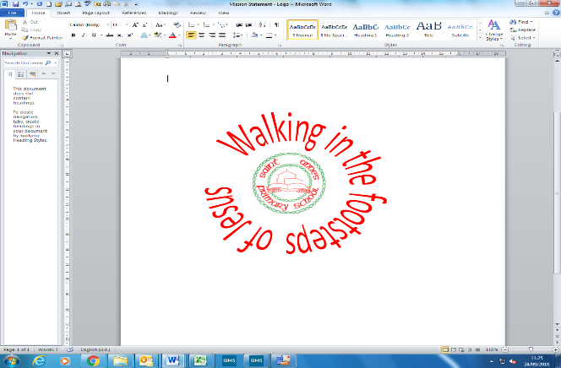
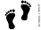
Our Local Area| Year 1 | Autumn Term
Can you label the compass?
In this unit, our enquiry question is…
What is it like where we live?
Geography
What is our Local Area like?

Where do you go often/ rarely?

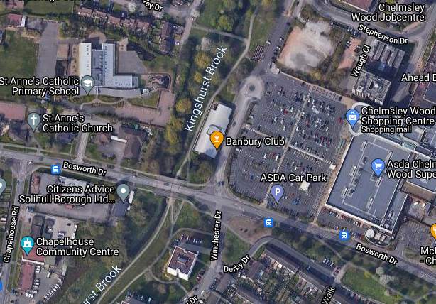
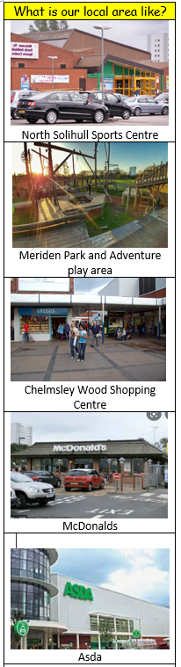
Ariel View
Key Vocabulary
1 | Local | Belonging to the area where you live, or to the area that you are talking about’ Our local area is Chelmsley Wood.
2 | map | A picture or drawing of a particular area
3 | Near | Not far; close by
4 | Far | A long journey away
5 | Often | Many times; regularly
6 | Rarely | Not often/ you almost never do something
7 | Aerial View | To look at something from above.
8 | Landmark | An object or a feature of a landscape or town that has importance or makes a place easily recognizable.
9 | Compass | A tool which shows us directions (North, South, East and West)
10 | Locate | to find the position or place of something.
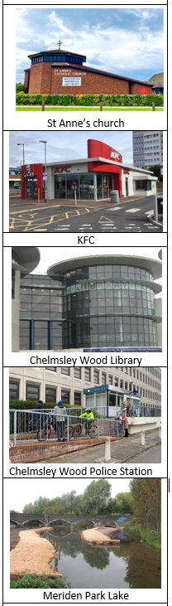

Prior knowledge
1 | The town our school is in | Chelmsley Wood
2 | Our nearest city | Birmingham
3 | The country we live in | England

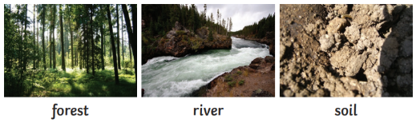
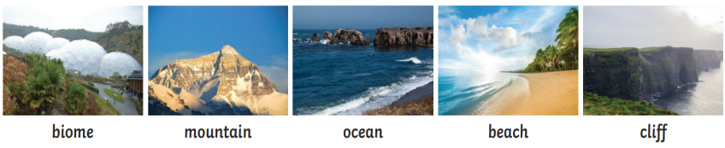
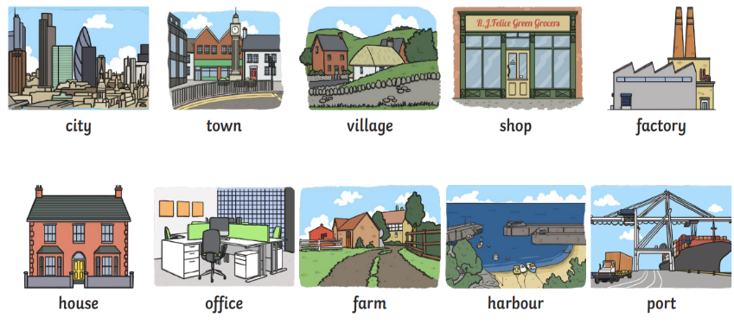
Physical features like seas, mountains and rivers are natural. They would be here even if there were no people around.

Human features are things like houses, roads and bridges. They have been built by people.

