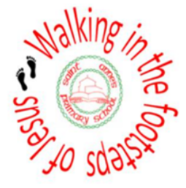
Relationship Education Programme
A Guide for Families at St. Anne’s Catholic Primary School

The Relationships Education, RSE, and Health Education (England) Regulations 2019 have made Relationships Education compulsory in all primary schools from September 2021, a delay in timeline due to Covid. Sex education is not compulsory in primary schools.
The content set out in our programme covers everything that we should teach about relationships and health, including puberty. The national curriculum for science also includes subject content in related areas, such as the main external body parts, the human body as it grows from birth to old age (including puberty) and reproduction in some plants and animals.
Our resources are LIFE TO THE FULL by TenTen, which has been approved by our diocese.
TenTen is an award-winning Catholic educational organisation that is well-respected and very experienced in this field of work.
Furthermore, TenTen have entered into a partnership with the Catholic Education Service and the Department for Education to provide training for teachers in Catholic schools on the subject of the new statutory curriculum. Therefore, we are confident that this programme is a very good fit for our school.
Through their programme, TenTen understand the foundational role that parents have in educating and nurturing their children on these matters. Within the programme, they have built in resources which will not only keep you informed about what is being taught in school, but will also give you the opportunity to engage your children in discussion, activity and prayer.

Our new programme was implemented from September 2021.
KEY PRINCIPLES AND DECISIONS
- In line with E Safety, including keeping children safe online, we will teach the children about inappropriate images on line. In year 6, some sessions address the risks that children face from seeing inappropriate images and videos online. This is very much a lesson about ‘internet safety’ and therefore falls under the statutory Health Education curriculum. If the topic of pornographic material was raised by any child this would be dealt with in an appropriate way on an individual basis in consultation with the family.
- We explained the significant importance of using appropriate terminology and vocabulary linked to genitalia with children for safeguarding reasons from an early age. Moving forward, from the Summer term of Year 2 we will explore the appropriate terminology for genitalia and our policy shares more information with you. Furthermore, when we have our Year 2 workshop with families in the Autumn term we will explain this in more detail and share with you the vocabulary that is used so that you are fully informed with all the relevant information.
- Puberty will be taught to children in Year 5 and 6. However for some groups of children/individuals if there is a requirement we may also look at this in the latter part of the summer term in Year 4 as we are fully aware that children develop at different stages especially girls. As required some sessions may be taught separately for boys and girls in Year and Year 6.
- In the resource Life to the Full (once the children move into Year 6) there is a specific unit linked to “making babies”. It is in 2 parts. As a school, we have chosen to teach the children part one only
not part 2 which is about Talking about Sex. Teaching about sexual intercourse is not part of the statutory curriculum.
- Sex Education is for families to discuss with their own child when they feel it is the appropriate time for their child at home.
This is also in keeping with our mission statement “Each one of us is unique, each one of us is special”. Children develop and mature at different stages so families can decide when the time is best. We will also discuss this in more detail when we have the Year 6 parent workshop in the Autumn term. As we will not be teaching Part 2 in school there will not be a need for parents to opt –out of this teaching.
- The National Curriculum for science also includes subject content in related areas, such as the main external body parts, the human body as it grows from birth to old age (including puberty) and reproduction in some plants and animals.
- The school incorporate PSHE into the curriculum, placing a great deal of importance on the children’s emotional health and well-being and the part they can play in the sustainability agenda.
We use the Jigsaw PSHE strategy, which is a unique, spiral, progressive and effective scheme of work, aiming to prepare children for life, helping them really know and value who they truly are and understand how they relate to other people in this ever-changing world. The children are very familiar with Jigsaw resources as part of our Personal, Social , Emotional and Health curriculum as we have been using this resource in school for many years. The TenTen resources fully complement our existing PSHE programme. Moving forward the two units in Jigsaws linked to Relationships will be replaced with the Life to the Full resources.

PARENT/CARER RESOURCES
We have included once again the TenTen Online Parent Portal, which will be a tool we can use throughout the year to keep you informed and updated about the work we are doing in school.
By logging on you will be able to familiarise yourself with the resources that children will also access at school.
- You will need the following login credentials for our school:
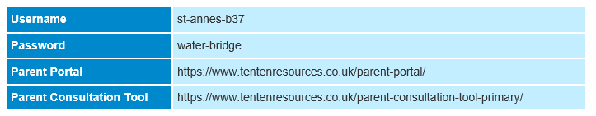
Kindly take the time to familiarise yourself with the resources so you are up to date with what your child will be taught in school.

Frequently Asked Questions
We understand that children, families and the staff leading these sessions may come from a wide variety of backgrounds and belief structures, so our programme is sensitive to their needs, and fully inclusive of all.
In addition, we hope you will agree that the curriculum content of ‘Life to the Full’ and all of the values and virtues developed within it are incredibly valuable and worthwhile regardless of faith status.

FAQ: What if my child comes home and asks difficult questions that I don’t know how to answer?
As a parent, you already have all the skills at your disposal to respond to curve-ball questions! However, when the subject content is sensitive it can feel more difficult, or even at times uncomfortable. Of course, our job is not to tell you how to parent your child, but here are some pointers that other parents have found helpful:
- Be honest. Information based on an untruth can lead to confusion and a sense of embarrassment when children realise they haven’t been told the truth.
- Never feel pressured to answer something immediately. You can always say, “Let me come back to you on that” and check in with your partner, or another parent or friend for advice.
- “You’ll learn about that when you’re a bit older” can be an acceptable response. Children will know there is more to learn, just as they know there is more to learn about Maths beyond Year 1. Most children are happy with a response which acknowledges there is more to learn, but that they will learn about it at a later date.
- Never shame or embarrass children for the questions they ask. Most often, children are genuinely curious about topics such as puberty, and the chance to air their queries and exploratory thoughts should be pressure and judgment-free. Shame and embarrassment has too often been associated with education around sex and relationships – you might even have experienced this yourself – and this is the opposite of what we are trying to achieve through ‘Life to the Full’.
Our aim through this programme is to build children up as they discover the people they were called by God to be.

FAQ: Is my child going to learn about sex?
It is not mandatory that primary schools teach about sexual intimacy. At. St. Anne’s we recognise that this is the role for the family to discuss at home with your child. This is so important because all children mature and develop at different stages. We have included the Life to the Full resources (web based) to support you with this.
FAQ: Can I withdraw my child from the lessons?
In primary schools, the new statutory curriculum is called: ‘Relationships and Health Education.’ Parents do not have the right to remove their children from Relationships Education or Health Education lessons. Likewise all children follow the National Curriculum for Science.
Parents retain the right to withdraw children from ‘Sex Education’ lessons in primary schools. However, this is not relevant to St. Anne’s because we have opted for this aspect of learning to be taught at home.

FAQ: How can I best support my child throughout this programme?
The best way to support your child’s learning is through using the Online Parent Portal.
This will advise you on the content they have been studying in school so that you can continue conversations at home. It also suggests home learning activities to help you bring these topics up in specific ways.
Another fantastic way that you can support your child is through prayer. We have provided details in the Online Parent Portal of Unit Prayers that children will be using in school. You can integrate these into your home prayer life to help reinforce the common messages and values of each Unit.

FAQ: Is the programme inclusive?
Life to the Full is inclusive of all children, families and teaching staff;
The programme acknowledges that families are made up differently including single-parent families, blended families, step-parents, carers, etc and it celebrates the family unit in whatever form it takes.
We will ensure RSHE is sensitive to the different needs of individual pupils in respect to pupils’ different abilities, levels of maturity and personal circumstances; for example their own sexual orientation, faith or culture and is taught in a way that does not subject pupils to discrimination, teasing, bullying and aggressive behaviour (including cyber-bullying), use of prejudice-based language and how to respond and ask for help.
The school’s Relationships and Health programme will reflect the ethos of the school, by providing a secure, non-judgemental environment in which to learn. All RSHE will be appropriate to the needs and experiences of each child at St Anne’s using a sensitive approach, which will recognise individual needs and will take due regard of gender, disability and cultural issues. “Each one of us is unique, each one of us is special.”

CONTENT OF PROGRAMME

BROAD CONTENT OF RSHE
Three aspects of RSHE – attitudes and values, knowledge and understanding, and personal and social skills will be provided in three inter-related ways: the whole school/ethos dimension; a cross curricular dimension and a specific relationship and sex curriculum.

OUR PROGRAMME
At St. Anne’s we will be following ‘Life to the Full’. This programme follows a three-stage structure which is repeated across three different learning stages
- Early Years is aimed at Nursery and Reception
- Key Stage 1 is aimed at Years 1 and 2
- Lower Key Stage 2 is aimed at Years 3 and 4
- Upper Key Stage 2 is aimed at Years 5 and 6
Within each learning stage, there are three modules:
- Created and Loved By God
- Created to Love Others
- Created to Live in Community
Each Module is then broken down into Units of Work:
Module 1 | Created and Loved by God
Units | Religious Understanding  Me, My Body, My Health  Emotional Well-Being Life Cycles
Module 2 | Created to Love Others
Units | Religious Understanding  Personal Relationship Keeping Safe
Module 3 | Created to Live in Community
Units | Religious Understanding  Living in the Wider World

The programme adopts a spiral curriculum approach so that as a child goes through the programme, year after-year, the learning will develop and grow, with each stage building on the last.
Running alongside the classroom sessions there are links to prayer, music and assessment activities.

METHODS OF TEACHING
Due to the sensitive nature of RSHE and the exploration of emotions, a wide range of teaching strategies will be used, such as:
- Establishing ground rules
- Discussions/ activities with class or small group
- Reflection
- Brainstorming
- Use of relevant books, film and video
- Group Work
- Assemblies
- Professional visitors e.g. school nurse, NSPCC
- Question box approach (for sensitive or complex issues)

PARENTS AND CARERS
We recognise that parents and carers are the primary educators of their children. As a Catholic school, we provide the principal means by which the Church assists parents and carers in educating their children. Therefore, the school will support parents and carers by providing materials to be shared with their children at home. Parents/ carers will be informed by letter when the more sensitive aspects of RSHE will be covered in order that they can be prepared to talk and answer questions about their children’s learning.

CHILDREN’S QUESTIONS
Sometimes an individual child may ask an explicit or difficult question in the classroom. Questions do not have to be answered directly and can be addressed individually later. All staff can use the question box approach and can then discuss the question with a senior member of staff and/ or parent, who may wish to discuss the question with their child themselves.

SUPPORTING CHILDREN AND YOUND PEOPLE WHO ARE AT RISK
Effective RSHE will provide opportunities for discussion of what is and is not appropriate in relationships. Such discussion may well lead to disclosure of a safeguarding issue. Teachers will need to be aware of the needs of their pupils and not let any fears or worries go unnoticed. Where a teacher suspects that a child or young person is a victim of or is at risk of abuse, they are required to follow the school’s safeguarding policy and immediately inform the designated senior member of staff responsible.
BALANCED CURRICULUM
Whilst promoting Catholic values and virtues and teaching in accordance with Church teaching, we will ensure that pupils are offered a balanced programme by providing an RSHE programme that offers a range of viewpoints on issues.

RESPONSIBILITY FOR TEACHING THE PROGRAMME
Responsibility for the specific RSHE programme lays with the class teacher. However, all staff will be involved in developing the attitudes and values aspect of the RSHE programme. They will be role models for pupils of good, healthy, wholesome relationships as between staff, other adults and pupils. They will also be contributing to the development of pupils’ personal and social skills.

EXTERNAL VISITORS
Our school will often call upon help and guidance from outside agencies and health specialists to deliver aspects of RSHE. Such visits will always complement the current programme.

OVERVIEW OF UNITS ACROSS THE KEY STAGES
Nursery:
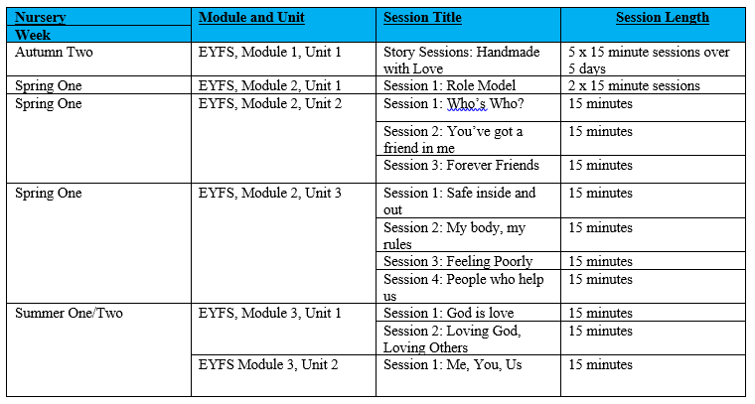

Reception:
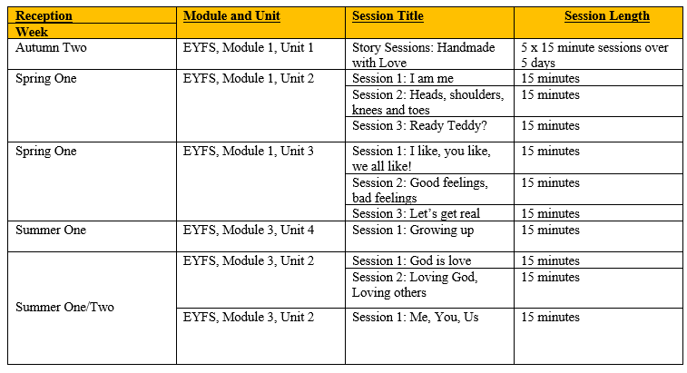
Year One:
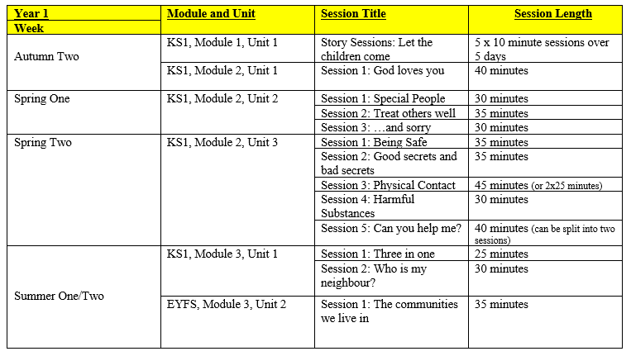

Year Two:
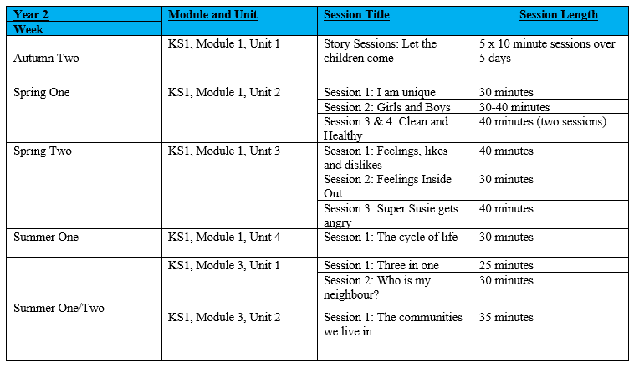
In Year 2 Summer term children are introduced to technical vocabulary linked to genitalia *
Year Three:
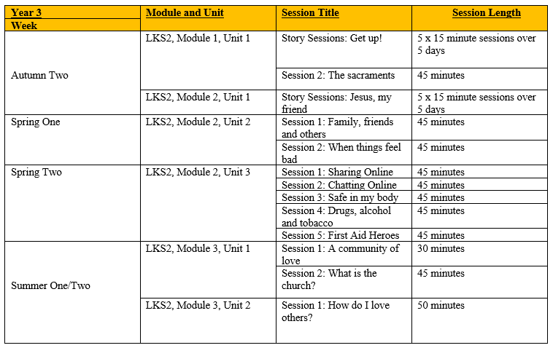

Year Four:
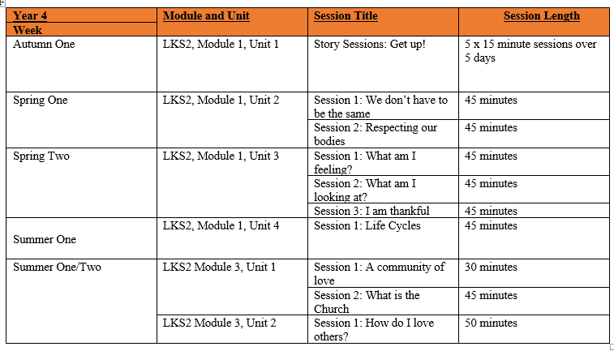
Year Five:
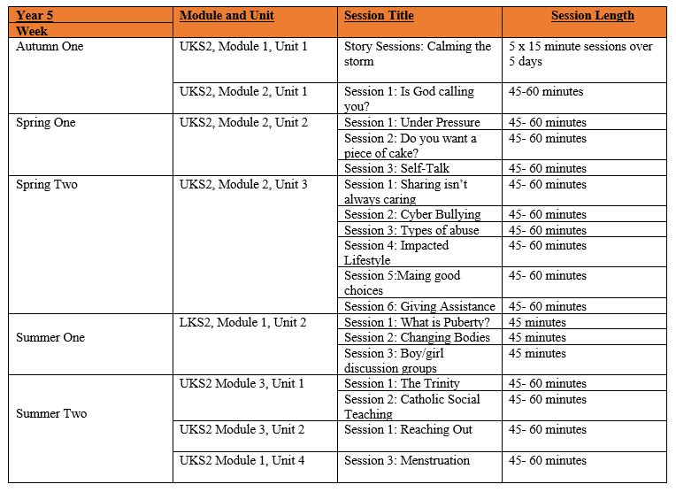

Year 6:
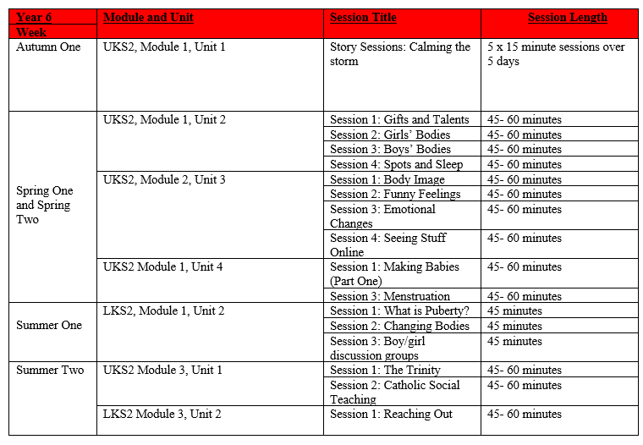
Programme Structure
In Life to the Full there are three modules
□ Created and Loved by God
□ Created to Love Others
□ Created to Live in Community
Each Module is then broken down into Units of Work.

Module 1 | Created and Loved by God
Units | Religious Understanding  Me, My Body, My Health  Emotional Well-Being Life Cycles
Module 2 | Created to Love Others
Units | Religious Understanding  Personal Relationship Keeping Safe
Module 3 | Created to Live in Community
Units | Religious Understanding Living in the Wider World

Module One: Created and Loved by God
Module One: Created and Loved by God explores the individual. Rooted in the teaching that we are made in the image and likeness of God, it helps children to develop an understanding of the importance of valuing themselves as the basis for personal relationships.

In these sessions, we explore:
Foundation - Uniqueness in real terms, including celebrating differences and individual gifts, talents and abilities. Likes, dislikes and self-acceptance. Actions have consequences; that when we make mistakes we should say sorry and ask for forgiveness. The natural human cycle of life, focusing on what children can remember about their development so far and what they know will happen as they get older.
Key Stage One – that we are uniquely made by a loving God, that we have differences and similarities (including physical differences between boys and girls), key information about staying physically healthy, understanding feelings and emotions, including strong feelings such as anger, and the cycle of life from birth to old age.
Lower Key Stage Two – understanding differences, respecting our bodies, strategies to support emotional wellbeing including practicing thankfulness, and the development of pupils understanding of life before birth.

Upper Key Stage Two – appreciation of physical and emotional differences, a more complex understanding of physical changes in girl and boys bodies, body image, strong emotional feelings, the impact of the internet and social media on emotional well-being, a more nuanced and scientific understanding of life in the womb and menstruation.

Module Two: Created to Love Others
Module Two: Created to Love Others explores the individual’s relationship with others. Building on the understanding that we have been created out of love and for love, this unit explores how we take this calling into our family, friendships and relationships, and teaches strategies for developing heathy relationships and keeping safe. This religious understanding is then applied to real-world situations relevant to the age and stage of the children:

Foundation - Explores the individual’s relationship with others. How we take this calling into our family, friendships and relationships, and teaches strategies for developing healthy relationships and keeping safe. Understand why the Bible is so special to Christians. Expand vocabulary by applying names to different family/friend relationships. Resolve conflict and the importance of asking for forgiveness: that when we hurt others, we also hurt Jesus – but that Jesus teaches us how to forgive ourselves and others. Learn practical ways to stay safe inside and out, about bodily privacy.
Key Stage One – In the Unit ‘Personal Relationships’, children are taught to identify the Special People in their lives who they love and can trust, how to cope with various social situations and dilemmas, and the importance of saying sorry and forgiveness within relationships. In the Unit ‘Keeping Safe’, we explore the risks of being online by incorporating the ‘Smartie the Penguin’ resources from Childnet, the difference between good and bad secrets, and teaching on physical boundaries (incorporating the PANTS resource from the NSPCC which we already deliver each year in school).

Lower Key Stage Two – The sessions here help children to develop a more complex appreciation of different family structures and there are activities and strategies to help them develop healthy relationships with family and friends; here, they are also taught simplified Cognitive Behavioural Therapy (CBT) techniques for managing thoughts, feelings and actions.

Once again, for the ‘Keeping Safe’ unit, there are some excellent NSPCC resources, as well as teaching on bullying and abuse through a series of animated stories.

Upper Key Stage Two – The sessions for UKS2 in the ‘Personal Relationships’ module, aim to equip children with strategies for more complex experiences of relationships and conflict; this includes sessions that help children to identify and understand how to respond to spoken and unspoken pressure, the concept of consent and some practical demonstrations of this, and further teaching on how our thoughts and feelings have an impact on how we act.

Module Three: Created to Live in Community
Finally, Module Three: Created to Live in Community explores the individual’s relationship with the wider world. Here we explore how human beings are relational by nature and are called to love others in the wider community through service, through dialogue and through working for the Common Good.
In the first Unit, Religious Understanding, the story sessions help children to develop a concept of the Trinity. In subsequent sessions, we apply this religious understanding to real-world situations, such as the community we live in, and through exploring the work of charities which work for the Common Good.

Home/ School Partnership
Life to the Full is intended to be a partnership between home, school and Church. We know that you already do a fantastic job and we see our new programme, Life to the Full, as a means to further develop, support and enrich the partnership between home, school and Church so that your child is fully supported.

Life to the Full programme delivered by school and home celebrates our Mission Statement so well.
Each one of us is unique
Each one of us is special
Because we are created by God’s love
May God’s love shine on our lives
As we care, share and learn together

This is additional information from the DFE
Expectations from the Department of Education
The following information is taken from the DFE. We have included it in our guide to families so that you can see how well Life to the Full resources meet the DFE requirements and how our teachings linked to our mission statement “Each one of us is unique, each one of us is special” captures the expectations so well.
The focus in primary school should be on teaching the fundamental building blocks and characteristics of positive relationships, with particular reference to friendships, family relationships, and relationships with other children and with adults.
This starts with pupils being taught about what a relationship is, what friendship is, what family means and who the people are who can support them. From the beginning of primary school, building on early education, pupils should be taught how to take turns, how to treat each other with kindness, consideration and respect, the importance of honesty and truthfulness, permission seeking and giving, and the concept of personal privacy.
Establishing personal space and boundaries, showing respect and understanding the differences between appropriate and inappropriate or unsafe physical, and other, contact.
Respect for others should be taught in an age-appropriate way, in terms of understanding one’s own and others’ boundaries in play, in negotiations about space, toys, books, resources and so on.
From the beginning, teachers should talk explicitly about the features of healthy friendships, family relationships and other relationships which young children are likely to encounter. Drawing attention to these in a range of contexts should enable pupils to form a strong early understanding of the features of relationships that are likely to lead to happiness and security. This will also help them to recognise any less positive relationships when they encounter them.
The principles of positive relationships also apply online especially as, by the end of primary school, many children will already be using the internet. When teaching relationships content, teachers should address online safety and appropriate behaviour in a way that is relevant to pupils’ lives. Teachers should include content on how information and data is shared and used in all contexts, including online; for example, sharing pictures, understanding that many websites are businesses and how sites may use information provided by users in ways they might not expect.
Teaching about families requires sensitive and well-judged teaching based on knowledge of pupils and their circumstances. Families of many forms provide a nurturing environment for children. (Families can include for example, single parent families, LGBT parents, families headed by grandparents, adoptive parents, foster parents and carers amongst other structures.) Care needs to be taken to ensure that there is no stigmatisation of children based on their home circumstances and needs, to reflect sensitively that some children may have a different structure of support around them; for example, looked after children or young carers.
A growing ability to form strong and positive relationships with others depends on the deliberate cultivation of character traits and positive personal attributes, (sometimes referred to as ‘virtues’) in the individual. In a school wide context which encourages the development and practice of resilience and other attributes, this includes character traits such as helping pupils to believe they can achieve, persevere with tasks, work towards long-term rewards and continue despite setbacks. Alongside understanding the importance of self-respect and self-worth, pupils should develop personal attributes including honesty, integrity, courage, humility, kindness, generosity, trustworthiness and a sense of justice. This can be achieved in a variety of ways including by providing planned opportunities for young people to undertake social action, active citizenship ‎and voluntary service to others locally or more widely.
Relationships Education also creates an opportunity to enable pupils to be taught about positive emotional and mental wellbeing, including how friendships can support mental wellbeing.
Through Relationships Education (and RSHE), schools should teach pupils the knowledge they need to recognise and to report abuse, including emotional, physical and sexual abuse. In primary schools, this can be delivered by focusing on boundaries and privacy, ensuring young people understand that they have rights over their own bodies. This should also include understanding boundaries in friendships with peers and also in families and with others, in all contexts, including online.
Pupils should know how to report concerns and seek advice when they suspect or know that something is wrong. At all stages it will be important to balance teaching children about making sensible decisions to stay safe (including online) whilst being clear it is never the fault of a child who is abused and why victim blaming is always wrong. These subjects complement Health Education and as part of a comprehensive programme and whole school approach, this knowledge can support safeguarding of children.

By the end of primary children should have an understanding of the following:-

Families and people who care for me
Pupils should know:
- that families are important for children growing up because they can give love, security and stability
- the characteristics of healthy family life, commitment to each other, including in times of difficulty, protection and care for children and other family members, the importance of spending time together and sharing each other’s lives
- that others’ families, either in school or in the wider world, sometimes look different from their family, but that they should respect those differences and know that other children’s families are also characterised by love and care
- that stable, caring relationships, which may be of different types, are at the heart of happy families, and are important for children’s security as they grow up
- how to recognise if family relationships are making them feel unhappy or unsafe, and how to seek help or advice from others if needed

Caring friendships
Pupils should know:
- how important friendships are in making us feel happy and secure, and how people choose and make friends
- the characteristics of friendships, including mutual respect, truthfulness, trustworthiness, loyalty, kindness, generosity, trust, sharing interests and experiences and support with problems and difficulties
- that healthy friendships are positive and welcoming towards others, and do not make others feel lonely or excluded
- that most friendships have ups and downs, and that these can often be worked through so that the friendship is repaired or even strengthened, and that resorting to violence is never right
- how to recognise who to trust and who not to trust, how to judge when a friendship is making them feel unhappy or uncomfortable, managing conflict, how to manage these situations and how to seek help or advice from others, if needed
Respectful relationships
Pupils should know:
- the importance of respecting others, even when they are very different from them (for example, physically, in character, personality or backgrounds), or make different choices or have different preferences or beliefs
- practical steps they can take in a range of different contexts to improve or support respectful relationships
- the conventions of courtesy and manners
- the importance of self-respect and how this links to their own happiness
- that in school and in wider society they can expect to be treated with respect by others, and that in turn they should show due respect to others, including those in positions of authority
- about different types of bullying (including cyberbullying), the impact of bullying, responsibilities of bystanders (primarily reporting bullying to an adult) and how to get help
- what a stereotype is, and how stereotypes can be unfair, negative or destructive
- the importance of permission-seeking and giving in relationships with friends, peers and adults

Online relationships
Pupils should know:
- that people sometimes behave differently online, including by pretending to be someone they are not
- that the same principles apply to online relationships as to face-to-face relationships, including the importance of respect for others online including when we are anonymous
- the rules and principles for keeping safe online, how to recognise risks, harmful content and contact, and how to report them
- how to critically consider their online friendships and sources of information including awareness of the risks associated with people they have never met
- how information and data is shared and used online

Being safe
Pupils should know:
- what sorts of boundaries are appropriate in friendships with peers and others (including in a digital context)
- about the concept of privacy and the implications of it for both children and adults; including that it is not always right to keep secrets if they relate to being safe
- that each person’s body belongs to them, and the differences between appropriate and inappropriate or unsafe physical, and other, contact
- how to respond safely and appropriately to adults they may encounter (in all contexts, including online) whom they do not know
- how to recognise and report feelings of being unsafe or feeling bad about any adult
- how to ask for advice or help for themselves or others, and to keep trying until they are heard,
- how to report concerns or abuse, and the vocabulary and confidence needed to do so
- where to get advice, for example family, school or other sources

Managing difficult questions
Primary-age pupils will often ask their teachers or other adults questions pertaining to sex or sexuality which go beyond what is set out for Relationships Education. Given ease of access to the internet, children whose questions go unanswered may turn to inappropriate sources of information. These questions will be explored on a 1.1 basis with a child with involvement from the parent.
Sex Education (Primary)
The Relationships Education, RSHE, and Health Education (England) Regulations 2019 have made Relationships Education compulsory in all primary schools. Sex education is not compulsory in primary schools and the content set out in this guidance therefore focuses on Relationships Education.
Primary schools should teach about relationships and health, including puberty. The national curriculum for science also includes subject content in related areas, such as the main external body parts, the human body as it grows from birth to old age (including puberty) and reproduction in some plants and animals.

