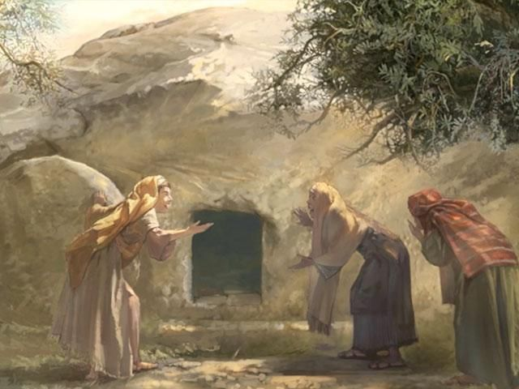
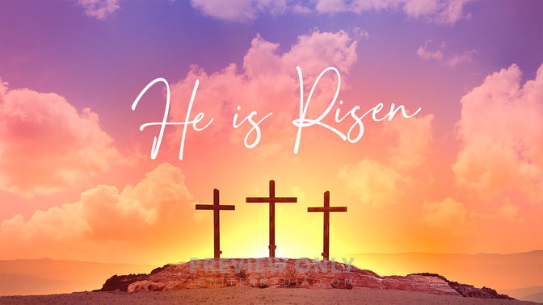
Easter: Year 1
Knowledge Organiser

This unit is designed to develop the children's knowledge and understanding of the Season of Easter as a celebration of the Resurrection of Jesus. The unit focuses on the importance of the resurrection and its message.

- What do you wonder about this picture?
- Who are these three women and why are they at a tomb?
- How do you think the women were feeling?

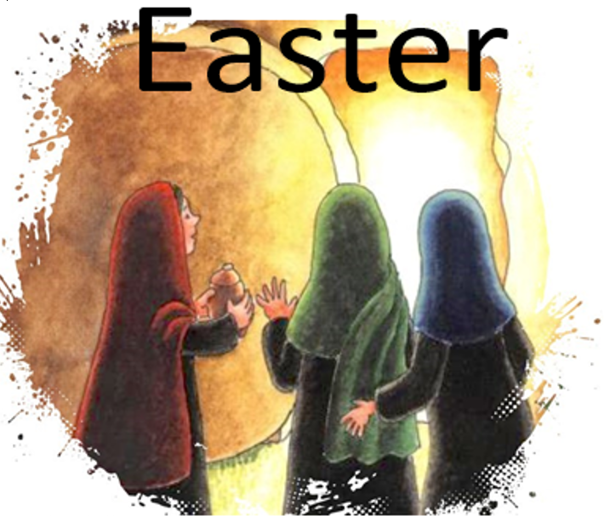

ER1 – I wonder… how would you have felt if you one of the three ladies at the tomb?
ER2 – I wonder… why did Thomas doubt that Jesus was still alive?
ER3/4 – I wonder… what questions would you ask if you went to the tomb and saw that Jesus was not there?

Catholic Social Teaching
Solidarity and the Common Good
Should we share what we know with others?

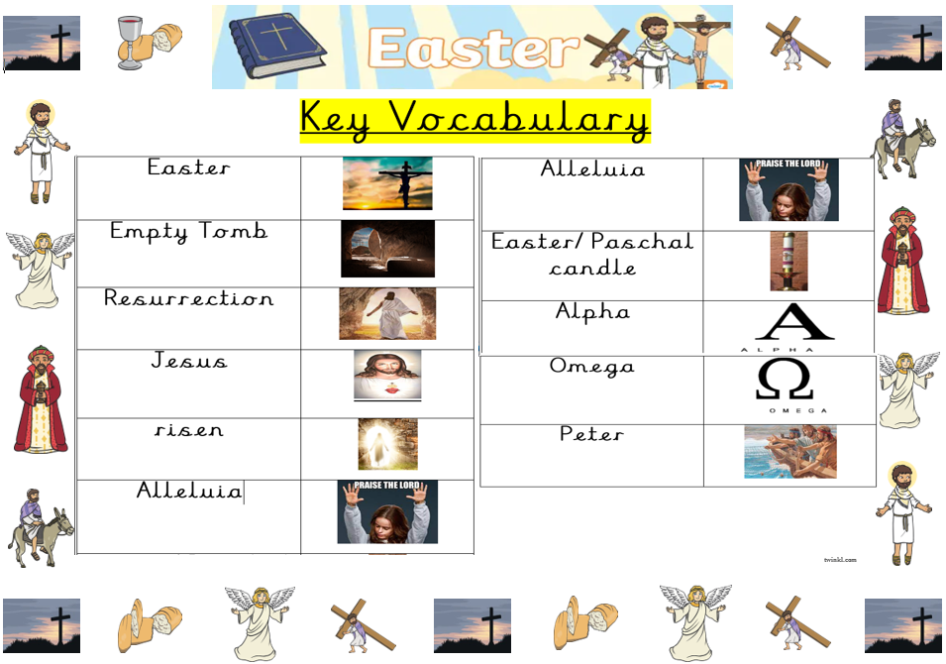
Bible References
Mt. 28: 1-10 – The Resurrection of Jesus
Mk. 16: 1-8
Lk. 24: 1-12
Jn. 20: 1-18



