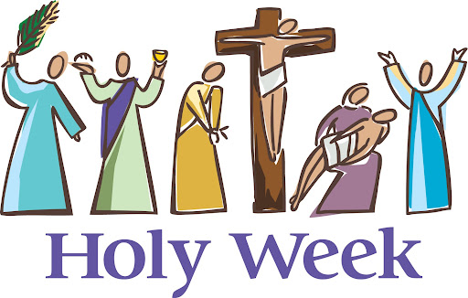
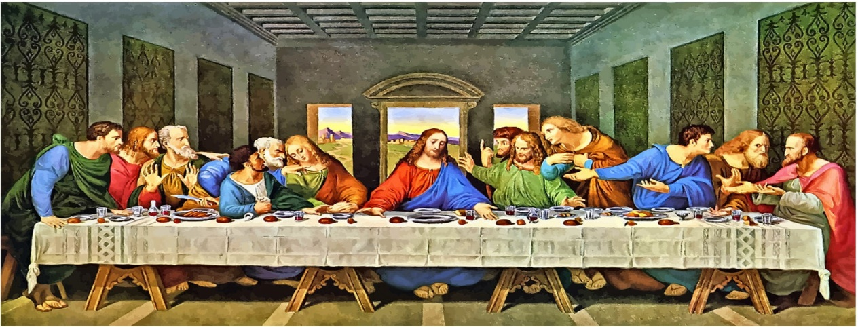
Holy Week: Year 1
Knowledge Organiser

This unit is designed to develop the children’s knowledge and understanding of the important events of Holy Week and how they tell the last days of Jesus’ life on earth. The unit focuses on Palm Sunday, the Last Supper and the Stations of the Cross.

- What do you wonder about this picture?
- Why did Jesus want to sit and have His last supper with His disciples?
- How do you think the people surrounding Jesus were feeling?

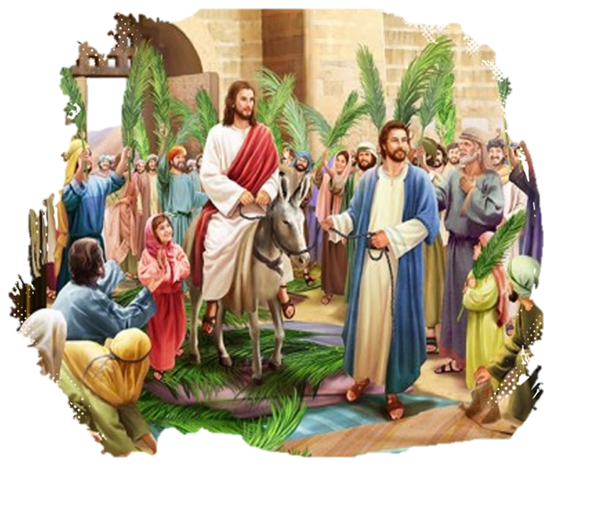
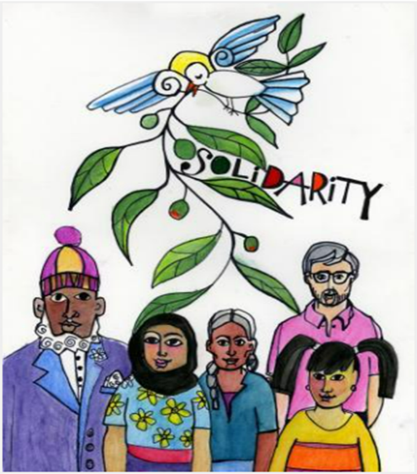
ER1 – I wonder… how would you have felt if you were a disciple at the Last Supper?
ER2 – I wonder… why did Jesus wash the disciples feet?
ER2 – I wonder… what does Hosanna mean and why did people say it when Jesus arrived on His donkey?
ER3/4 – I wonder… what questions would you ask if you were a disciple at the Last Supper?

Catholic Social Teaching
Solidarity and the Common Good
Why should we care about how others are feeling?

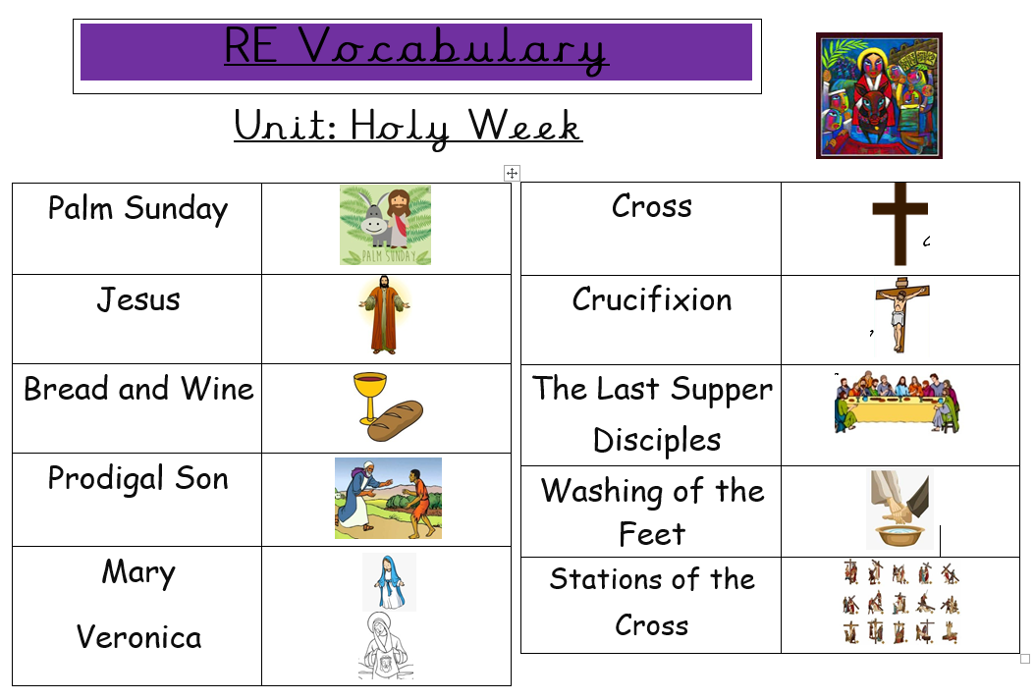
Bible References
Lk. 19: 28-39 – The Story of Palm Sunday
Mt. 21: 1-11
Mk. 11: 1-11
Mt. 26: 20-30 – The Last Supper
Mk. 14: 17-26
Lk .22: 14-23



