Catholic Social Teaching
Option for the Poor and Vulnerable
The needs of the poor and vulnerable should come first.
RELATED SCRIPTURE
Mt. 22: 34-40 – Jesus Teaches About the Greatest Commandment
Mk. 12: 28-34
Lk. 10: 25-37 – The Parable of the Good Samaritan
Lk. 15: 11-32 The Parable of the Prodigal Son
Lk. 15: 1-10 – The Parable of the Lost Sheep Mt. 9: 18-26 – The Healing of Jairus’ Daughter
Mt. 14: 13-21 – The Miracle of the Feeding of the Five Thousand
Mt. 20: 29-34 – The Healing of the Blind Man
Jesus: Teacher and Healer – Year 1
Knowledge Organiser

This unit is designed to develop the children’s knowledge
and understanding of the person of Jesus and his ministry as a teacher and healer. The unit will also develop their understanding of what Jesus’ ministry reveals to us about God, how the Church continues that ministry today in various ways and how Christians are called to follow the example of Jesus in their lives.

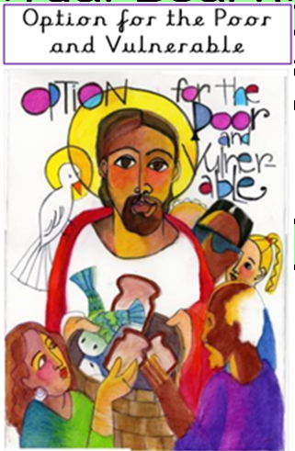

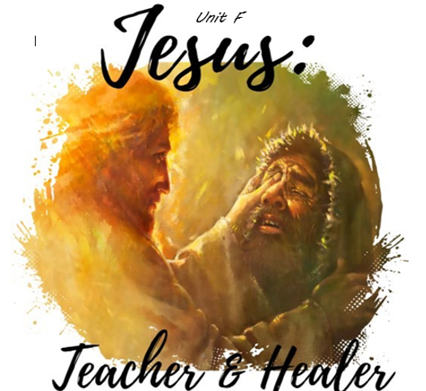

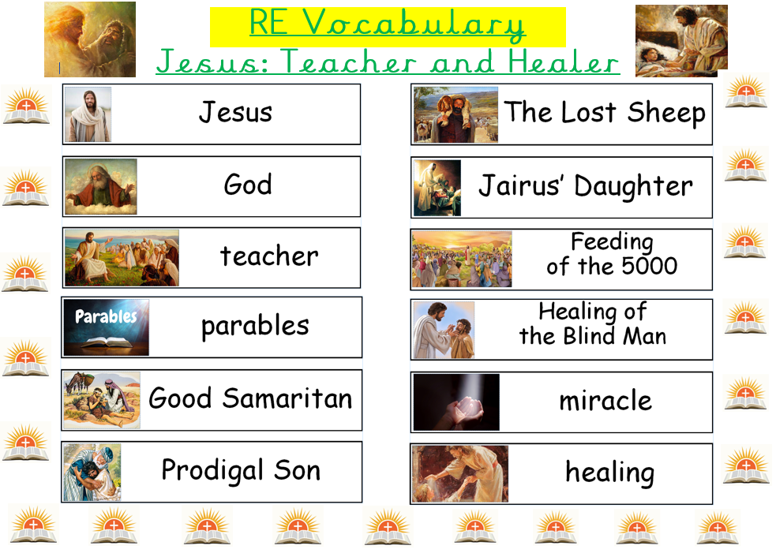



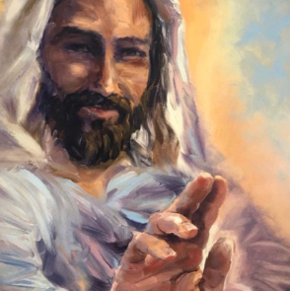
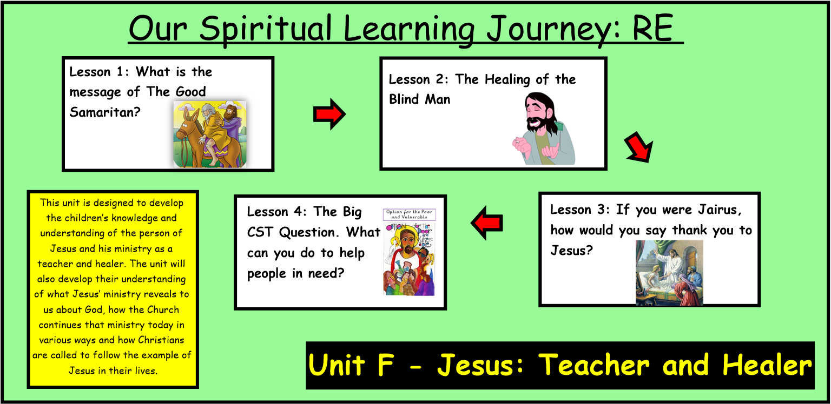
ER1 – I wonder… what does The Good Samaritan parable teach us about good choices and bad choices?
ER2 – How do you think the blind man felt before Jesus healed him, how do you think he felt after the miracle?
ER3/4 – Why is it important to be a good Samaritan? I wonder what can you do to be a good Samaritan for others?

