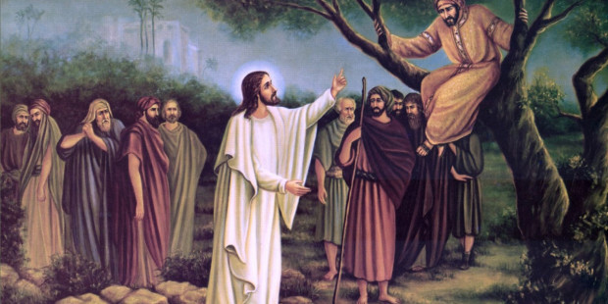
What are you going to do to change and grow to be more like Jesus following His example?
Lent: Year 1
Knowledge Organiser

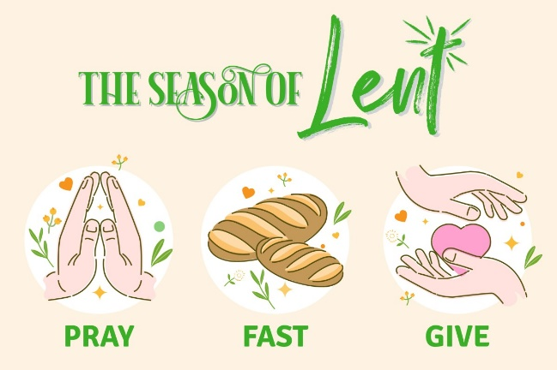
This unit is designed to develop the children’s knowledge and understanding of Lent as a time of change and of growing to be more like Jesus by following his example. In the unit children will explore various aspects of Jesus’ message and ways in which Christians can apply these to real life situations.
- What do you wonder about this picture?
- Why did Jesus decide to go to a sinner’s home?
- How do you think the people surrounding Jesus were feeling?
- How did Zacchaeus change his ways and prove to Jesus that he could be a good man?


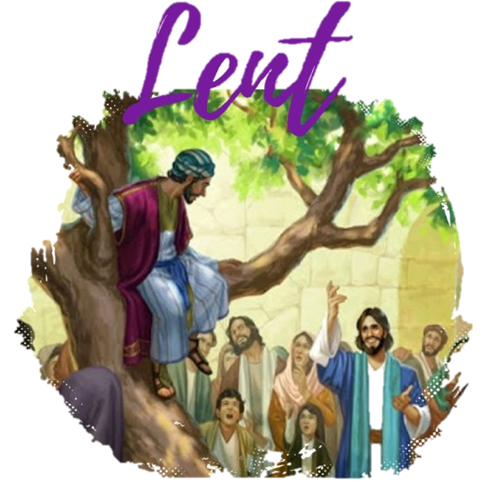

ER1 – I wonder… how can we show that we are listening to God during Lent?
ER1 – I wonder… what advice would you give to someone to grow their relationship with Jesus?
ER2 – Lent is a season of change. How do you think we can do this?
ER3 – Why did meeting Jesus make such a big difference to Zacchaeus?
ER3/4 – What did Jesus mean when he said ‘’Love one another as I have loved you?’’ How do we experience the love and care of Jesus?

Catholic Social Teaching
Rights and Responsibilities
Is it easy to follow Jesus all of the time?

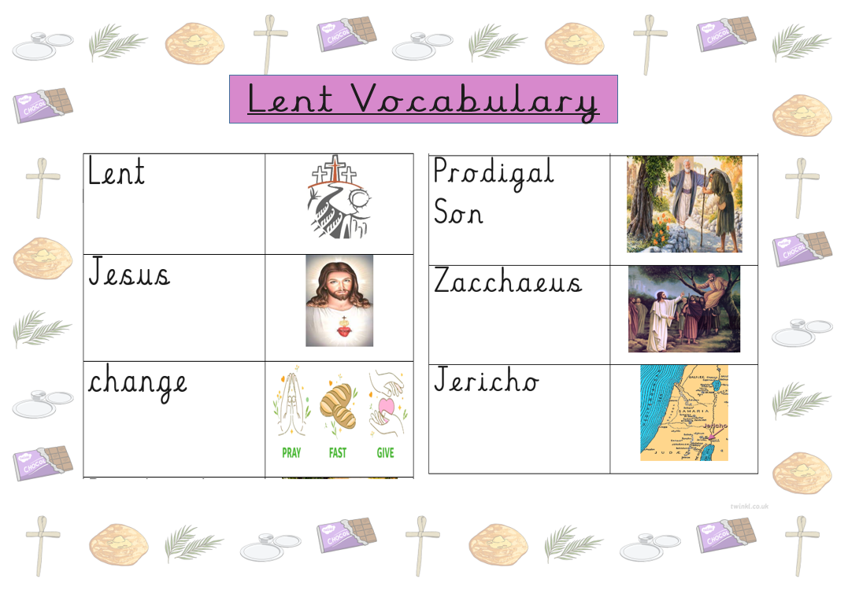
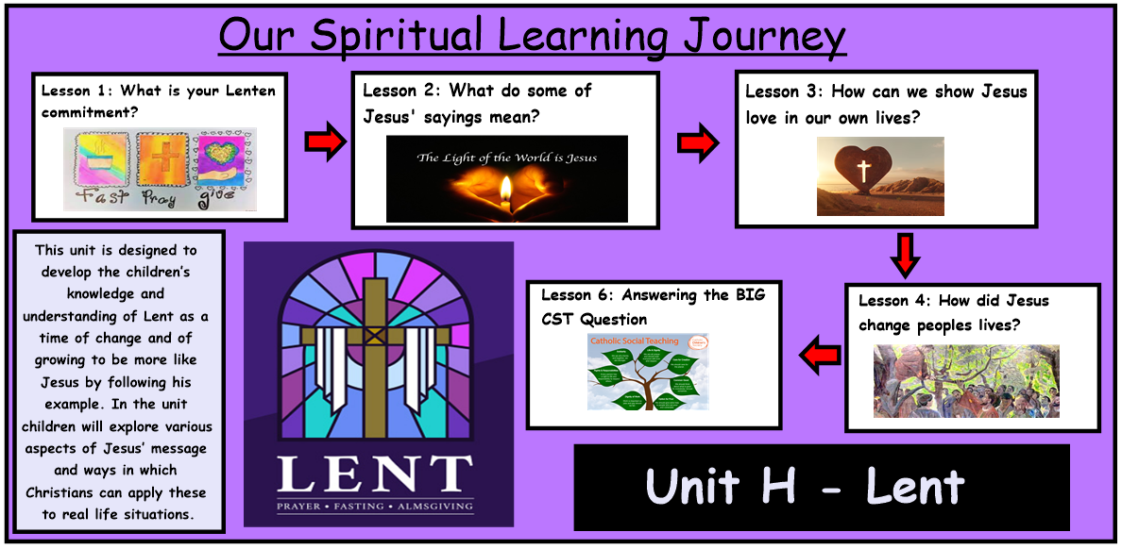
Bible References
Lk. 19: 1-10 – The Story of Zacchaeus



