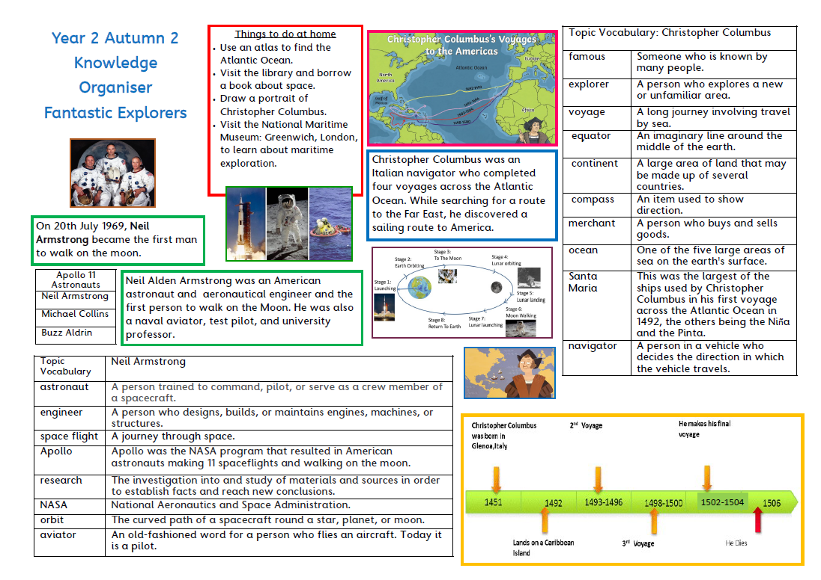
Year 1
Spring Term
History - Great Explorers

