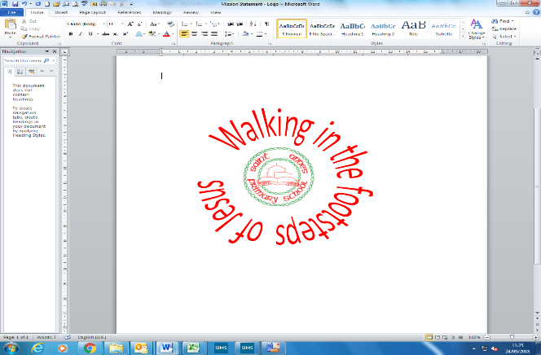
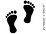
‘People and their communities’| Year 1 | Spring Term
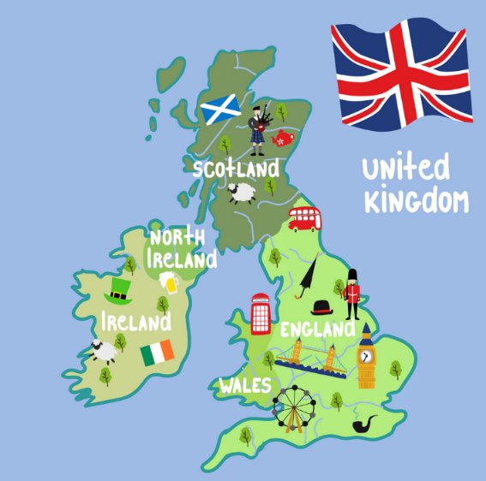
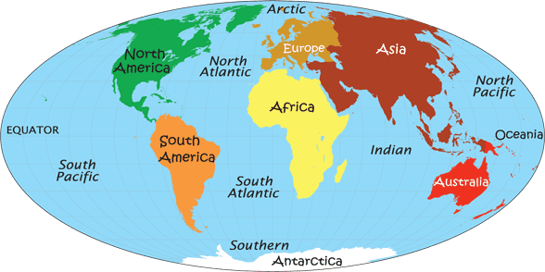
Geography
In this unit, our enquiry question is…
Where in the world do these people live?
Key Vocabulary
1 | United Kingdom | It is an island made up of the countries: England, Scotland, Wales and Northern Ireland.
2 | landmark | An object that is easily seen or recognised and holds great importance.
3 | coast | Where the sea and land meet. Also known as a coastline.
4 | rainforest | Forests with tall trees, warm climates and lots of rain. They are found in the continents Africa, Asia, Oceania and South America.
5 | Africa | The second largest continent.
6 | climate | The typical weather conditions in a particular area over a long period of time.
7 | equator | The imaginary circle around the earth. It is half way between the North Pole and the South Pole.
8 | continent | A continent is a large solid area of land. Earth has seven continents.
9 | country | Continents can be further divided up into regions of land, which we call countries.
10 | city | Any town that has a cathedral (a large, important church).
11 | desert | Any large area that gets very little rain each year. Very few plants or animals live in desert areas.

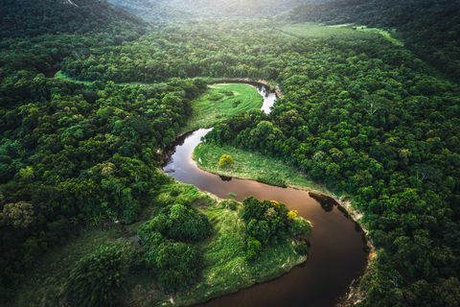
Prior knowledge
1 | The town our school is in | Chelmsley Wood
2 | Our nearest city | Birmingham
3 | The country we live in | England

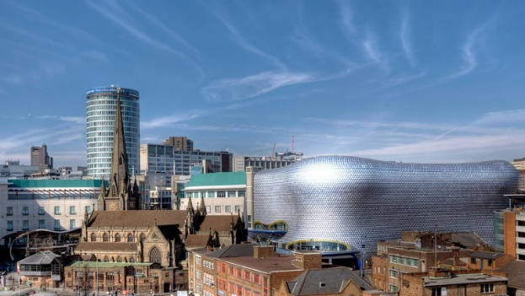
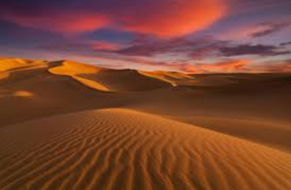
The city of Birmingham
Sahara Desert in Africa
Amazon Rainforest in South America

