Catholic Social Teaching
Family and Community
How are we building the Kingdom of God?

Following Jesus Today: Year 1
Knowledge Organiser
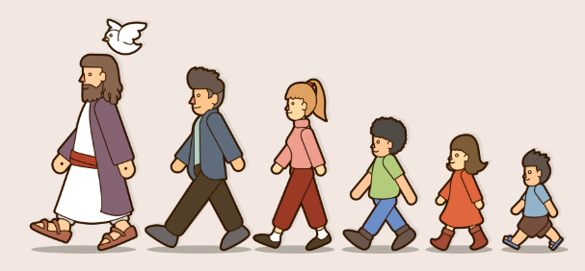

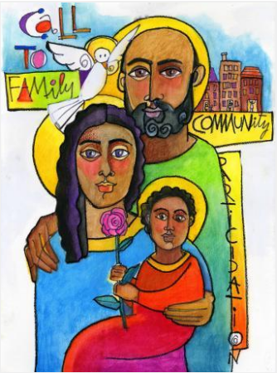
This This unit is designed to develop the children’s knowledge and understanding of what it means to follow Jesus today. The unit develops the children’s understanding of how, as followers of Jesus, we belong to the Church and the different ways that the Church, and the different members of it, follow Jesus.

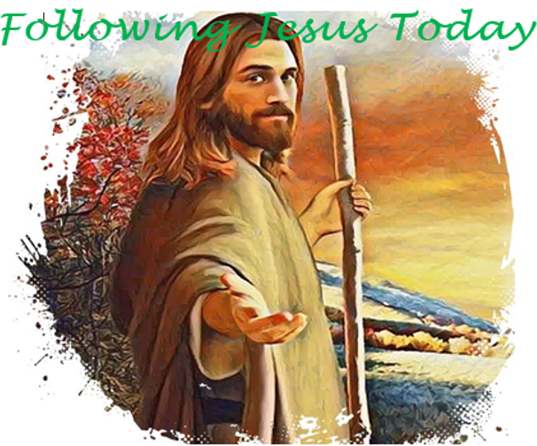
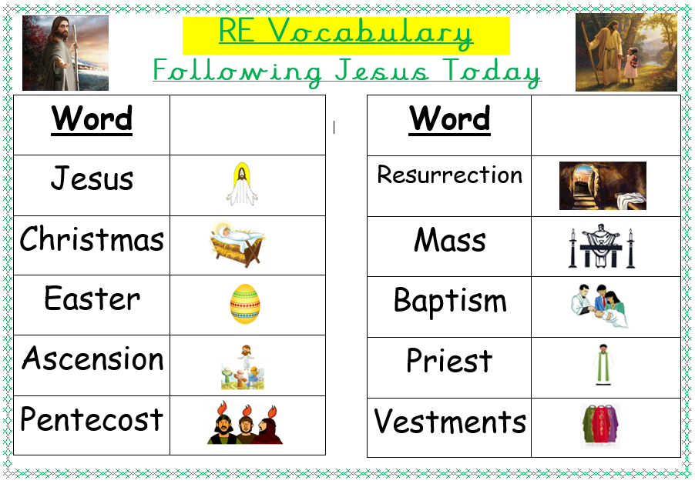

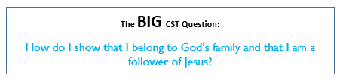

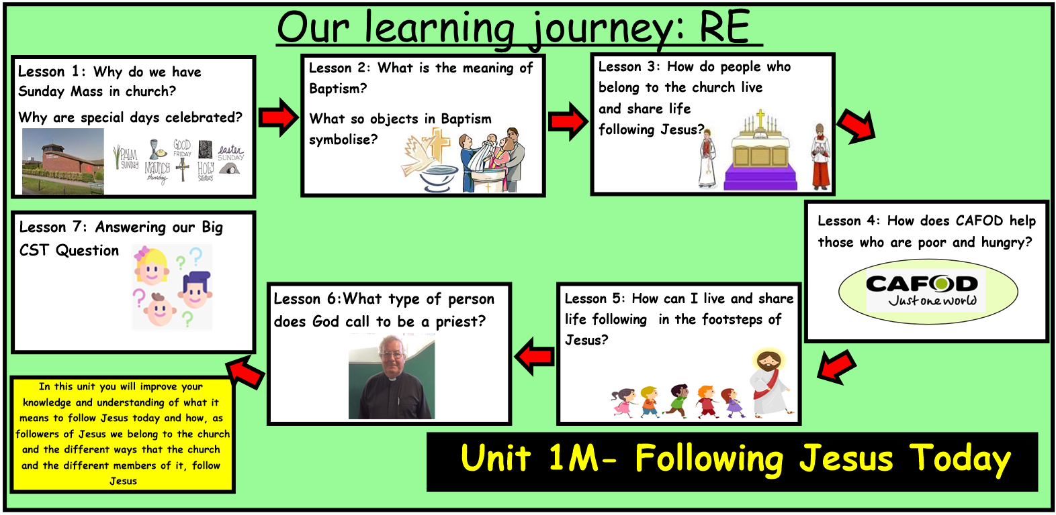
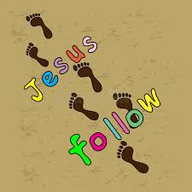
ER1 – I wonder… Why do people go to church?
ER2 – Jesus said we should pray together at different times of the year. Why do you think this is important?
ER3/4 – I wonder… How do you feel when you go to Mass and pray?

