

- What do you wonder
- How does Jesus teach us in the Parable of the Prodigal Son?
- What could you do to ensure that you are showing love and forgiveness to your class mates? Family? Friends?
Forgiveness: Year 1
Knowledge Organiser

This unit is designed to develop the children’s knowledge
and understanding of the importance of forgiveness as a gift we receive and as a way that we can show love to others. The unit will also explore the choices that children make that can be good or bad and the consequences that arise from them. The unit aims to develop the children’s understanding of the need to say sorry when bad choices are made.


ER1 – I wonder… How does Jesus teach us in the Parable of the Prodigal Son?
ER2 – I wonder… How does Jesus teach us in the Parable of the Prodigal Son?
ER3/4 – I wonder… have you ever had to show forgiveness or ask someone for forgiveness? How did you feel? How did the other person feel?


Catholic Social Teaching
Solidarity and the Common Good
Promoting Peace
Should I forgive everyone all of the time?

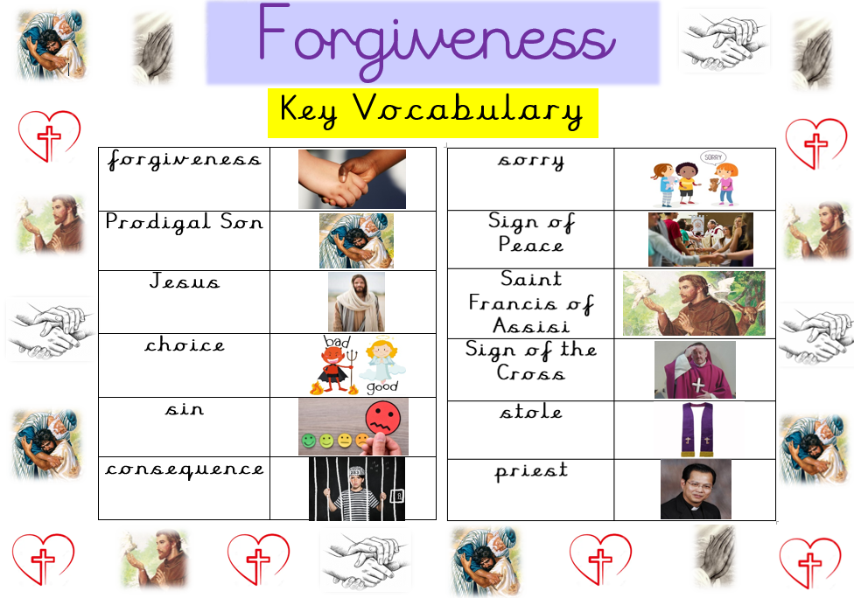

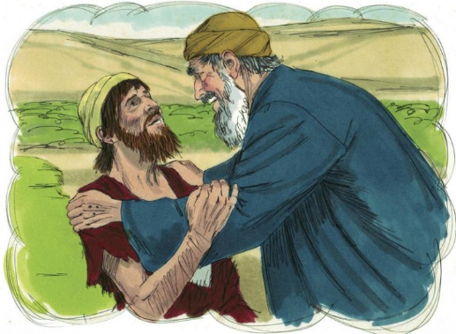
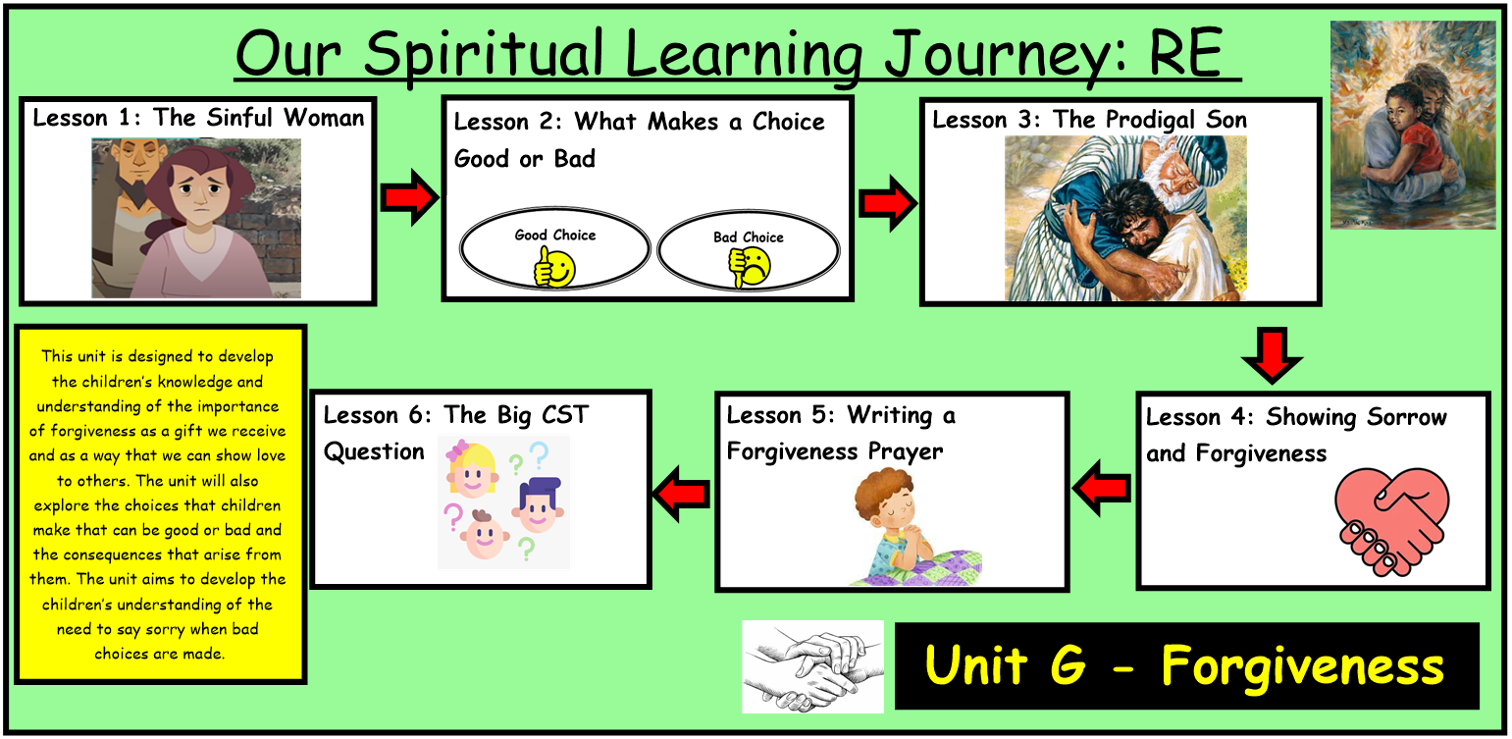
Bible References

Lk. 15: 11-32 – The Parable of the Prodigal Son

