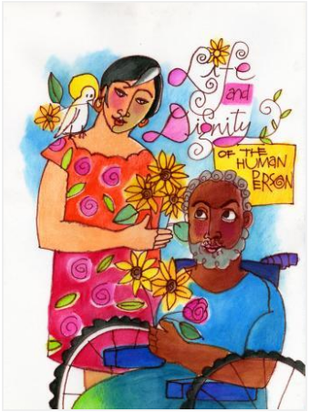
- What do you wonder
- How does the Holy Spirit teach and help us?
- What could you do to ensure you keep the promises you make? Just like Jesus kept His promise before his ascension.
Pentecost: Year 1
Knowledge Organiser


This unit is designed to develop the children’s knowledge and understanding of Pentecost as the fulfilment of Jesus’ promise to send the Holy Spirit. The unit focuses on the coming of the Holy Spirit as a promised gift that brought about a change in the lives of the disciples and how we celebrate and receive that gift in our lives today.

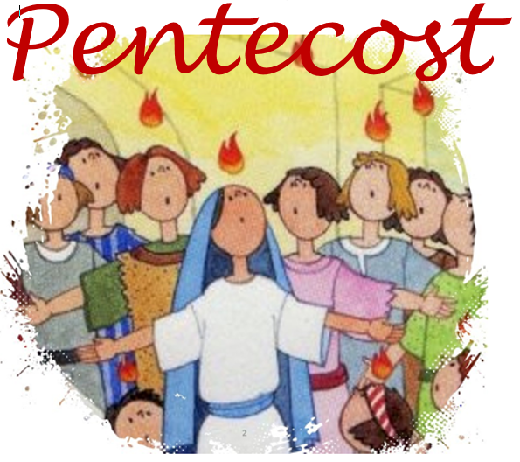
ER1 – I wonder… What questions would you like the ask the disciples about the resurrection?
ER2 – I wonder… How do you think the disciples’ way of life changed after Pentecost?
ER3/4 – I wonder… why do you thank and praise God as the Holy Spirit?



Catholic Social Teaching
Dignity of the Human Person
Why is it important to listen to others?

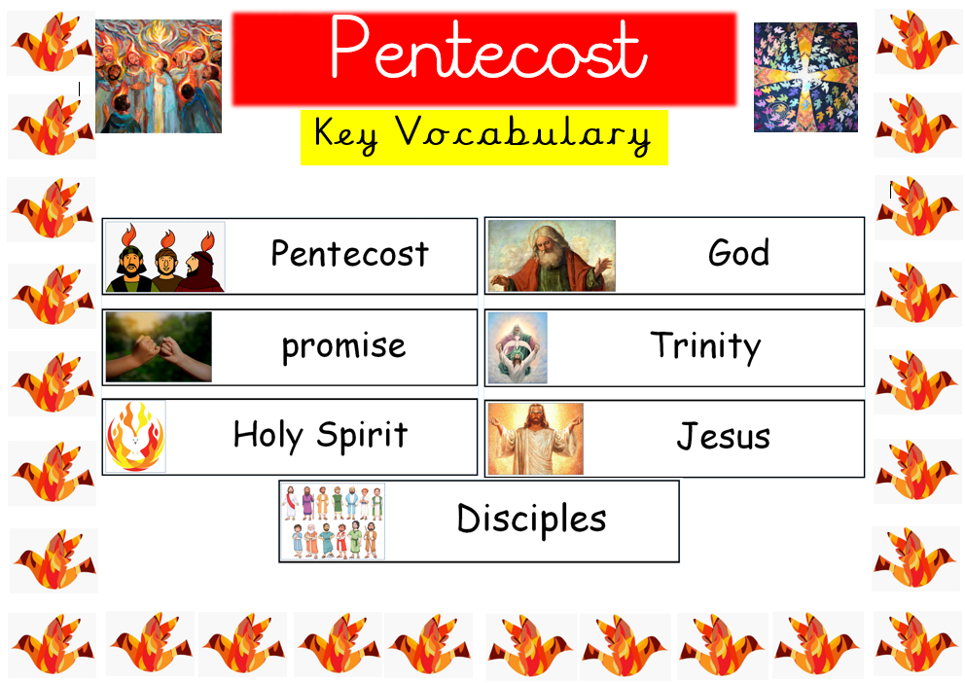

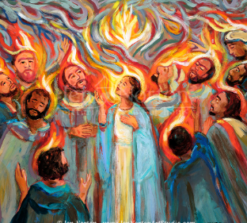
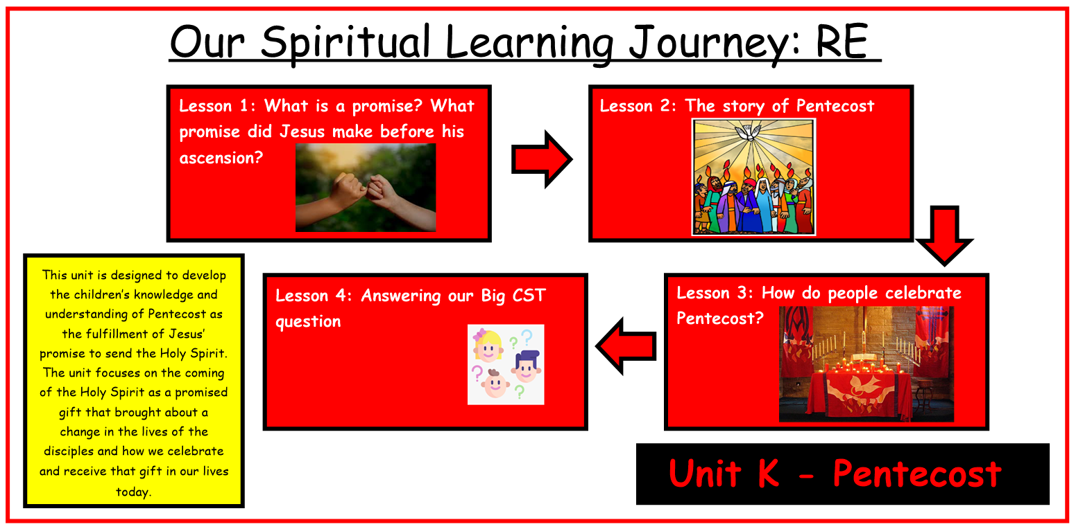
Bible References
Acts 2: 1-4 – The story of Pentecost
Acts 2: 14-36 – Peter Addresses the Crowd
Acts 12: 3-5 – Peter in Prison

