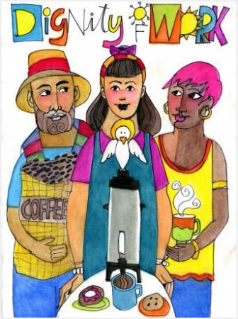
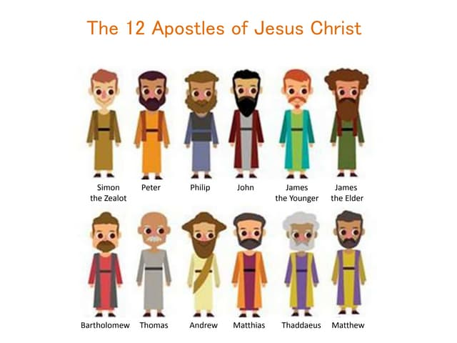

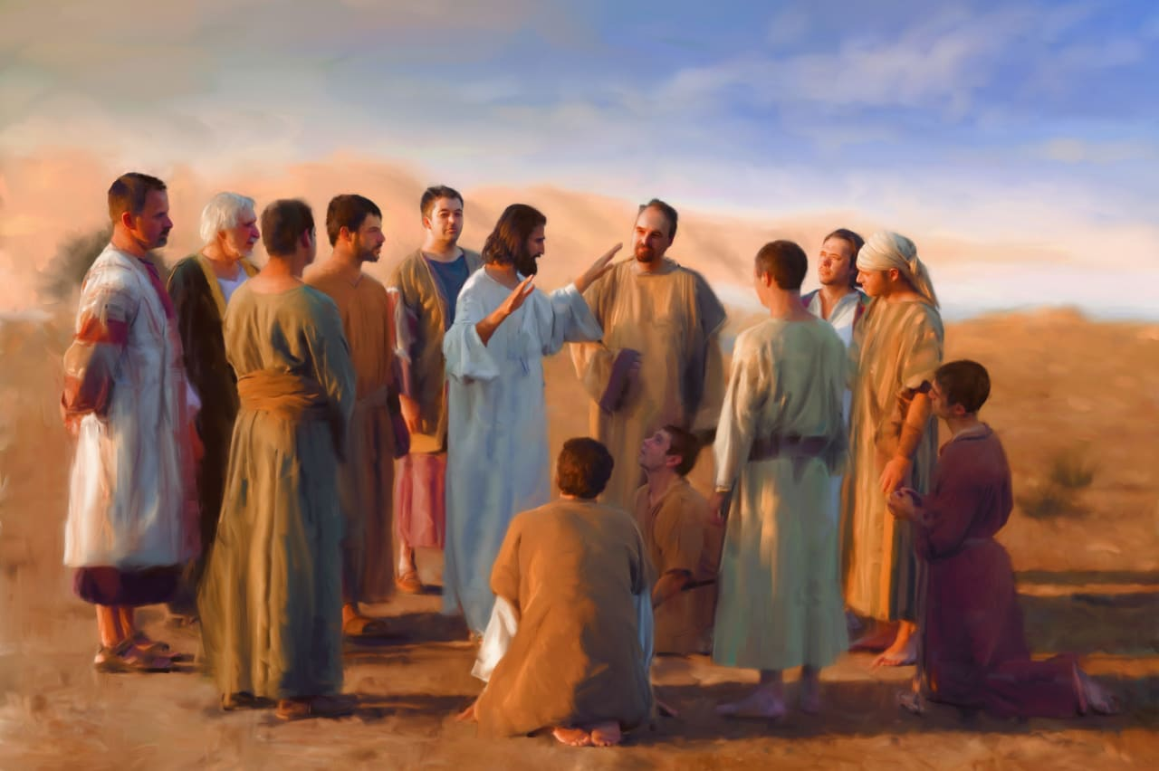
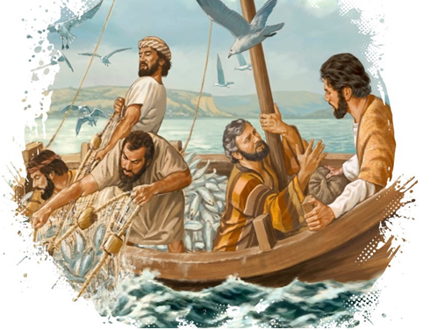
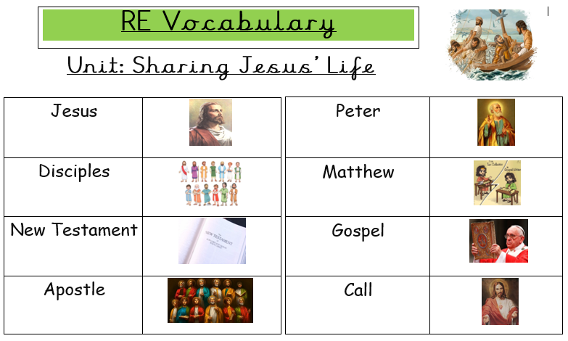
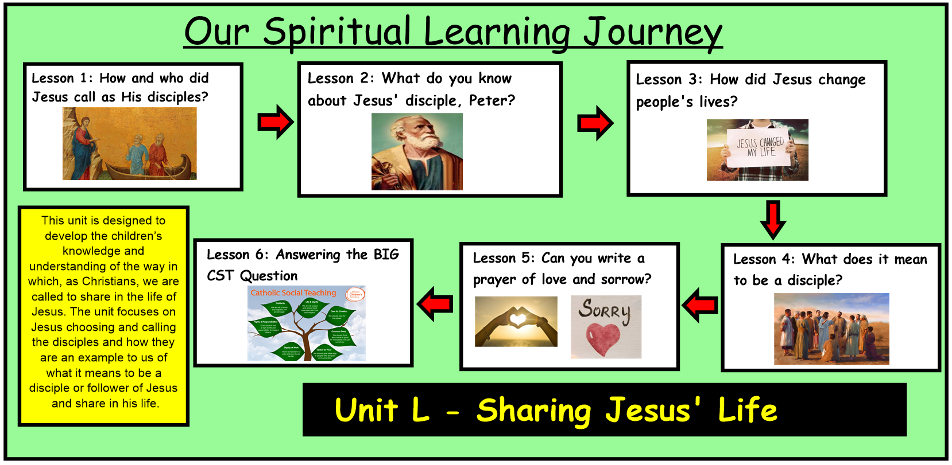
ER1 –What do you wonder about the call of the disciples?
ER2 – Jesus said ‘Follow Him’ How can you follow in Jesus’ footsteps like the disciples?
ER3 –How do you feel when you learn about the good news of Jesus?
- What questions do you have about this painting?
- Why do you think Jesus chose His disciples?
- What qualities did Jesus’ disciples have?
- What do you think Jesus is saying to His disciples in this painting?
This unit is designed to develop the children’s knowledge and understanding of the way in which, as Christians, we are called to share in the life of Jesus. The unit focuses on Jesus choosing and calling the disciples and how they are an example to us of what it means to be a disciple or follower of Jesus and share in his life.
Sharing Jesus’ Life: Year 1
Knowledge Organiser
Bible References
Lk. 5:1-11 – The Call of the Disciples
Mt. 16:13-19 – Simon Becomes Simon Peter
Catholic Social Teaching
Dignity of Work
We all have the right and duty to participate fully in society and to work together to build up a community.
How does Jesus being a friend of mine help me?

