

Enquiry Question
How have these inventors changed the world?
MARIE CURIE
Overview  A photograph of Marie Curie from around 1920. |  |  | Answers to Important Questions and Key Vocabulary
Marie Curie (1867-1934) was a world-famous scientist, who is known for a number of important discoveries.  Along with her husband, Pierre, she discovered radium and other elements. She also discovered radioactivity.  These findings allowed x-rays to be used in hospitals, which have saved the lives of millions of people.  During World War I, she helped to put x-rays into ambulances. This meant that doctors could see where bullets were in the body of soldiers.  Marie Curie won the Nobel Prize twice (the only woman to have done so) – once in Physics (1903) and once in Chemistry (1911). | 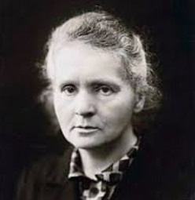   |  | Why did Marie Curie move to France? | 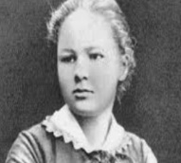  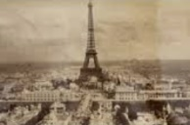 | -After she had finished school, Marie wanted to go to University, but this was not something that young women did in Poland at the time – the local University in Warsaw was for men only.  -There was a famous University in Paris called the Sorbonne, but it was expensive!  -So, Marie worked to pay for her sister to go, as long as her sister would help her once she graduated. She stuck to her promise! |  |  | Key Vocabulary  Scientist  Physics  Chemistry  Element  Nobel Prize  Poland  France  World War I  Radiation  X-Ray  Medicine  Exposure
 |  |  | How did Pierre Curie die? | 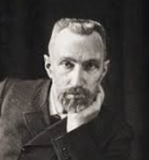 | -Pierre Curie died in a freak accident, when he was only 46 years old.  -In Paris on 19th April 1906, he slipped as he crossed the street, and fell into the path of a horse and carriage. He suffered a bad head injury and did not survive. Marie chose to continue his good work.
 |  |  | What things did Marie Curie invent/ discover? | 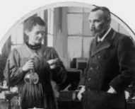  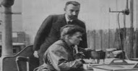 | -Marie Curie discovered the elements polonium and radium;  - She also furthered our understanding of radioactivity;  - She improved our ability to x-ray people;  - She added a great deal of research to help the fight against cancer.
Times in Her Life
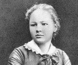  Early Life  -Marie is born as Maria Salomea Slodowska in Warsaw, Poland, on 7th November 1867.  -Her father taught maths and physics and her mother was a headmistress at a girls’ school.  -Marie was a very bright child who did well in her studies. | 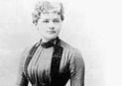  Move to Paris  -At the age of 25, Marie moved to Paris to study at the Sorbonne.  -In Paris, she could be free (Poland was ruled by Russia). She took Physics and Mathematics.  -She lived with her sister and brother-in-law. |  | How did Marie Curie die? | 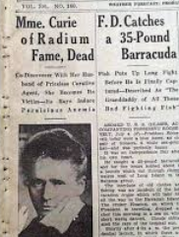 | -Marie Curie died on 4th July 1934.  -She died from aplastic anemia, which is believed to have been caused by her exposure to radiation over her years of research.  -She is thought to have carried test tubes of radioactive material around in her lab coat.  There are now much safer ways to handle radioactive materials.
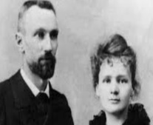
Work with Her Husband

-In 1894, Marie met Pierre Curie. He too was a scientist. They fell in love, and were married a year later. They soon had a daughter together – named Irene.

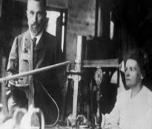
-Marie and Pierre discovered some new elements – radium and polonium. Radium gave off strong rays – Marie called this ‘radioactivity.’

-In 1903, Marie and Pierre were awarded the Nobel Prize in Physics for their work in radiation. Marie was the first woman to ever be awarded the prize.
 |  |  | Top 10 Facts!
 |  |  | - Marie was good friends with Albert Einstein!  - Pierre Curie was killed when he was run over by a carriage in Paris in 1906.  - Marie then took over her husband’s job as the Professor of Physics at Sorbonne.  - It is thought that her Petit Curie’s helped around 1 million soldiers in WWI.  - The clothes that Marie wore in the laboratory were the same clothes that she got married in. |  |  | - Marie’s research cost her life – she died from an overexposure to radiation.  - Her notebooks are still too radioactive to touch, even today!  - The Curie Institute in Paris is still a major centre of cancer research.  - Marie’s first daughter, Irene, later won her own Nobel Prize in Chemistry.  - Marie’s second daughter, Eve, wrote an autobiography about her mother’s life..
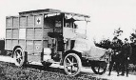  Work in World War I  -In WWI, doctors began to use x-rays to find out what was wrong with injured soldiers. However, there weren’t enough x-ray machines for every hospital to have one.  -Marie had the idea to move them in trucks. These trucks became known as ‘Petit Curie’s’, and helped many soldiers. | 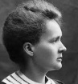  Later Work  -For her continued work exploring the two elements and radioactivity, Marie won a second Nobel Peace Prize in 1911.  -She also joined the fight against cancer, by opening a facility for cancer sufferers.

1911: Marie wins another Nobel Prize for her work with radioactivity.
1906: Pierre Curie is tragically killed in an accident.
1903: Marie and her husband win the Nobel Prize.
1914: X-rays are used to help wounded soldiers in WWI.
1932: Marie and her sister start a facility to fight cancer.
1934: Mary Curie dies of exposure to radiation.
1902: Marie Curie works with radium.
1895: Marie Curie gets married to Pierre Curie.
1891: Marie Curie moved to Paris to study.
Marie Curie Timeline
7th November 1867: Marie Curie is born.

