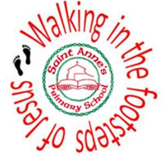
Enquiry Question
How have these inventors changed the world?
TIM BERNERS-LEE
Overview  A photograph of Tim Berners-Lee from 2014 |  |  | Answers to Important Questions and Key Vocabulary
Tim Berners-Lee (b.1955) is a British computer scientist who invented the World Wide Web.  He also created a new computer language called HTML (Hypertext Mark-Up Language) in which most web pages are written.  The first webpage was made available on 6th August 1991.  He first had the idea for the WWW in the early 1980s. He came up with the name World Wide Web in 1989.  He now leads the organisation that looks after the internet, called the World Wide Web Consortium.  He was knighted for his achievements in 2004. | 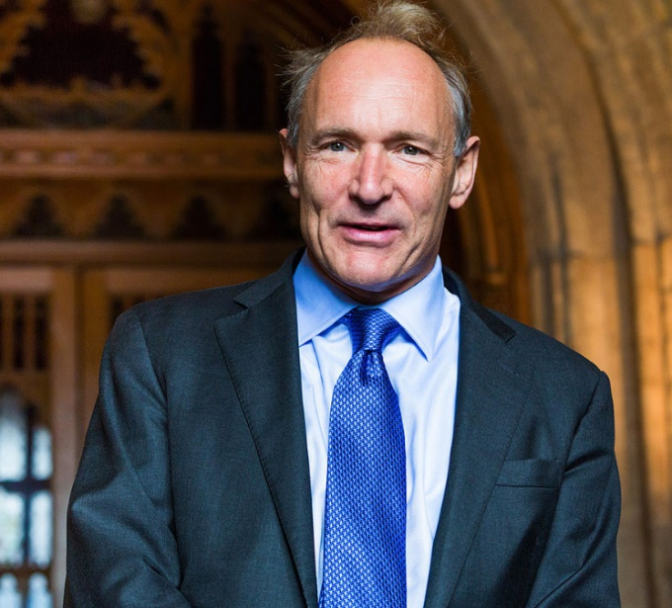   |  | What made Berners-Lee think of the World Wide Web? |  | -Berners-Lee found his work frustrating and difficult to do, because he was always having to log on to different computers to get information.  -He also realised that lots of researchers used different types of computers and programs.  -He learnt that it would be easier to create an information system that everyone could access, and send and receive information. It became the web! |  |  | Key Vocabulary  Inventor  World Wide Web  Internet  Computer Scientist  Laboratory  Online  Browsing  Website  Webpage  Hypertext  E-Safety  HTML
 |  |  | What were his biggest challenges? | 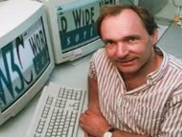 | -Berners-Lee has said that the hardest bit was not inventing the web, but persuading people to use it!  -People were worried about sharing information on this big system that they didn’t know.
 |  |  | What has Berners-Lee done since his invention? |  | -He had done lots of work to try and make the world wide web a better and safer system.  -This has included as the leader of the World Wide Web Consortium, and in partnership with different governments in the world.  -He also helped to set up the Alliance for Affordable Internet, to try and think of ways that people in poorer countries could get online.
Times in His Life
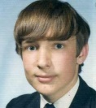  Early Life  -Tim Berners-Lee was born in London 8th June 1955. He was the eldest of four children.  -He did well at school, and so was able to go to Queen’s College at the University of Oxford from 1973-1976.  -There, he graduated with a first class degree in Physics. | 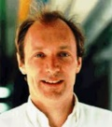  Early Work  -Whilst working as a contractor in Geneva for the CERN laboratory from 1980 onwards, Berners-Lee had an idea.  -He thought up the idea of ‘hypertext’, meaning that the researchers at the laboratory would be able to share information anywhere. |  | What does Berners-Lee think of the web now? |  | -Berners-Lee understands that sometimes the web has been used for all the wrong things.  -However, he points out that the web has saved other people’s lives, as they have found out about diseases that they didn’t know they had, or how to react in an emergency situation.  He wants people to use it for the right reasons.
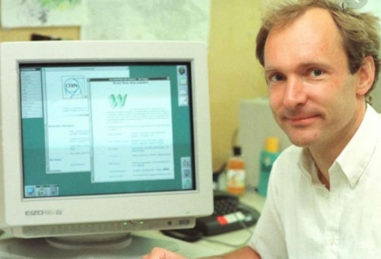
Invention of the Internet

-By 1989, Berners-Lee’s idea had grown, and he saw an opportunity to propose it to others. His managers allowed him to build the first website at CERN.

-His first webpage explained to people about the idea of hypertext and creating their own webpage.

It was put online on 6th August 1991 – and the rest is history!
 |  |  | Top 10 Facts!
 |  |  | - Berners-Lee never patented the web, meaning people could use it and make web pages.  - If he had done, he would probably be the richest person in the world.  - Instead, he decided that he wanted everyone to be able to access it.  - As a child, he was a keen train-spotter, and played with model railways.  - He has admitted that the pair of slashes (//) in web addresses are unnecessary – he didn’t know at the time. |  |  | - He was named as one of Time Magazine’s 100 Most Important People of the 20th Century.  - He is sometimes known as TimBL  - Being intelligent with computers obviously ran in the family – Berners-Lee’s parents worked on the first commercial computer.  - His first prototype for the internet was called ENQUIRE.  - Berners-Lee now wants to make internet access more affordable for people in poor countries.
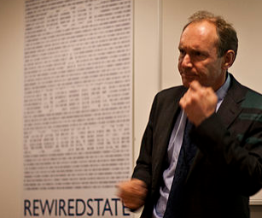
After the Invention

- Berners-Lee has spent much of his life since inventing the internet working alongside others to make the internet safe and of a better quality.

-He has received many awards and honours for his invention and work afterwards. He was knighted in 2004, and placed on the Queen’s personal Order of Merit in 2007. He has also been given many honorary degrees from universities all across the world.

2010: Continues to work in internet safety.
2004: Receives a knighthood.
1991: Berners-Lee makes the first website public.
1989: Berners-Lee is given permission to begin working on his project.
1981: Berners-Lee first has his idea that would become the WWW.
1980: Joins CERN laboratory in Geneva as a contractor.

1976: Joins a company called Plessey as an engineer.
1973-76: Attends University of Oxford – attains a first degree.
1969-73: Berners-Lee attends the Emanuel School.
Tim Berners-Lee Timeline
1955: Berners-Lee is born in London, UK.

