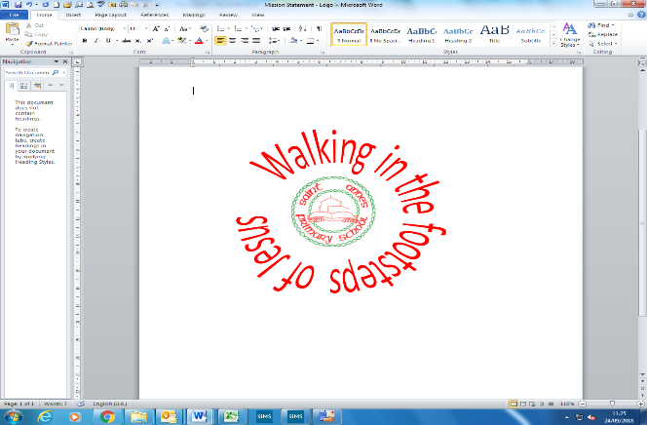
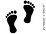
‘Animals and their habitats’| Year 1 | Summer Term
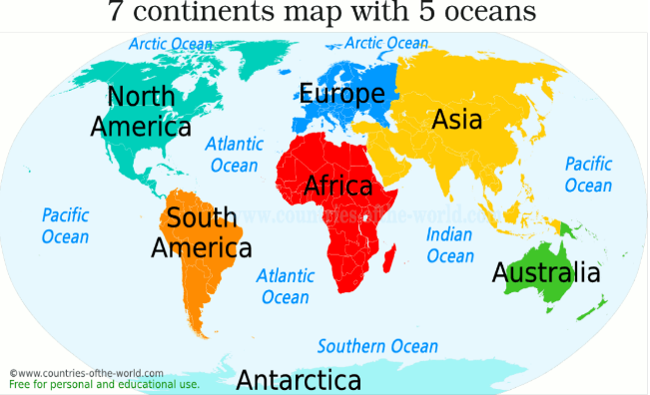
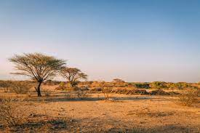
Geography
In this unit, our enquiry question is…
Where do our favourite animals live?
Key Vocabulary

1 | World | The earth, together with all of its countries and peoples.
2 | Globe | A sphere or ball that bears a map of the Earth on its surface.
3 | Ocean | The ocean is the body of salt water which covers the surface of the Earth. There are five oceans.
4 | Sea | Seas are smaller than oceans and are located where the land and ocean meet. There are seven seas.
5 | Savanna | Savannas are flat grasslands with scattered trees and shrubs. The temperature is warm all year round. Savannahs only have two seasons instead of four – wet and dry.
6 | Migration | When an individual or a group of animals move from their habitat to a new habitat. They travel long distances.
7 | Herd | A herd is a large group of animals. The word ‘herd’ is used for mammals, mainly hoofed animals.
8 | Habitat | The natural home or environment of an animal and plant.
9 | country | Continents can be further divided up into regions of land, which we call countries.
10 | Reef | Jagged rock, coral, or sand just above or below the surface of the sea.

Prior knowledge
1 | The earths seven continents | Asia, Africa, North America, South America, Antarctica, Europe, Oceania
2 | The country we live in | England (which is part of the United Kingdom)
3 | North and South Pole | The North Pole is at the northernmost point of the Earth. The South Pole is at the southernmost point on the Earth. The area around the North and South Poles is very cold.

The savanna
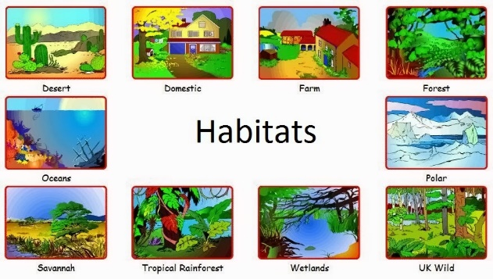

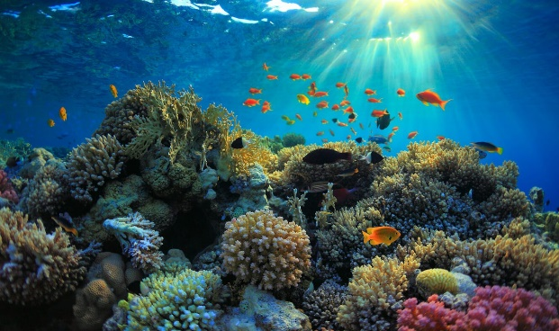
Reef

