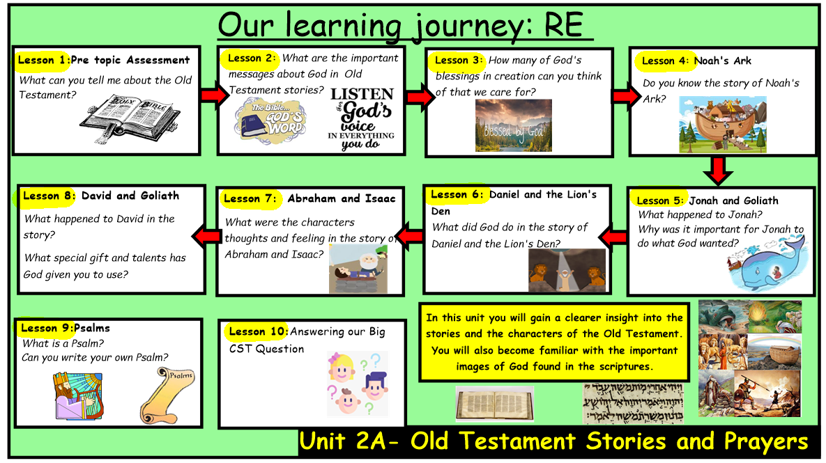
Old Testament Stories and Prayers
Knowledge Organiser
Learning Journey:

Bible References:
Learning Journey:
In this unit you will learn more about the stories and characters of the Old Testament and how precious the Bible is. You will start to understand the important images of God in scriptures and the messages they hold. You will learn how special psalms are and how they praise and thank God
Prior Knowledge
This unit builds on previous learning in Reception and Year 1 about the Bible being filled with important stories about God.

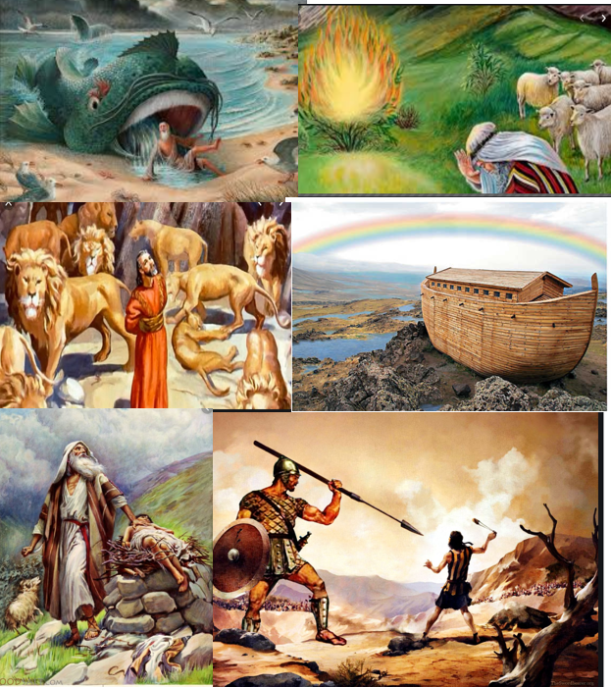
I wonder…
1. Is there any story that interests you?
2. What does the Bible make you wonder?
3. What are you curious to know about Abraham?
4. What questions would you like to ask God about Daniel?
5. What does the Bible teach us in our daily lives? Testament? Why?Why?created? Why?
6. What questions do you have about this story?
7. What are your favourite things that yoy would praise and thank God for?

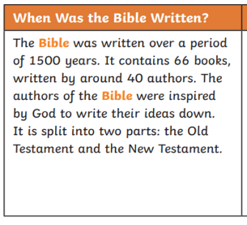

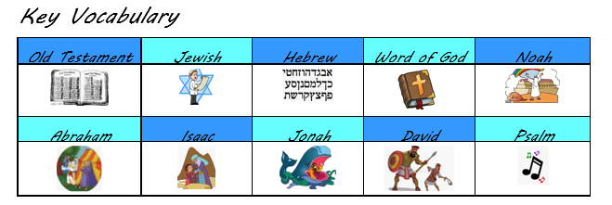
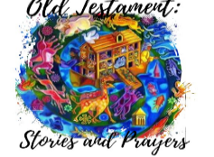
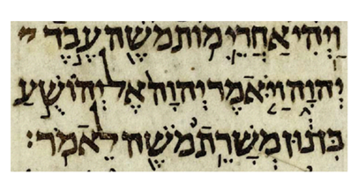
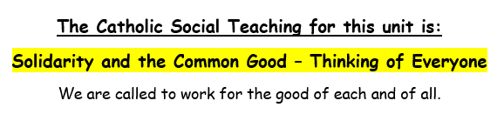

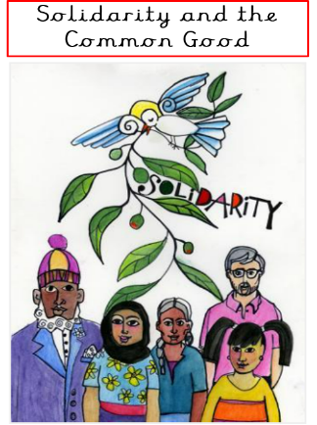
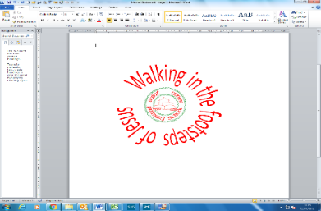

ER1: What do these images make you wonder?
ER2: What questions do you have about the image?

