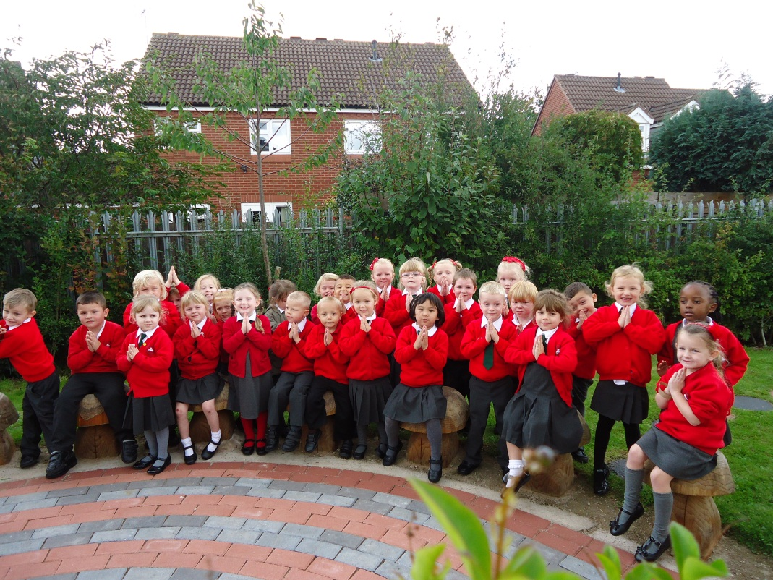
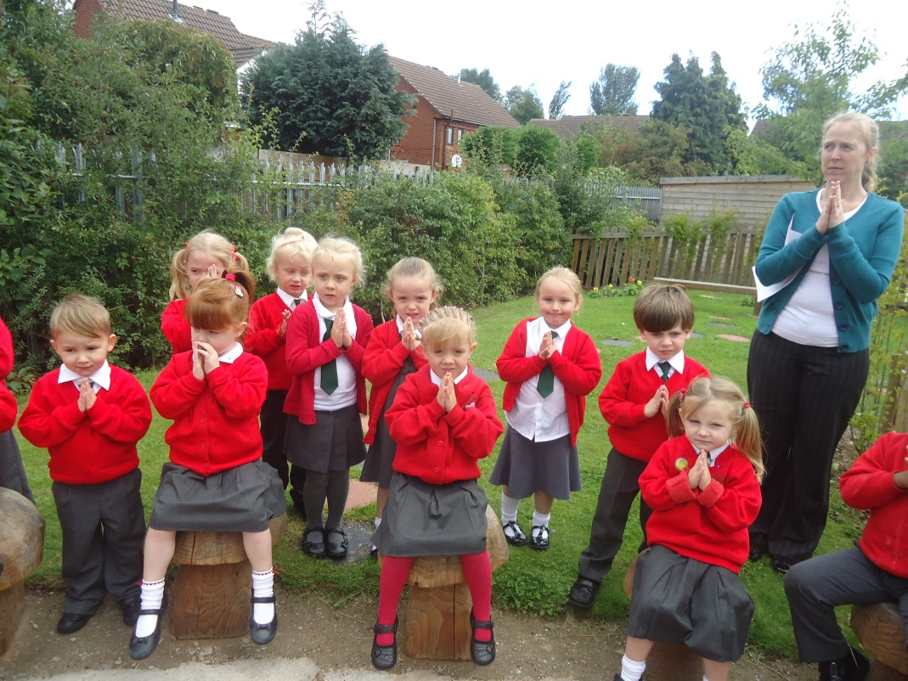
Prayer Garden
During Collective Worship we visited the Prayer Garden. We said special prayers and thought about all the wonderful things Jesus does for us.

