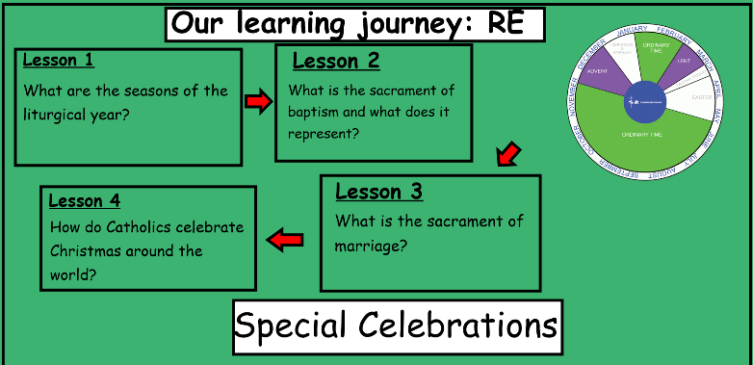
Unit F- Special Celebrations
Knowledge Organiser
Mark 1 9-13
The Baptism of Jesus

Bible References:
Learning Journey:
Learning Journey:

In this unit you will learn more about the seasons of the liturgical year as a celebration of the life of Christ. You will be able to describe some of the customs and symbols associated with these seasons. You will learn that the sacraments are special celebrations and you will be able to talk about some of the rituals that take place in Baptisms and weddings.

Prior Knowledge
This unit will build on your knowledge about Advent, Lent, Easter and some knowledge about the symbols of Baptism.
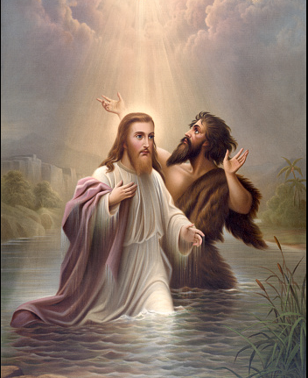
I wonder…
1. What questions would you like to ask to Mary and Joseph?
2. How do you think someone would feel after receiving the sacrament of Baptism? Why?
3. What would you like to say to Joseph, (thinking about how we he showed love and care to Mary.?
Testament? Why?Why?created? Why?

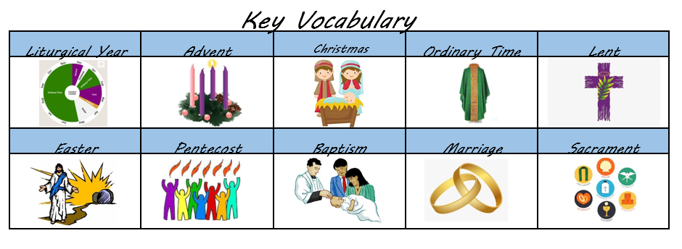
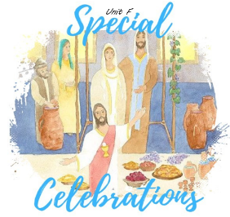
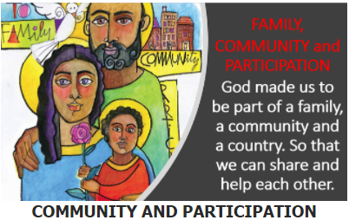
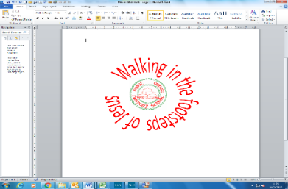

Catholic Social Teaching: Family and Community
Why is your family and other communities important to you?
How can you get involved with your community?
As members of families and communities, how can we participate together in Christ’s mission?
ER1: What do these images make you wonder?
ER2: What questions do you have about the image?

