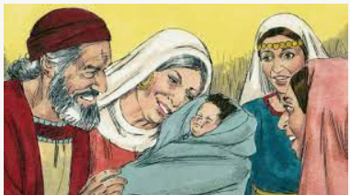
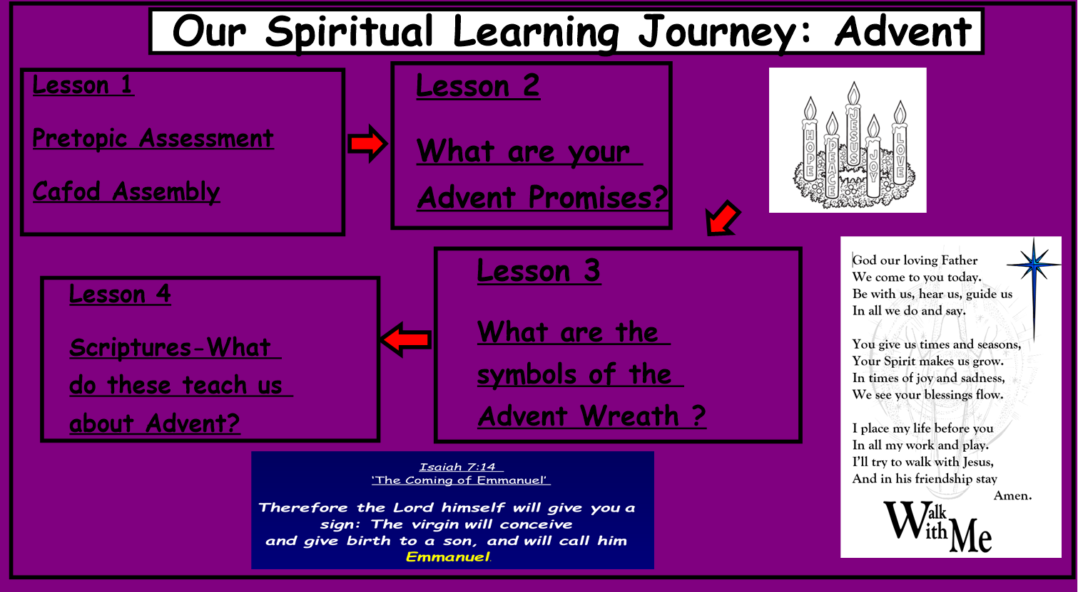


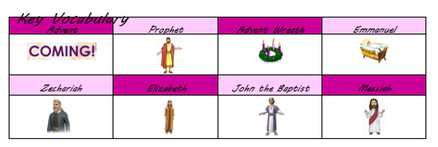
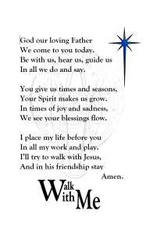
Advent: Year 2
Spiritual Knowledge Organiser
- What questions do you have about this painting?
- Why do you think Elizabeth looks so joyful?
- How will this baby help Jesus in his life?
- How is this paintings story similar to Mary?
Catholic Social Teaching – Solidarity and the Common Good
How will you tell people to prepare for Jesus to come again?


S C R I P T U R E
Isaiah 7: 14 – The Coming of Emmanuel
Lk. 1: 1-24, 57-80 – The Story of Zechariah and the Birth of John
Mt. 3: 1-12 – The Proclamation of John the Baptist
This unit will develop your knowledge of
the time, symbols and characters of the liturgical Season of Advent. It will focus on Advent being a season of preparation for Christmas through the story of John the Baptist and parish activities.

